Azure Data Factory

Create a data Factory:

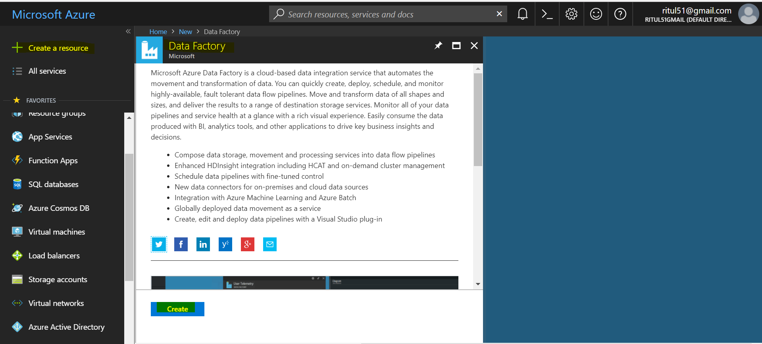

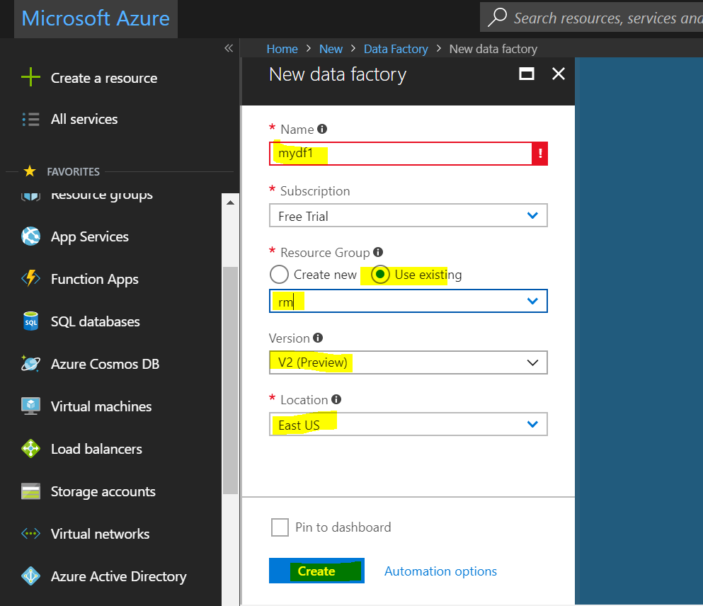

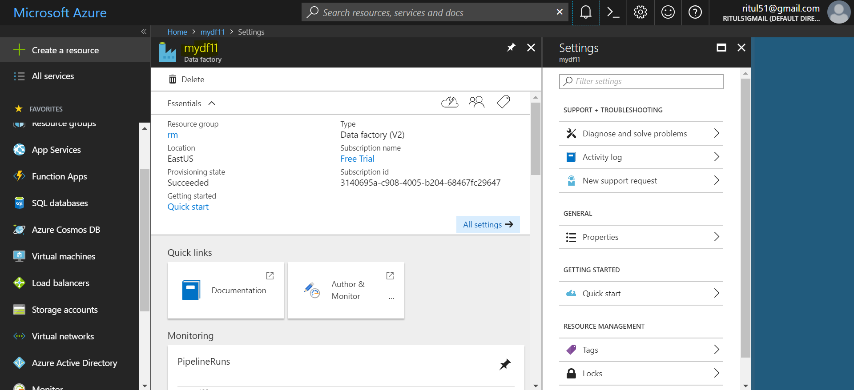

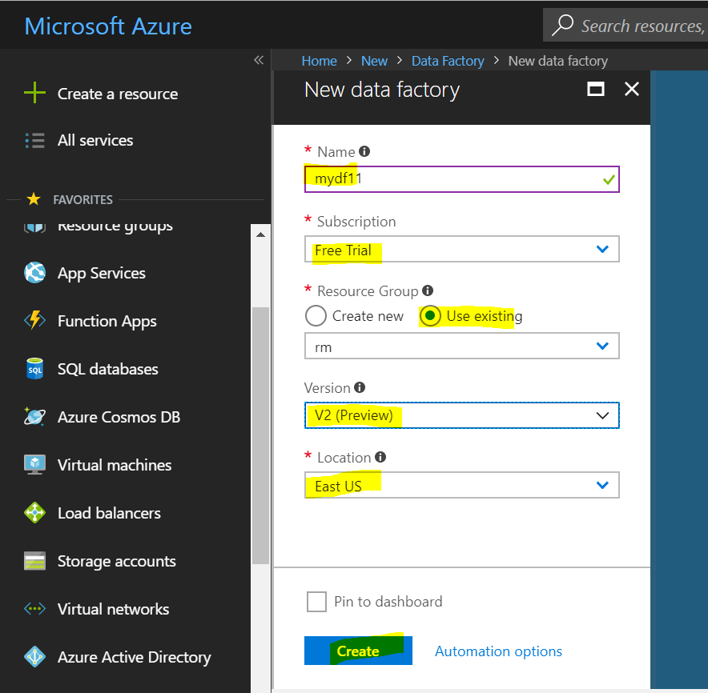

**Data factory use to perform ETL and load type of operations:**

**Pipeline-** Collection of task in pipeline

**Data Sets-** Data Structure

**Trigger-manually & Automate & Schedule**

**BLOB to BLOB file load Using ADF:**

When we transfer data from one place to another we need data factory in between. New linked service is help to link source and destination, need one linked service for SOURCE and one for DESTINATION.

In case of BLOB one linked service is require because source and destination is same.

Data sets need to set path of data and file which need to transfer one dataset for SOURCE and one data set for DESTINATION

In case of BLOB 2 dataset one for source path and another for destination path.

**Create BLOB Storage:**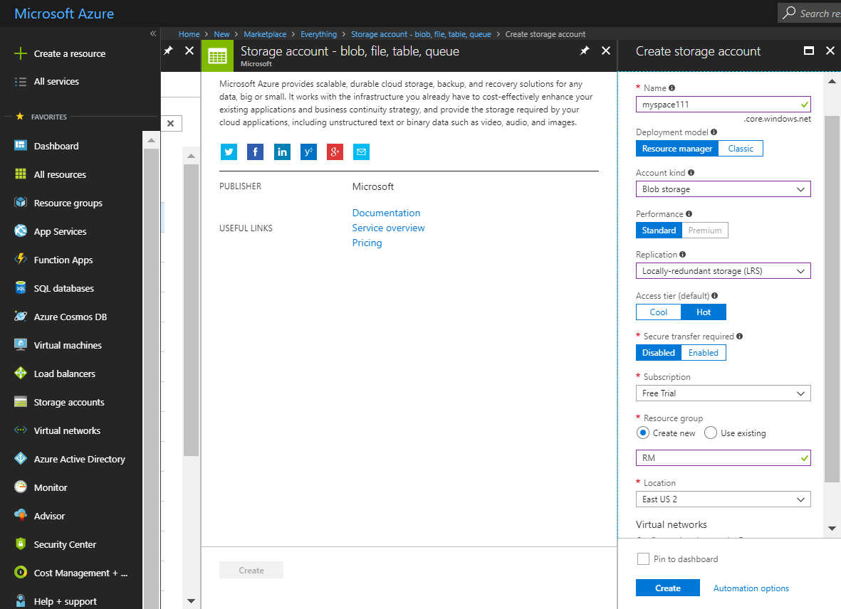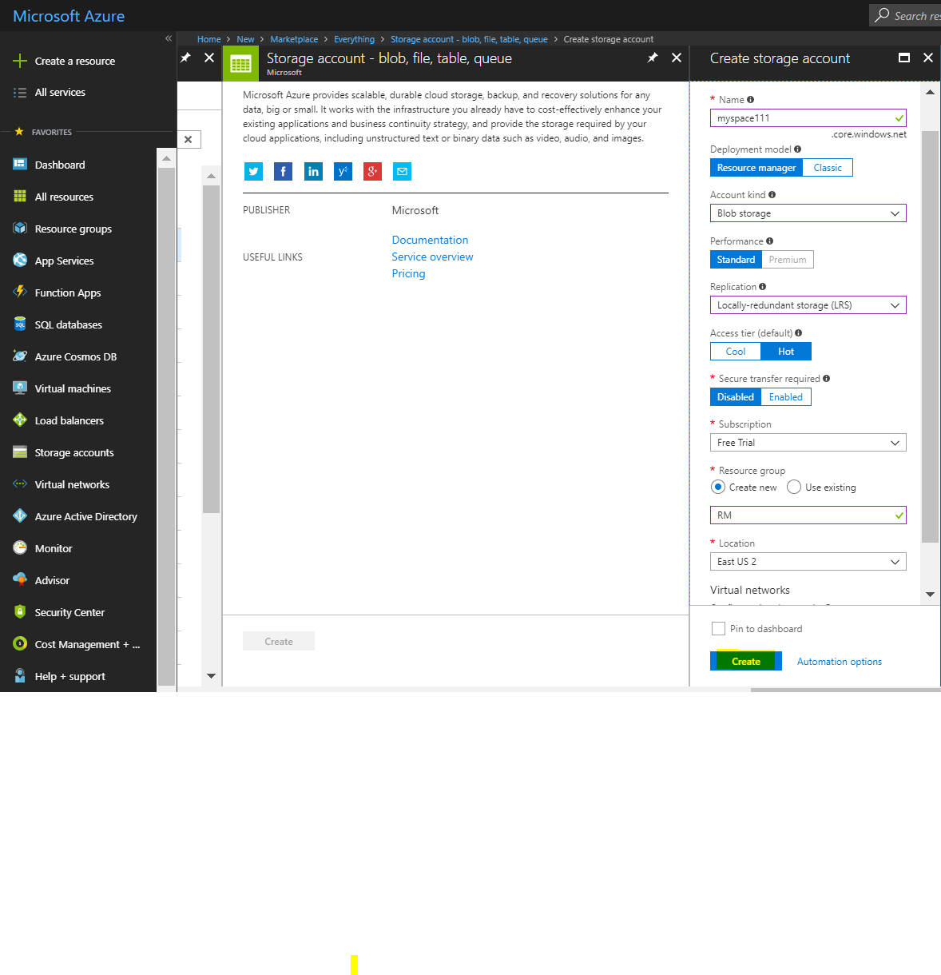

**Create container**: **source** and **target**, and load a file into source.

**Task:** load file which is inside source container file using DATA FACTORY to target container

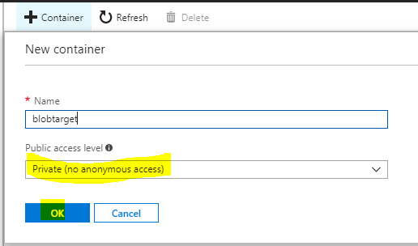

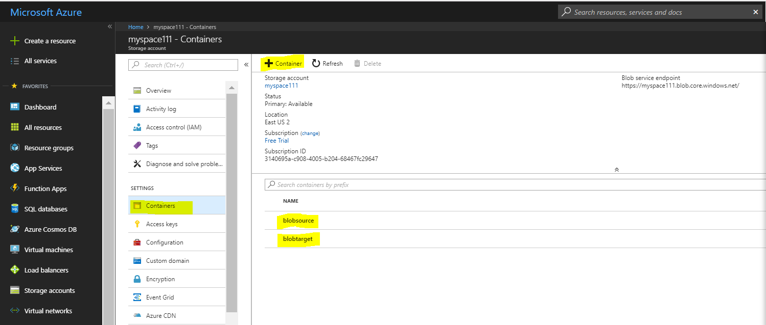

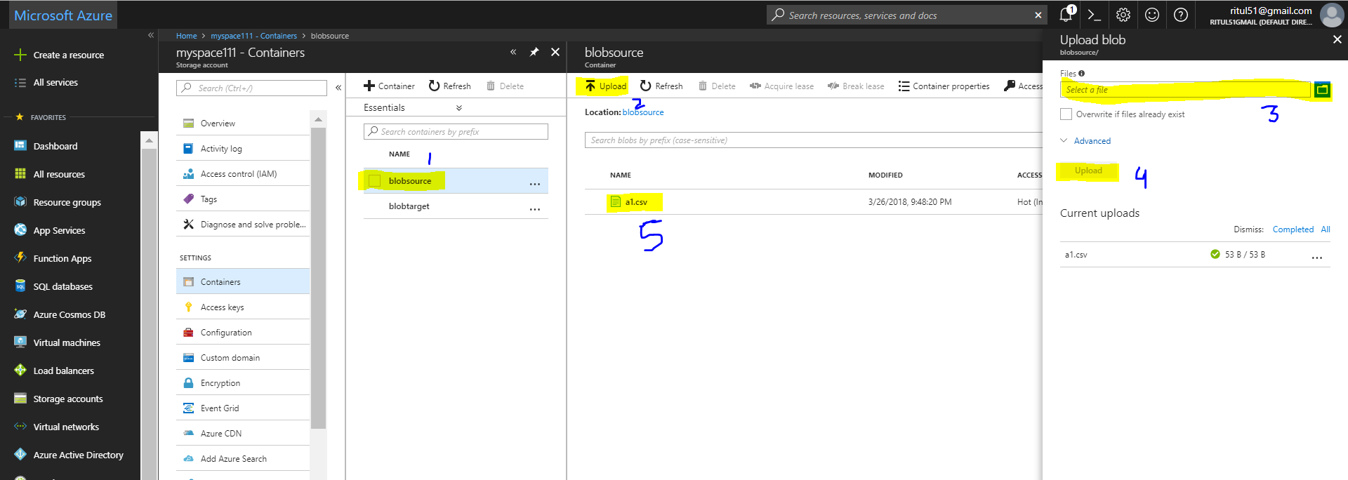

Create Data Factory:

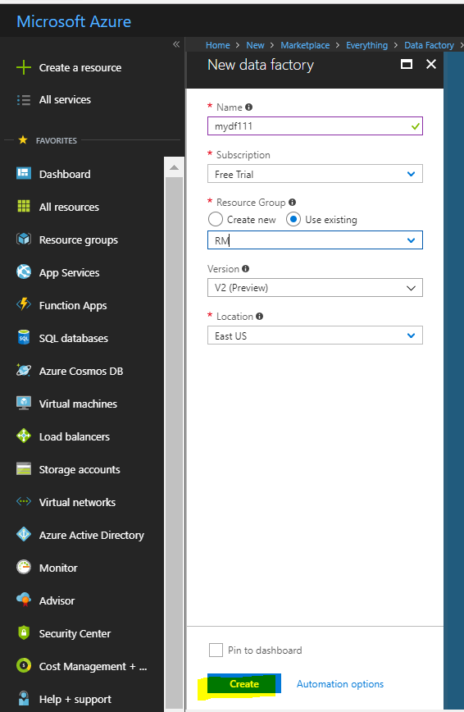

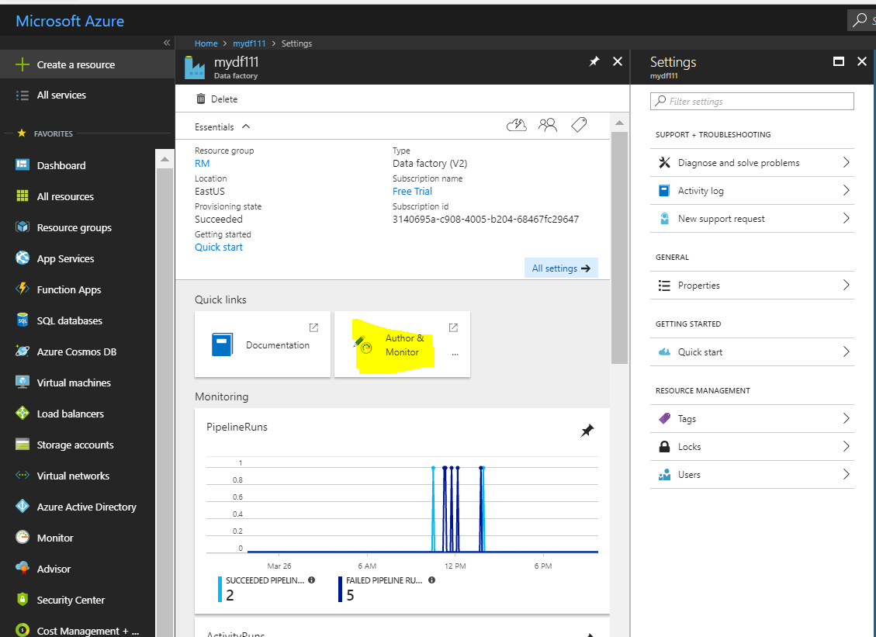

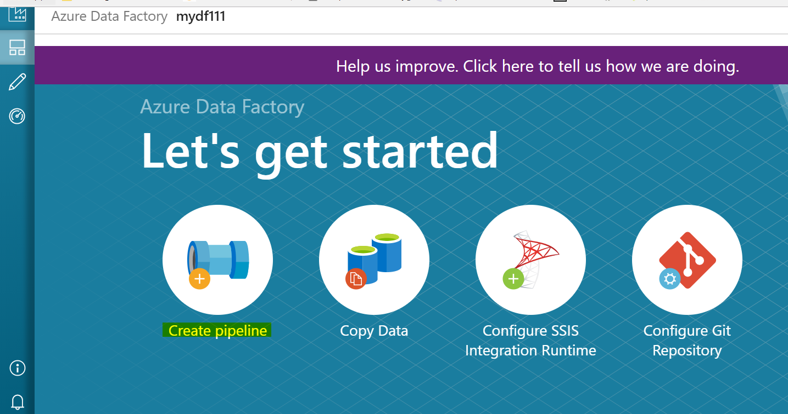

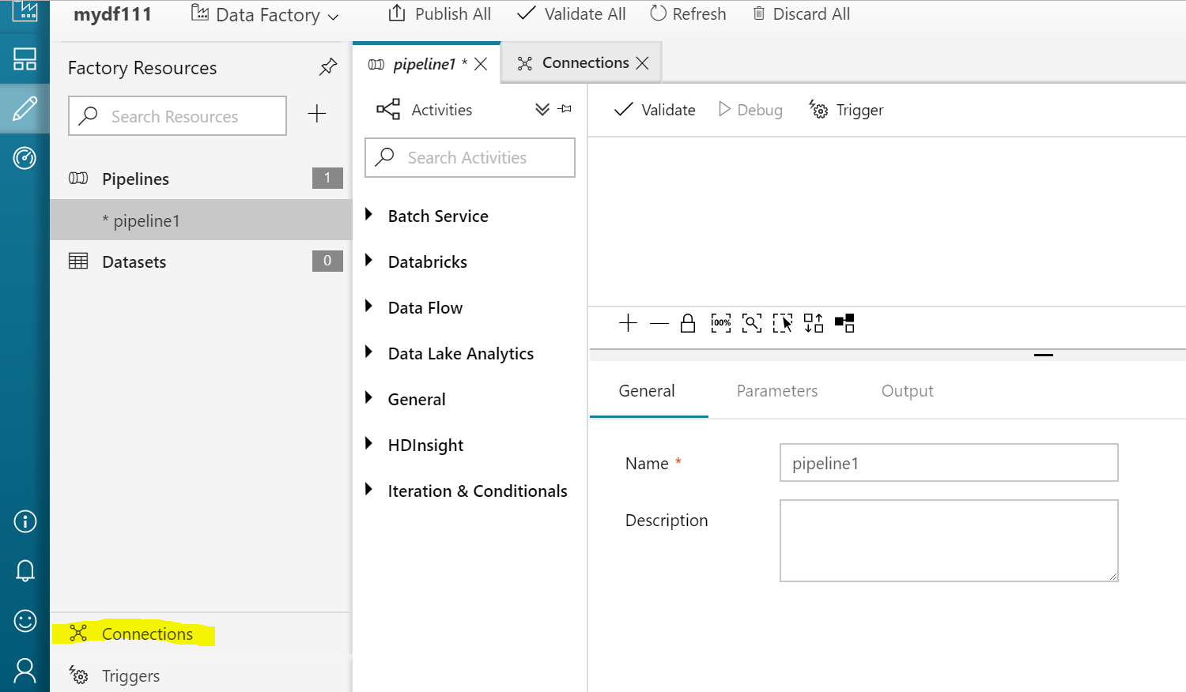

Create Linked Service:

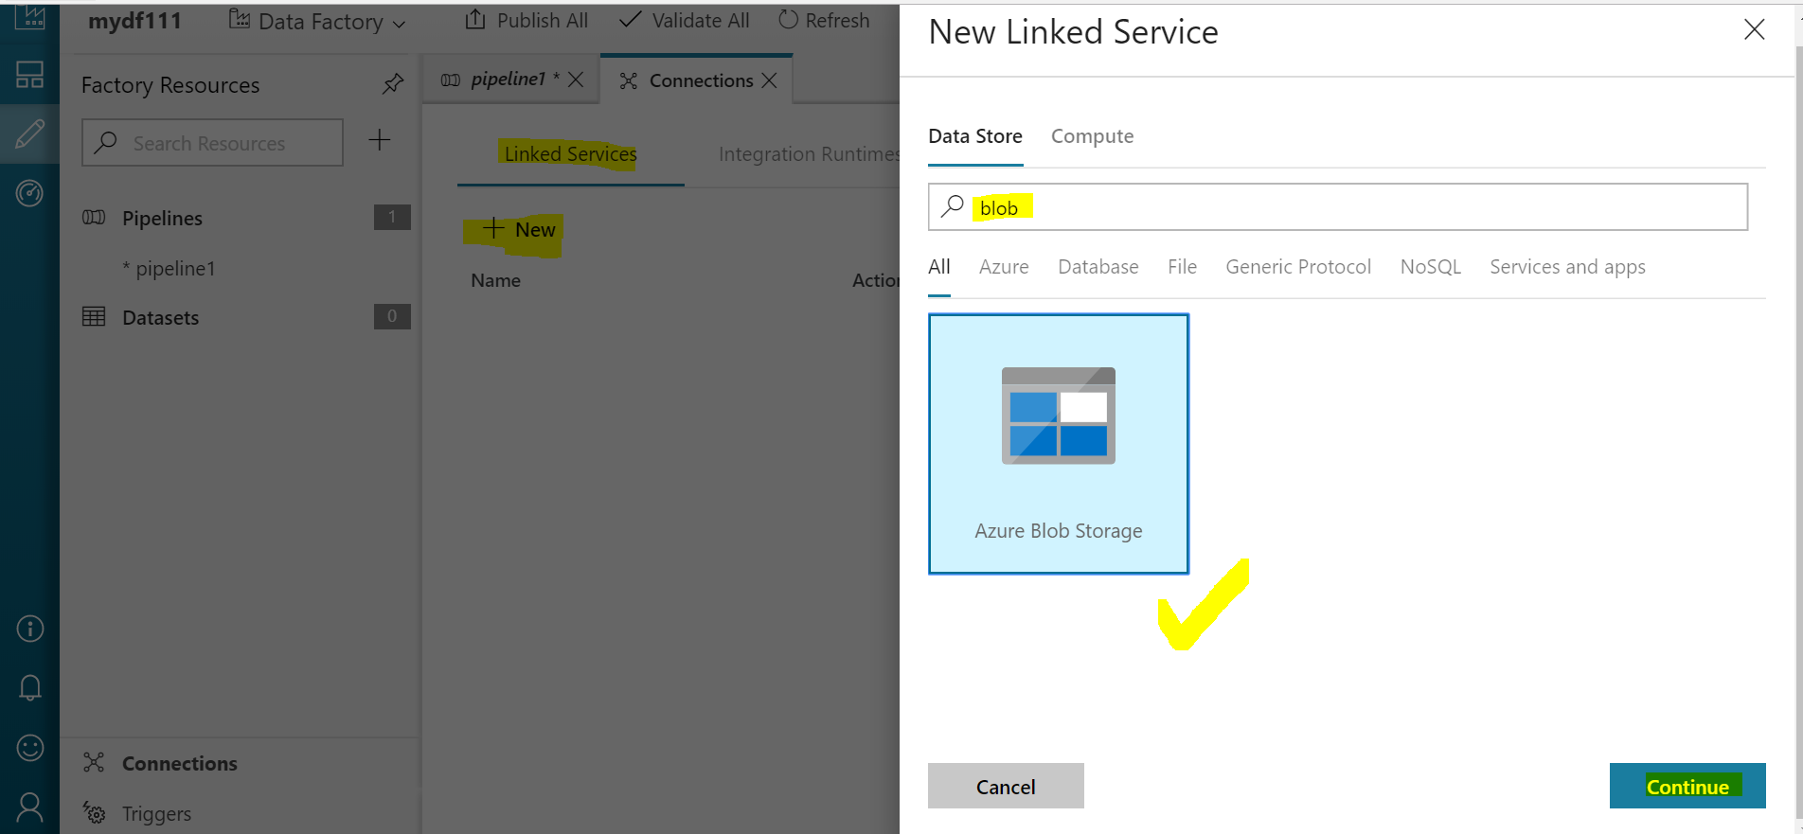

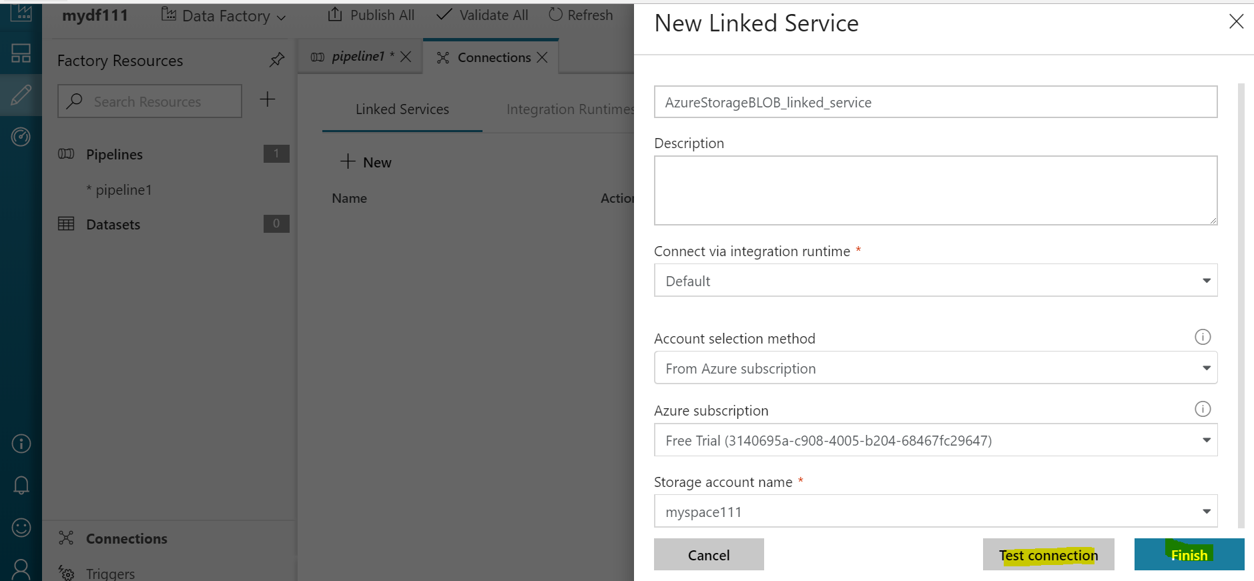

Create Data Sets:

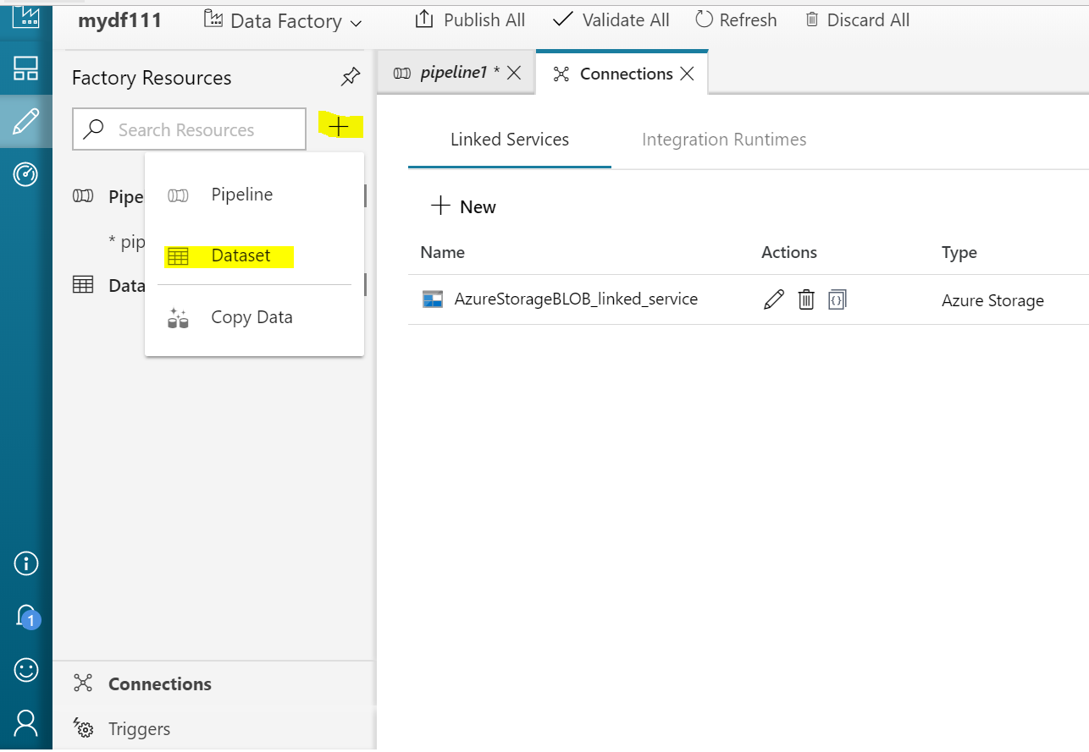

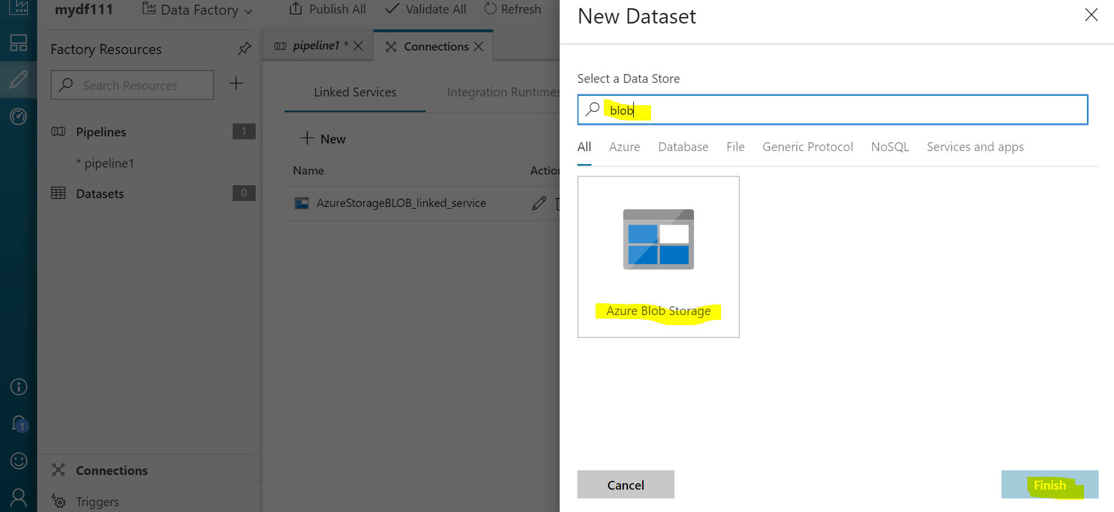

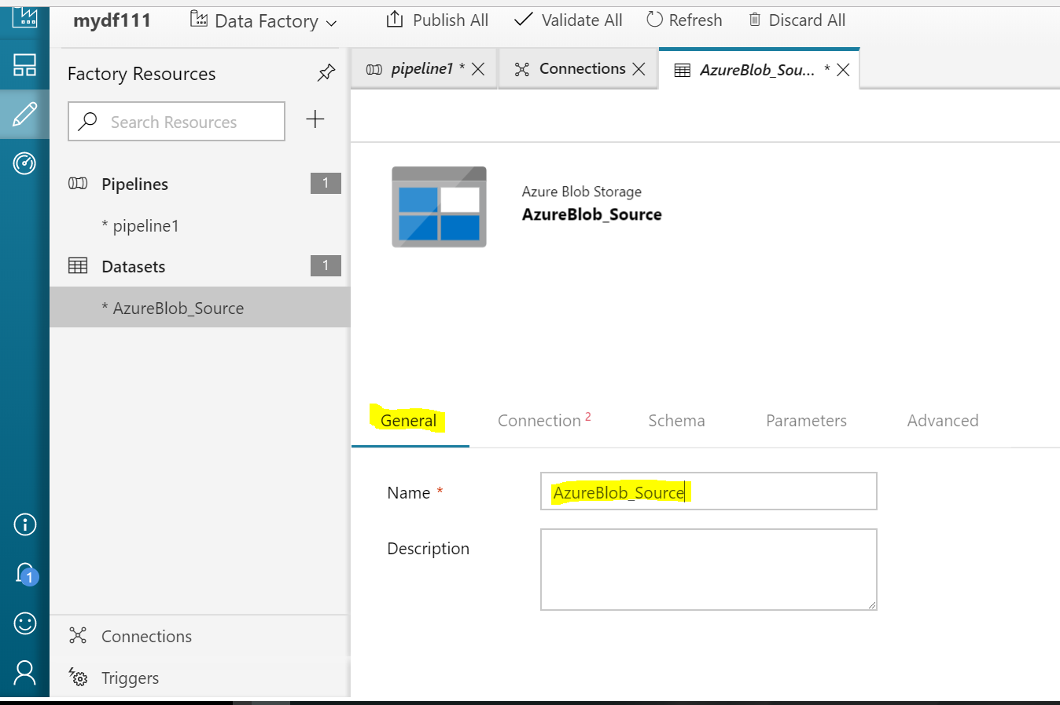

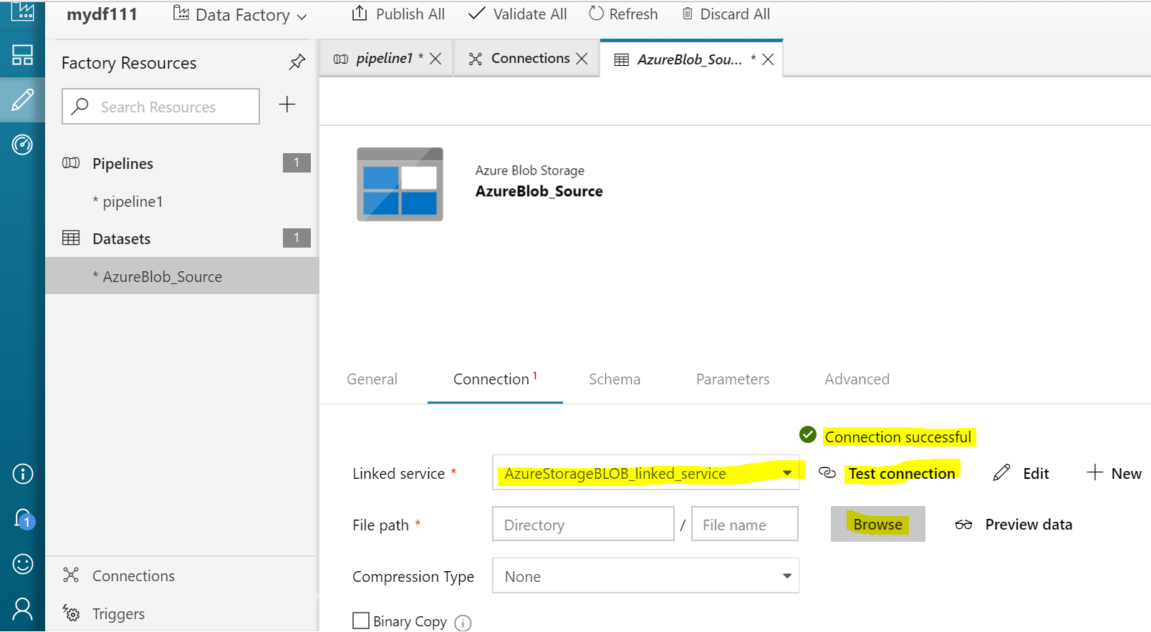

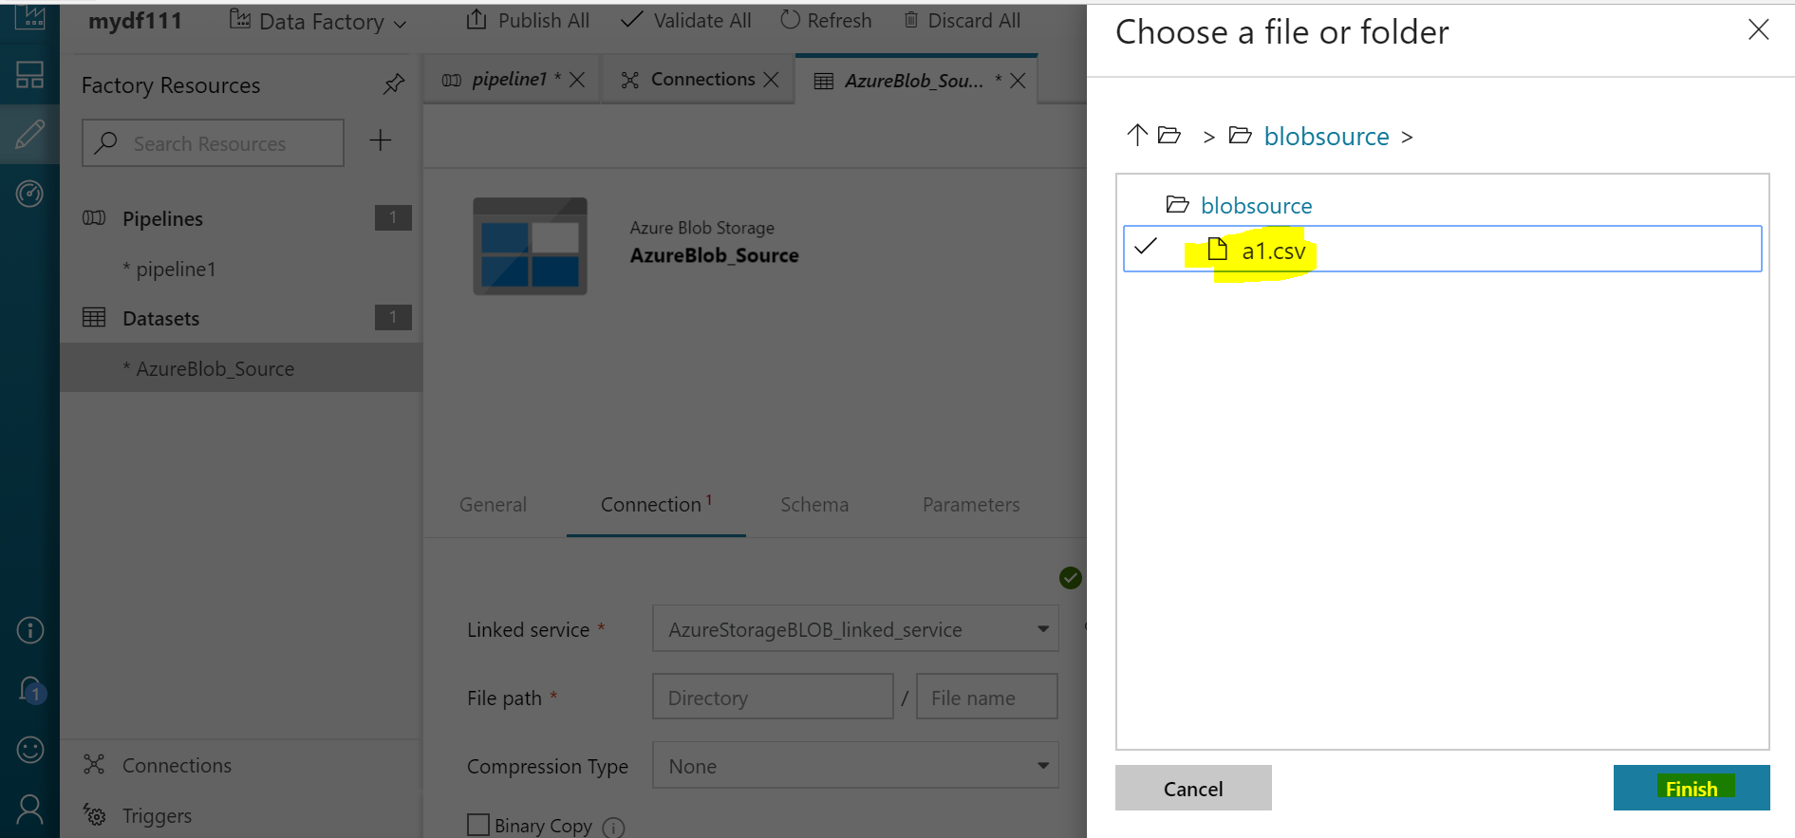

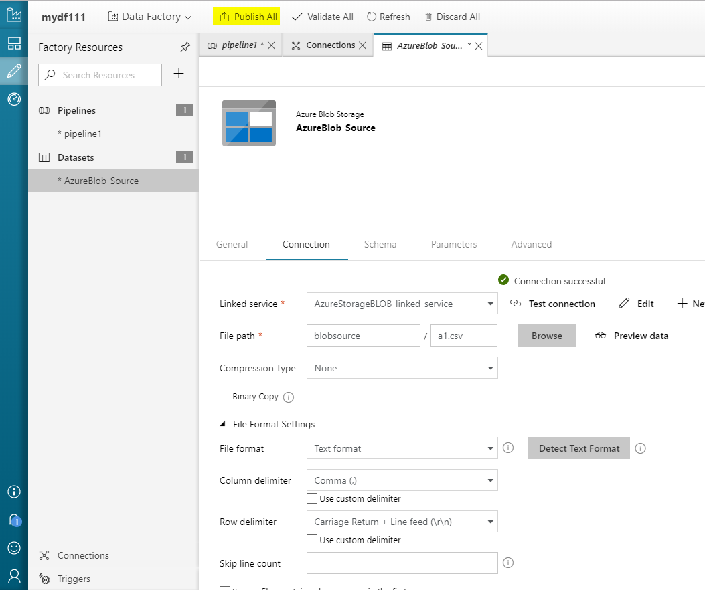

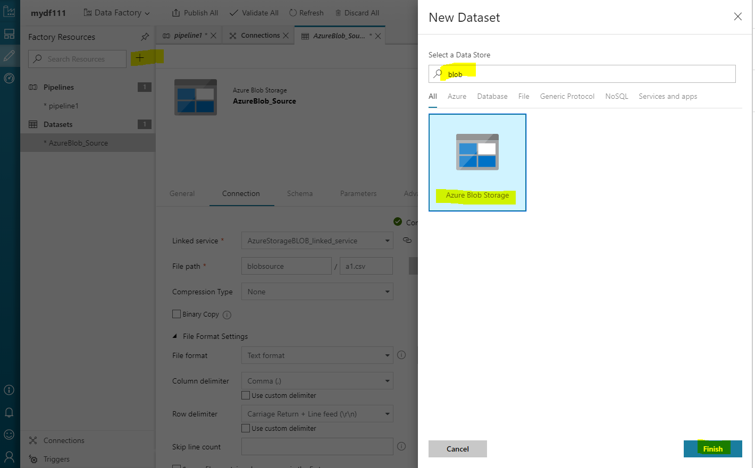

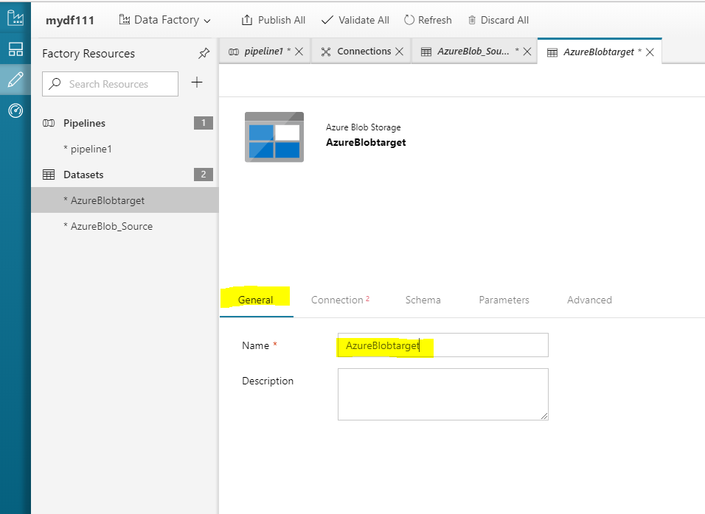

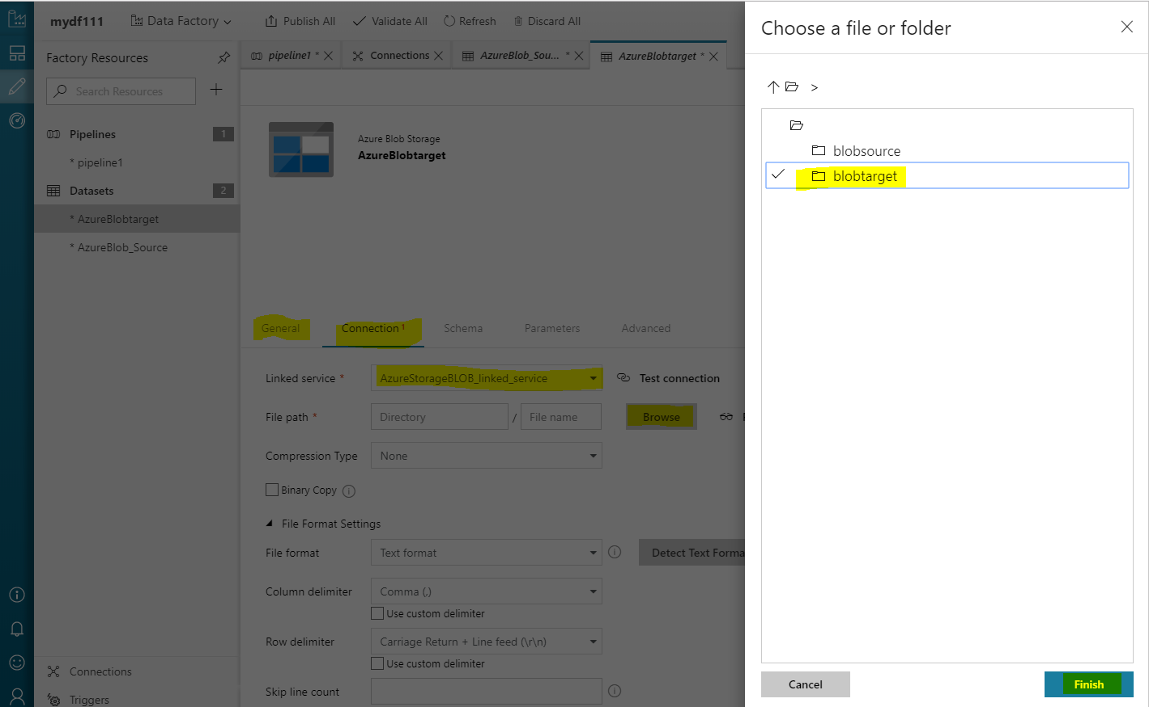

Create Pipeline:

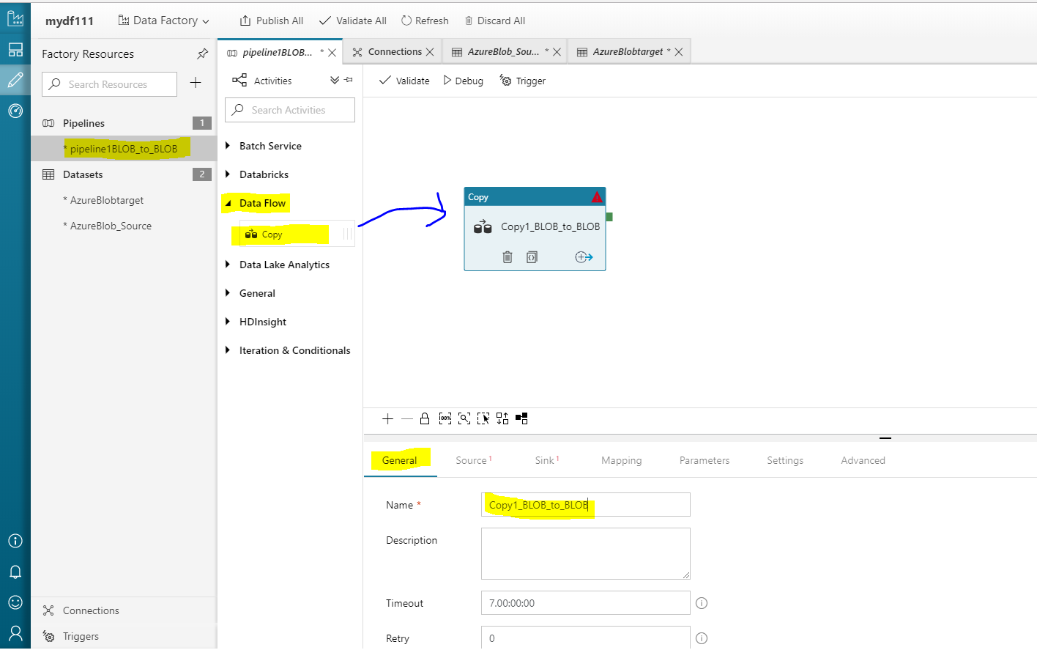

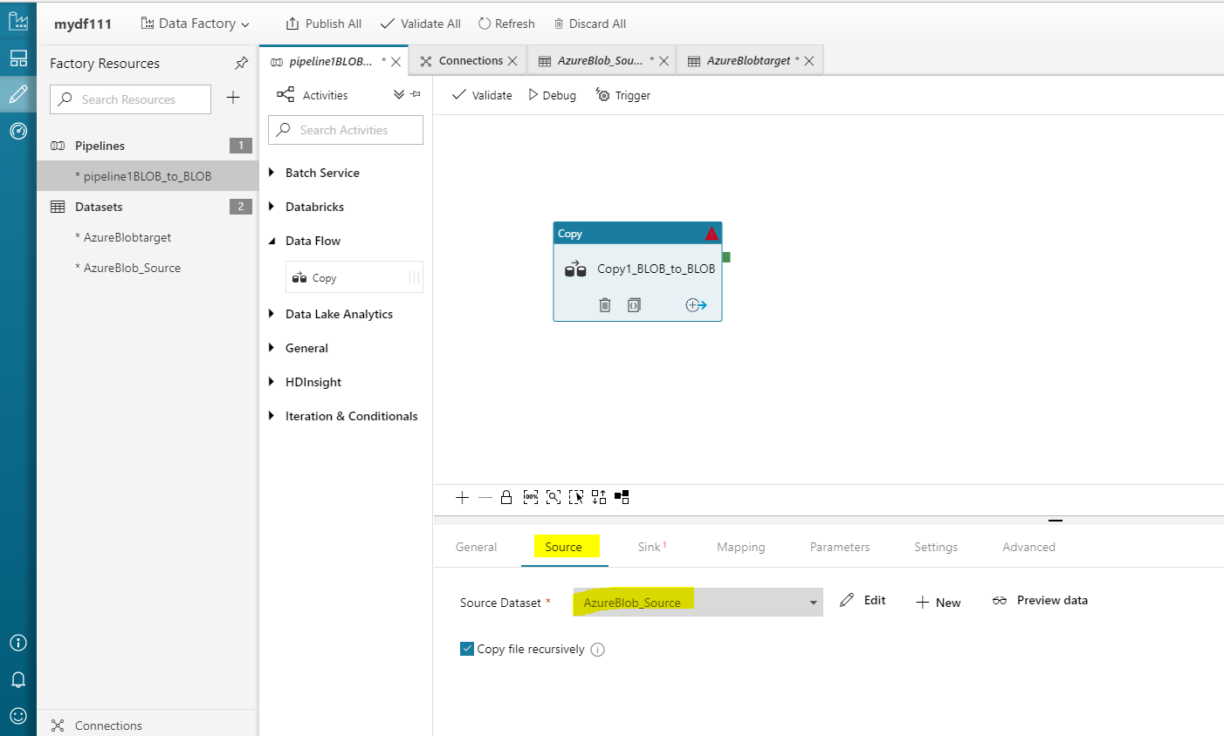

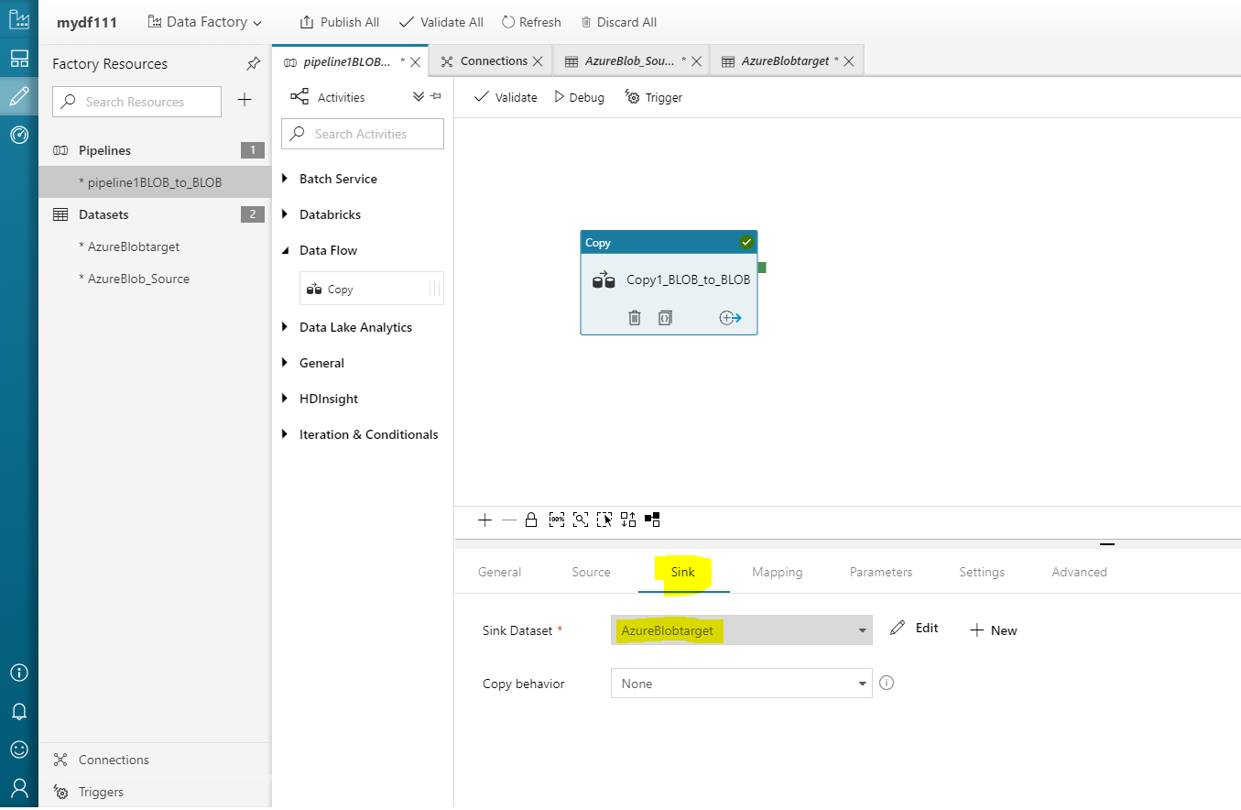

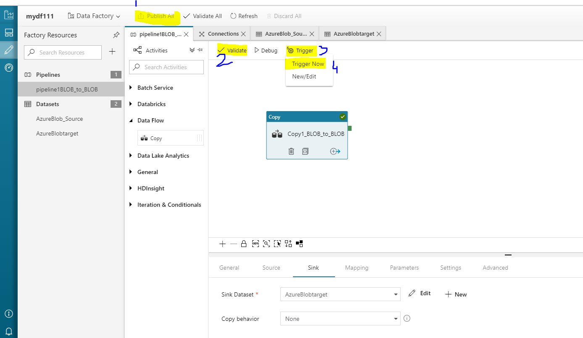

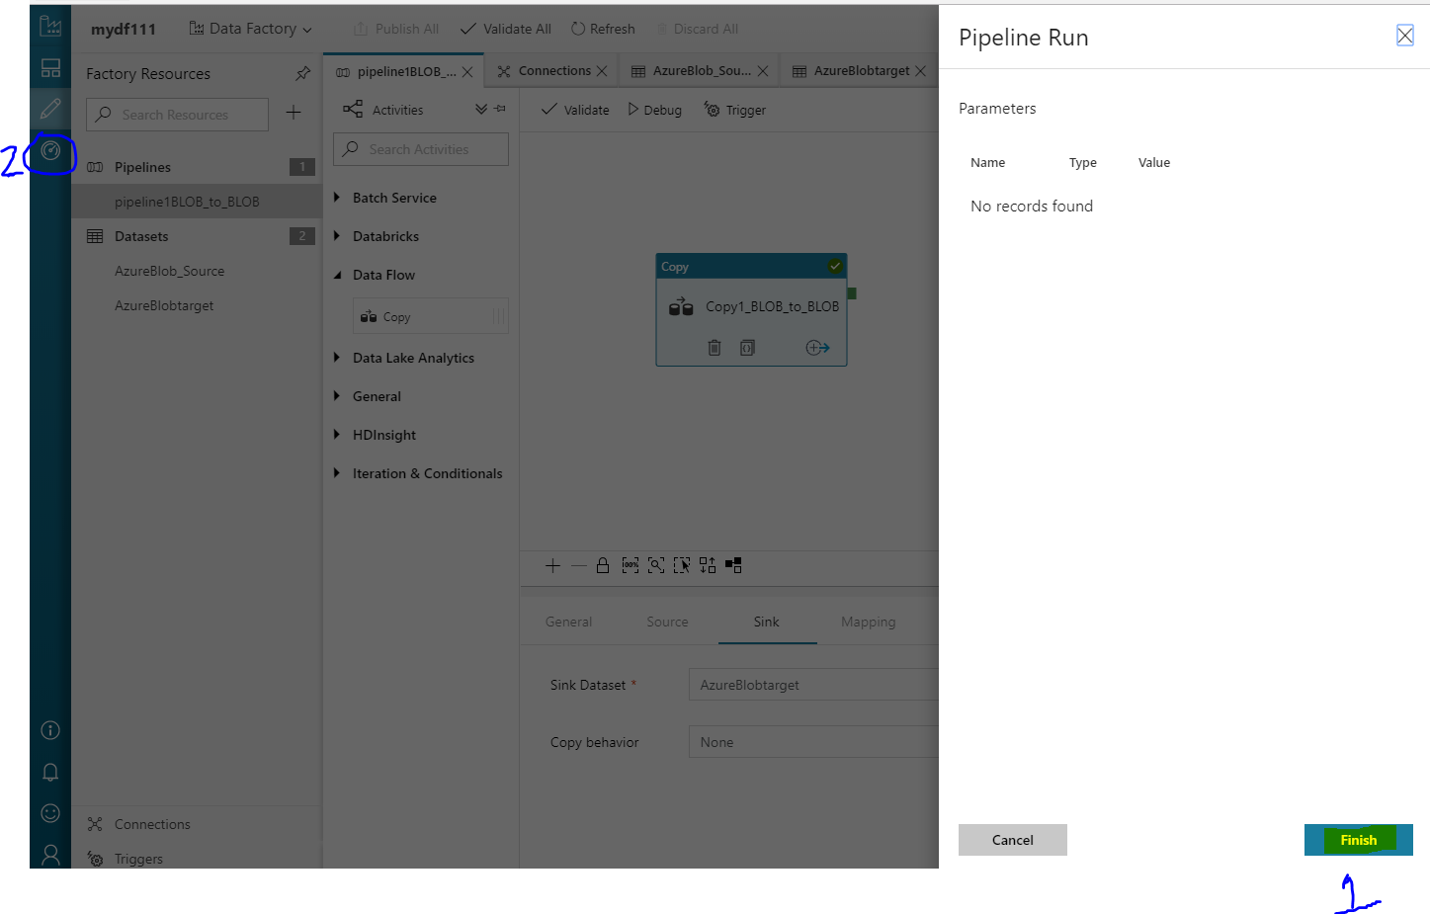

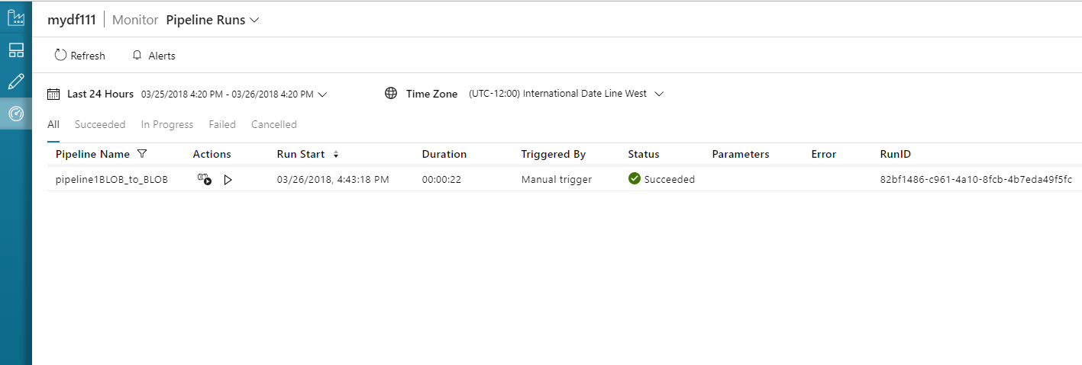

Check data in BLOB target folder:

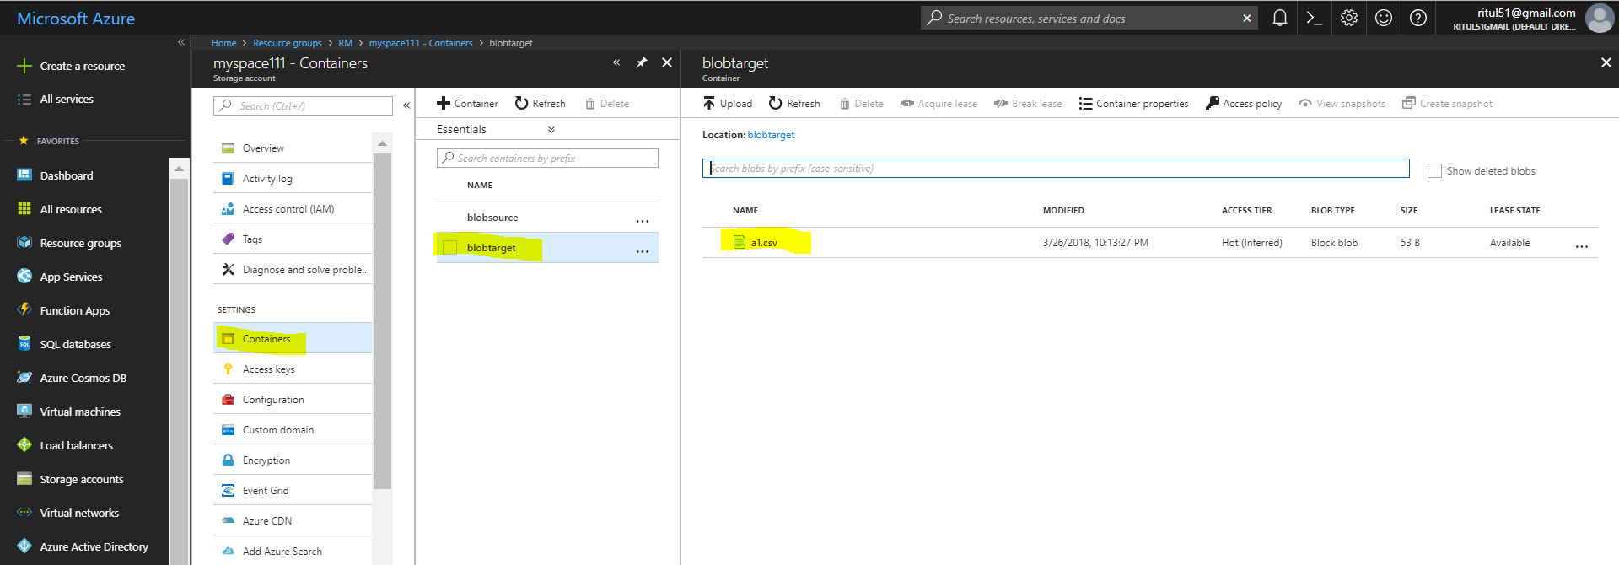

SQL DB to BLOB using ADF:

Create SQL DB:

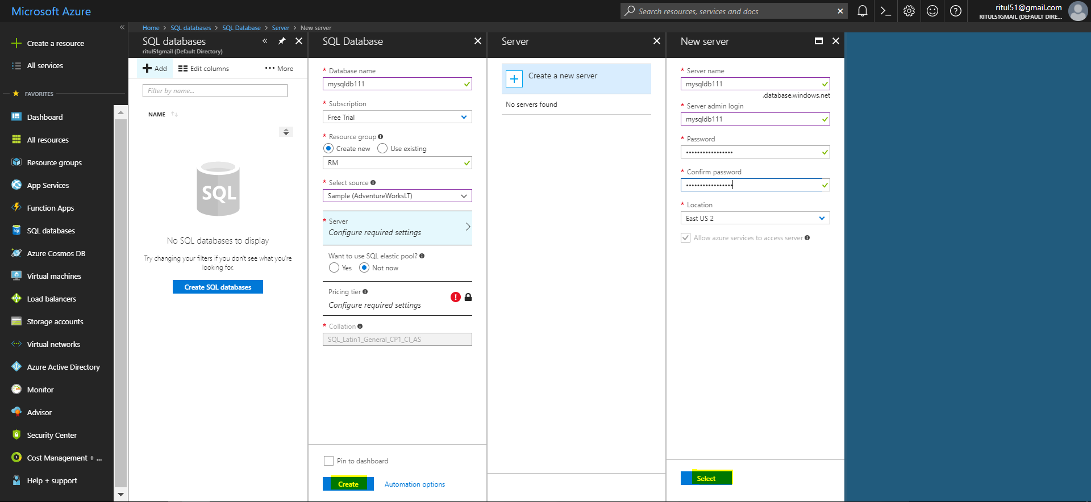

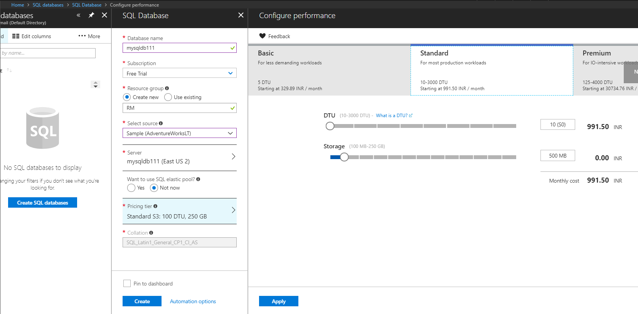

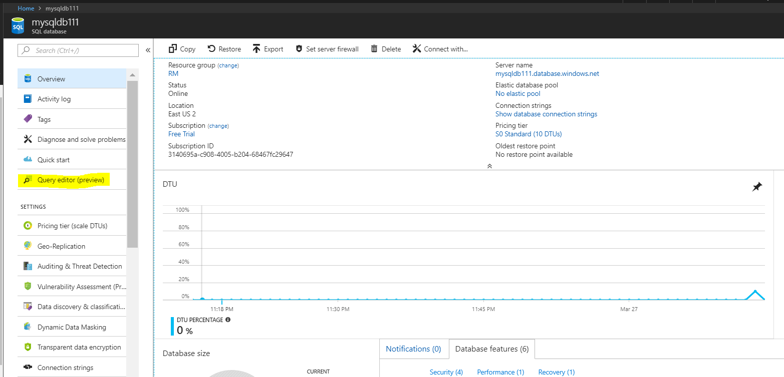

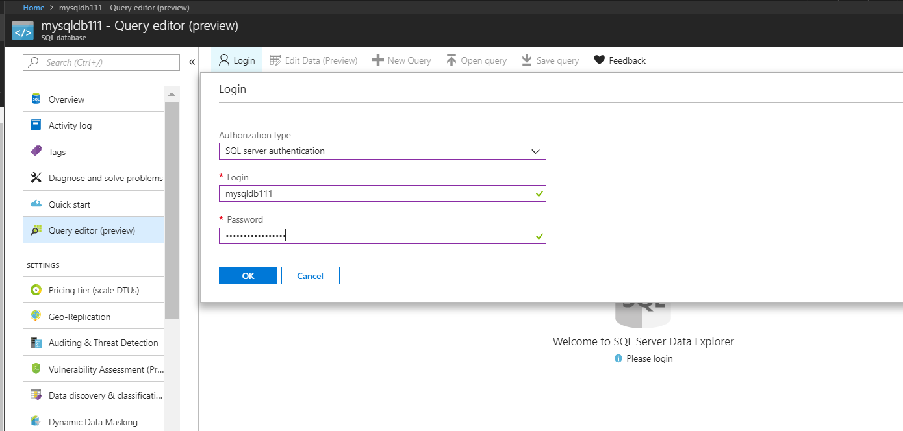

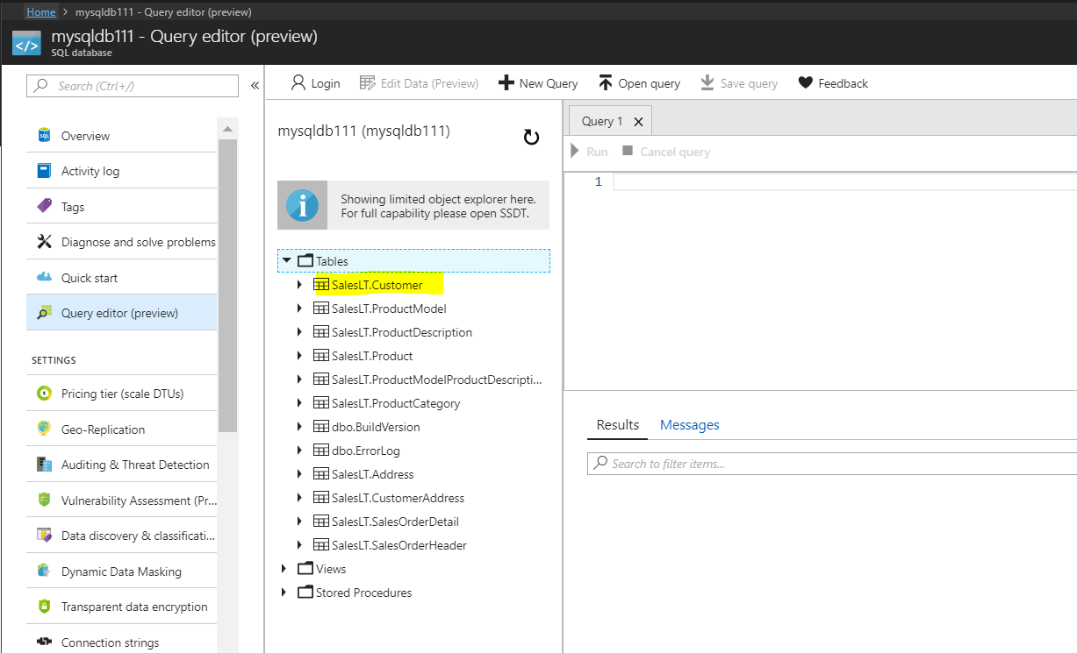

Create a BLOB:

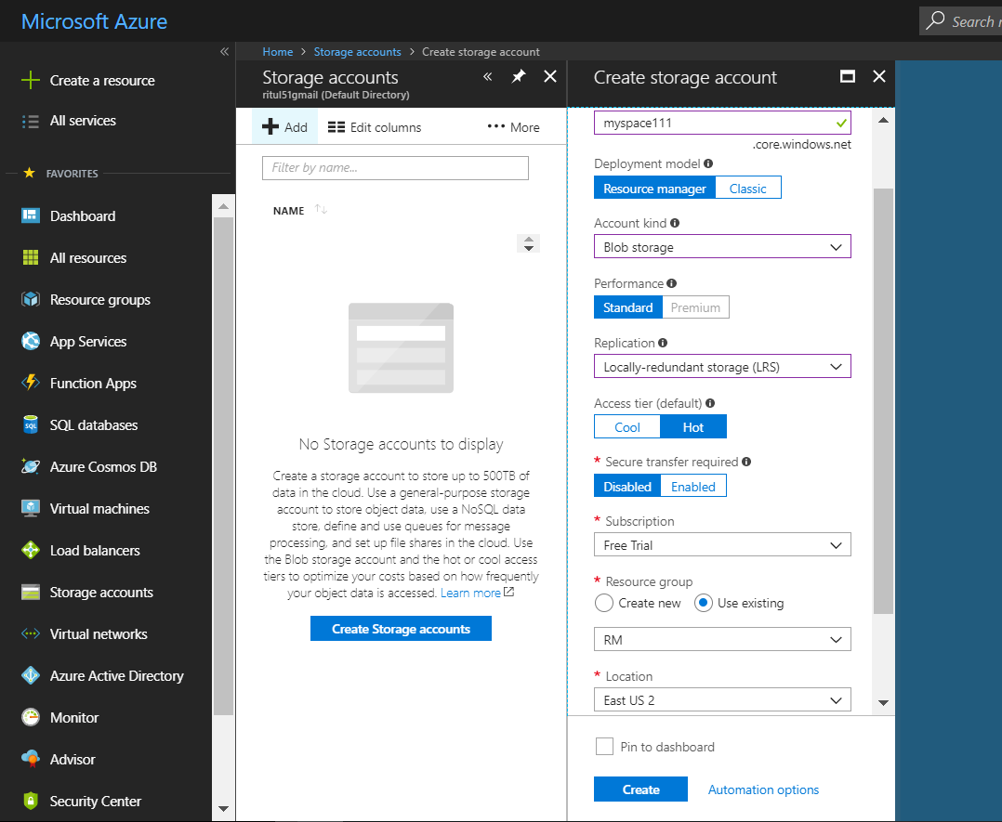

Create a container and create target folder in it, where we are going to load data from SQL to BLOB storage using DATA factory

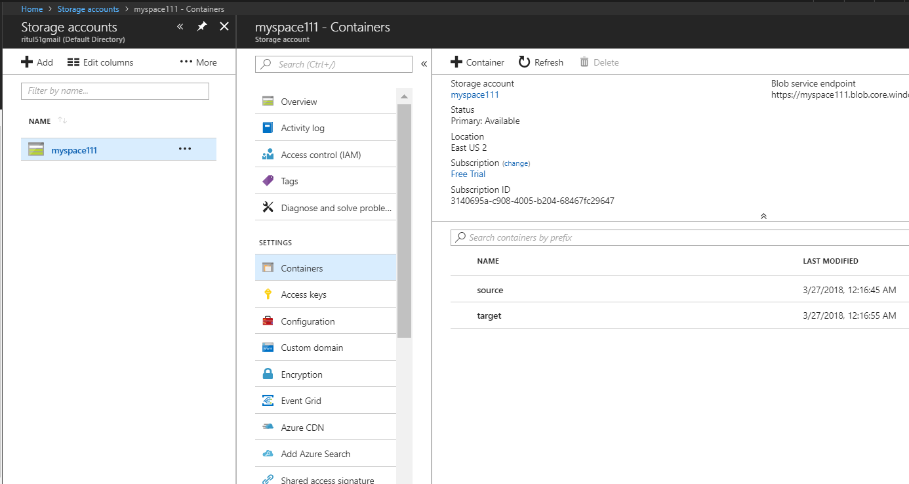

Creating Data Factory:

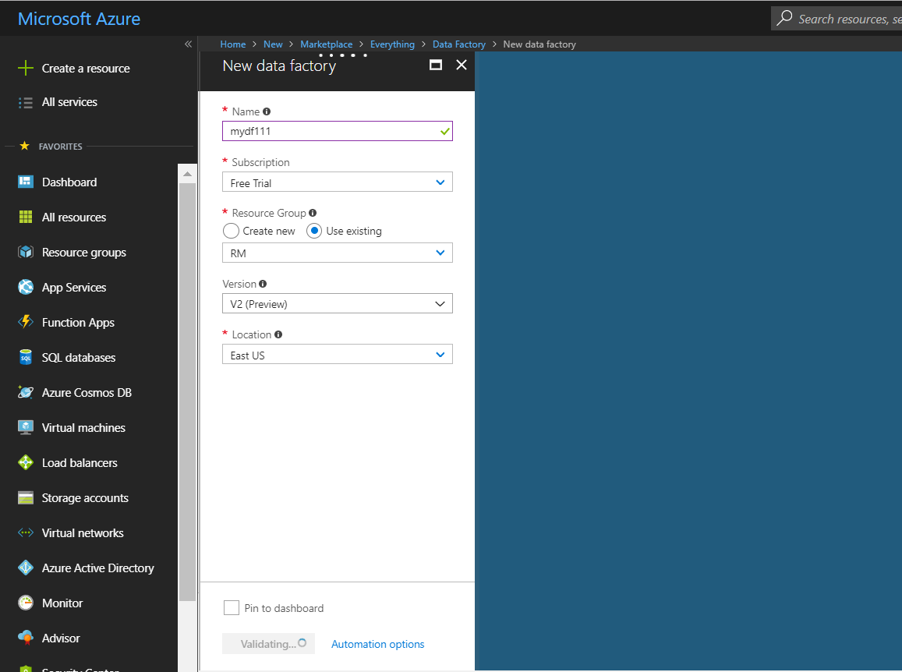

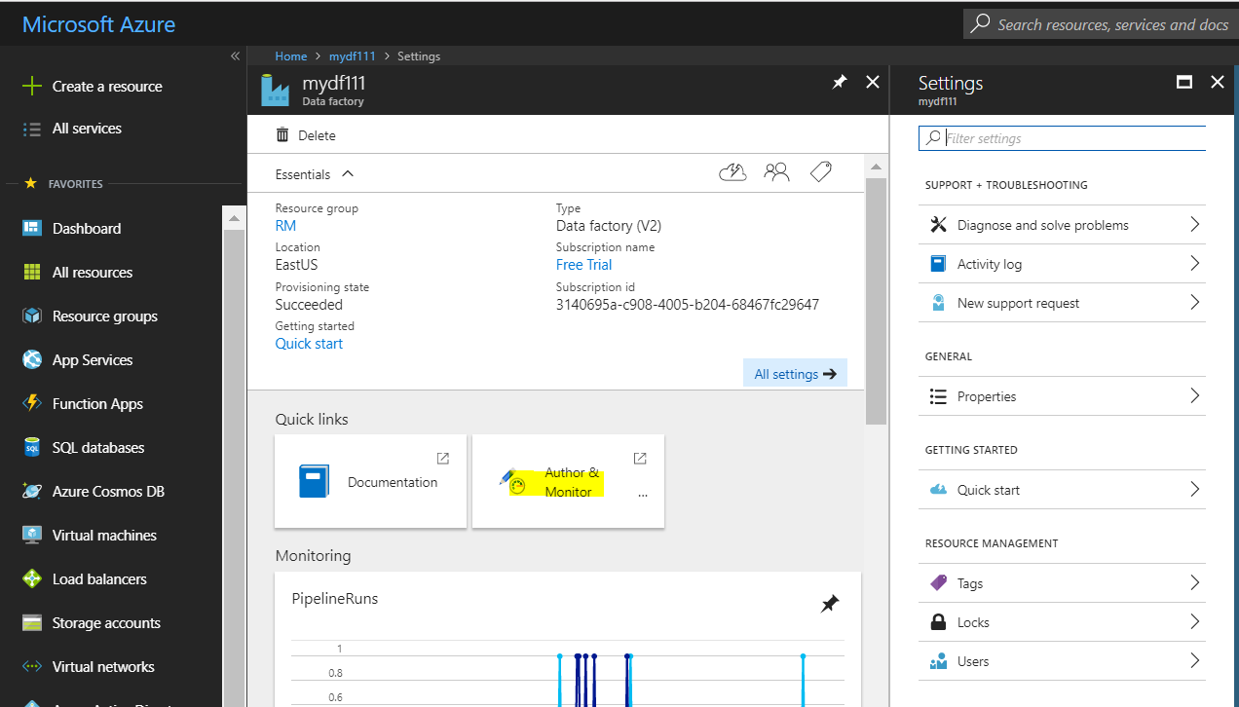

Creating Linked Services:

Linked service for SQL DB:

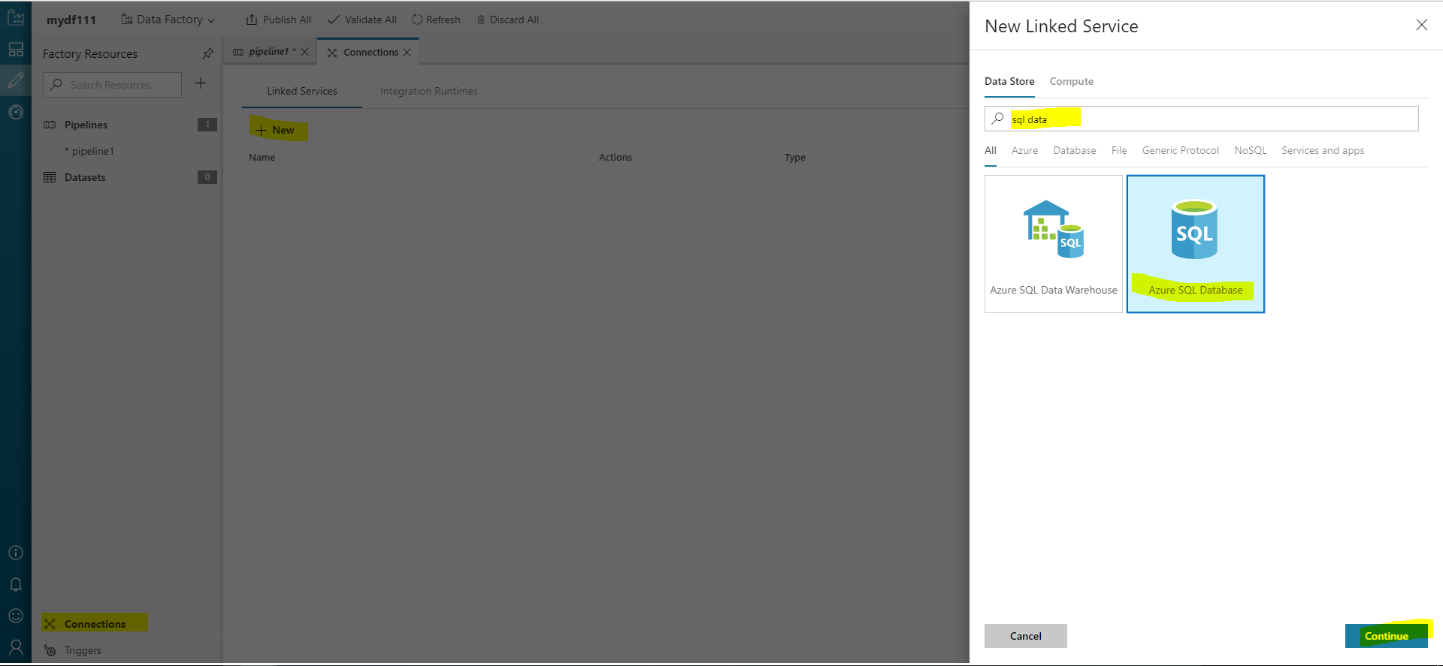

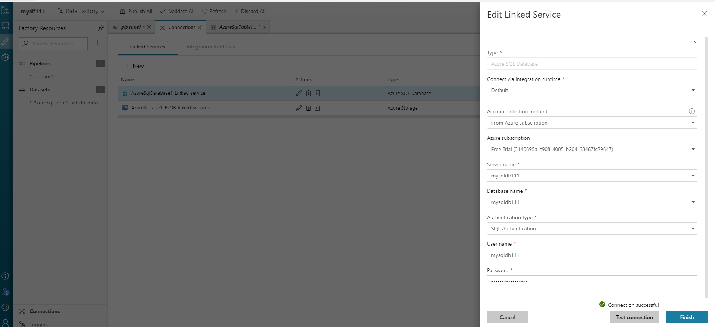

Linked Service for BLOB:

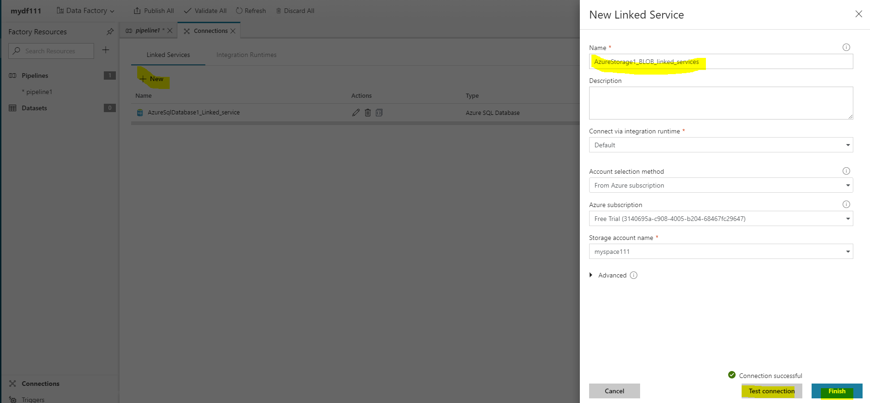

Create Dataset for SQL DB:

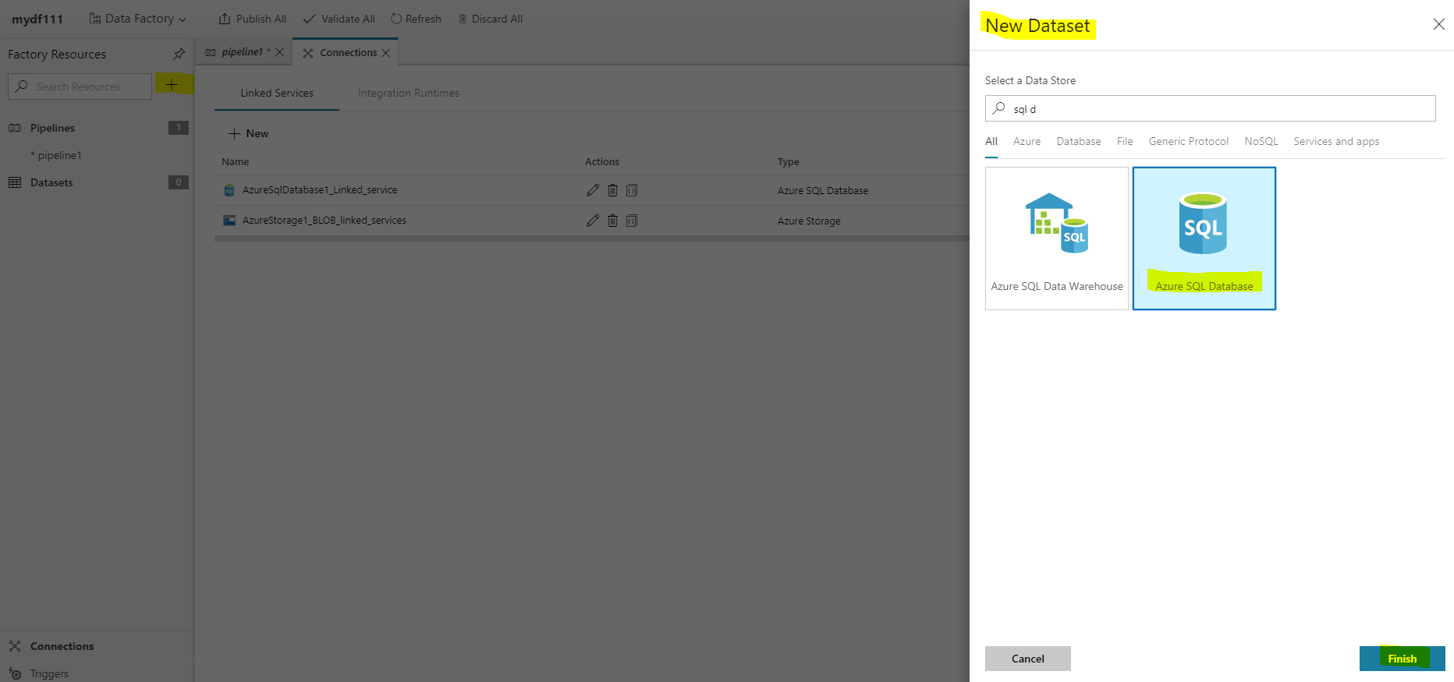

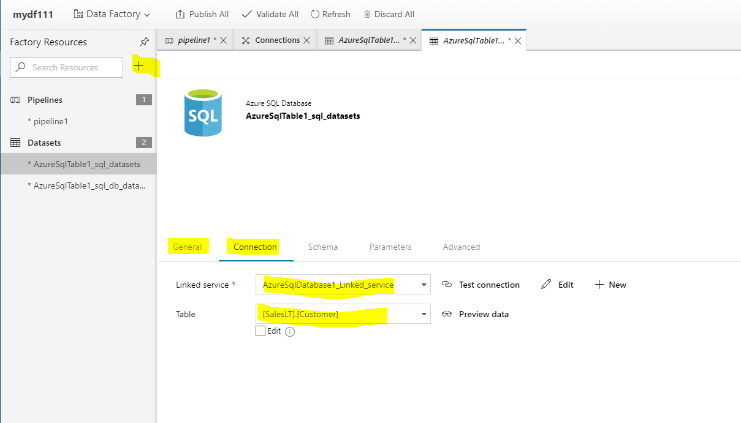

Create Dataset for BLOB:

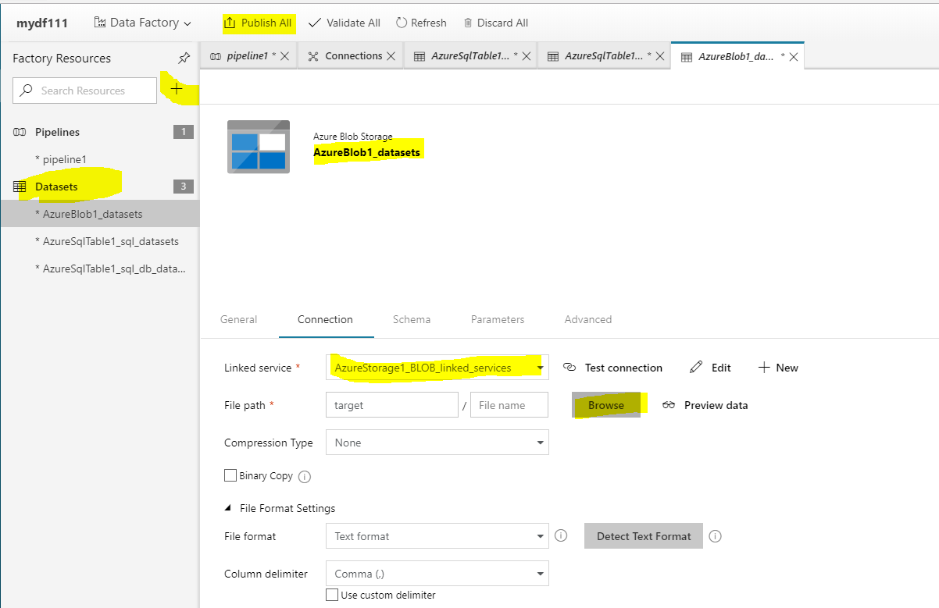

Create Pipeline and Triger:

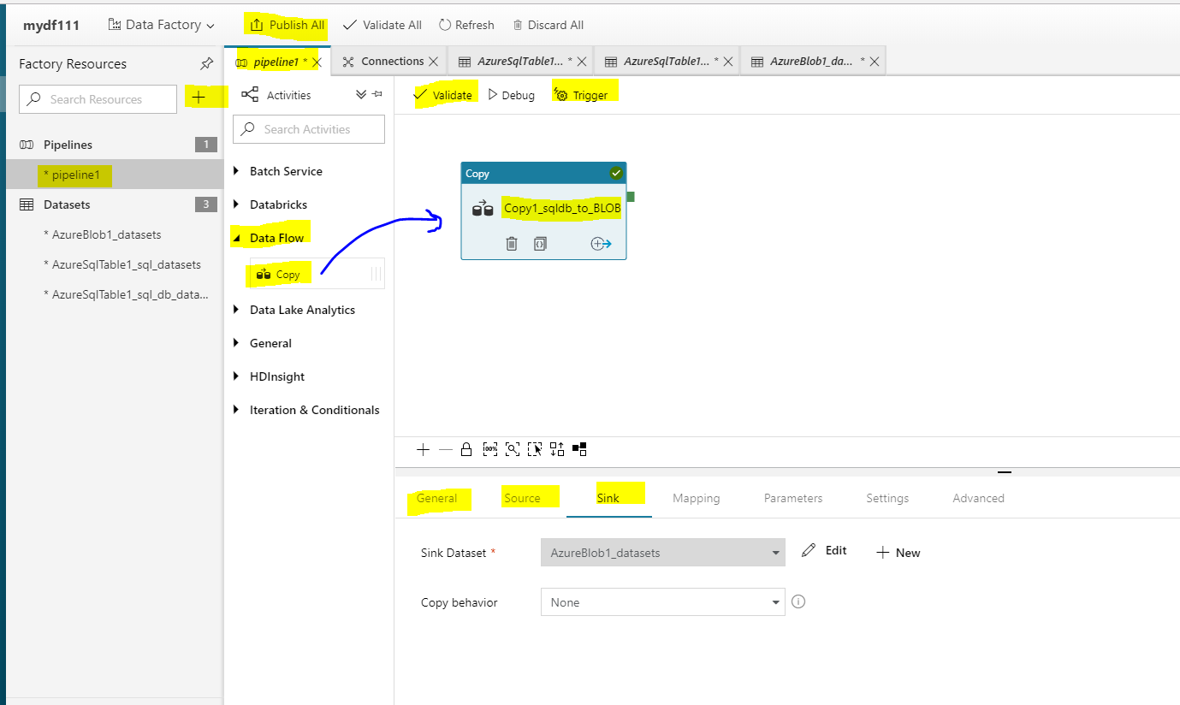

Publish all and trigger

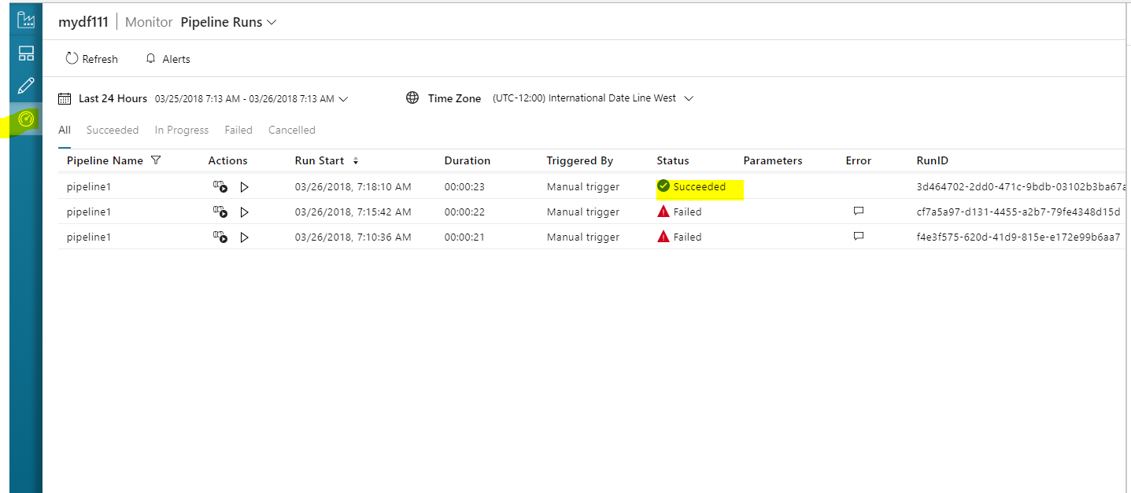

Check Target container in BLOB:

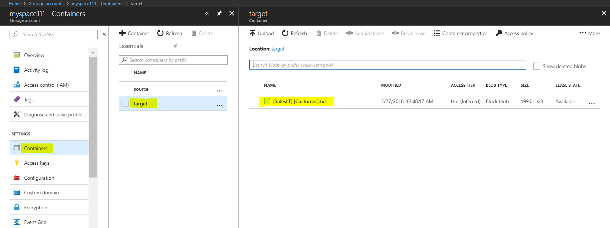

SQL DB (MS Azure) to Data Lake using ADF:

1. Deploy SQL DB
2. Deploy Data Lake
3. Deploy Data factory

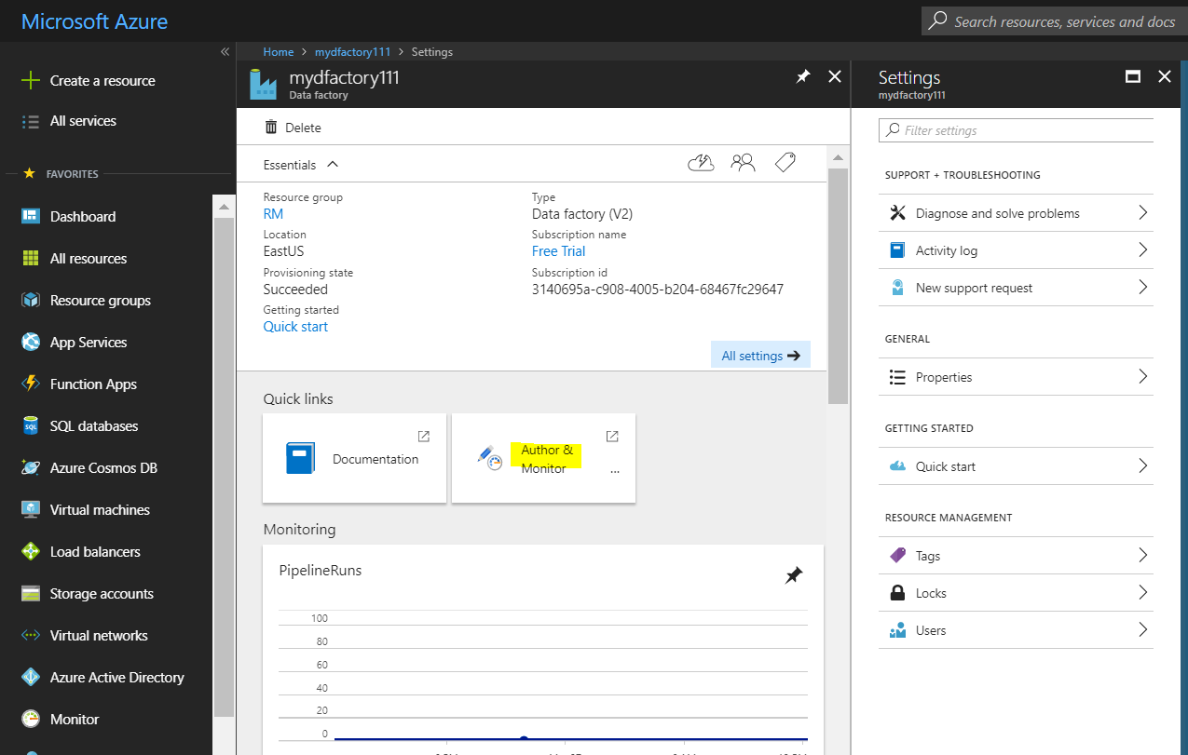

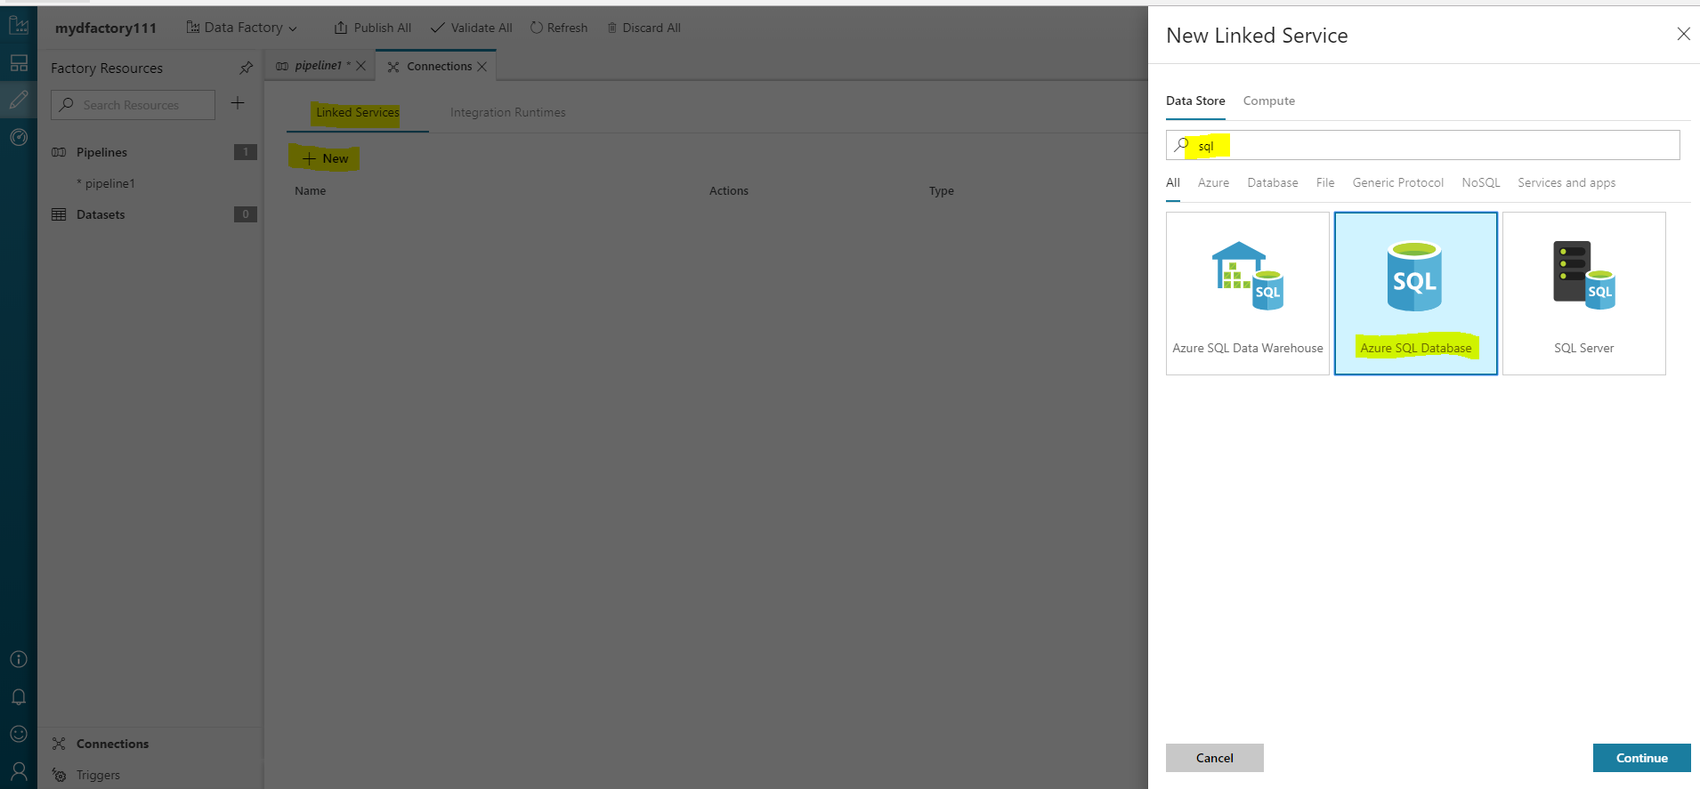

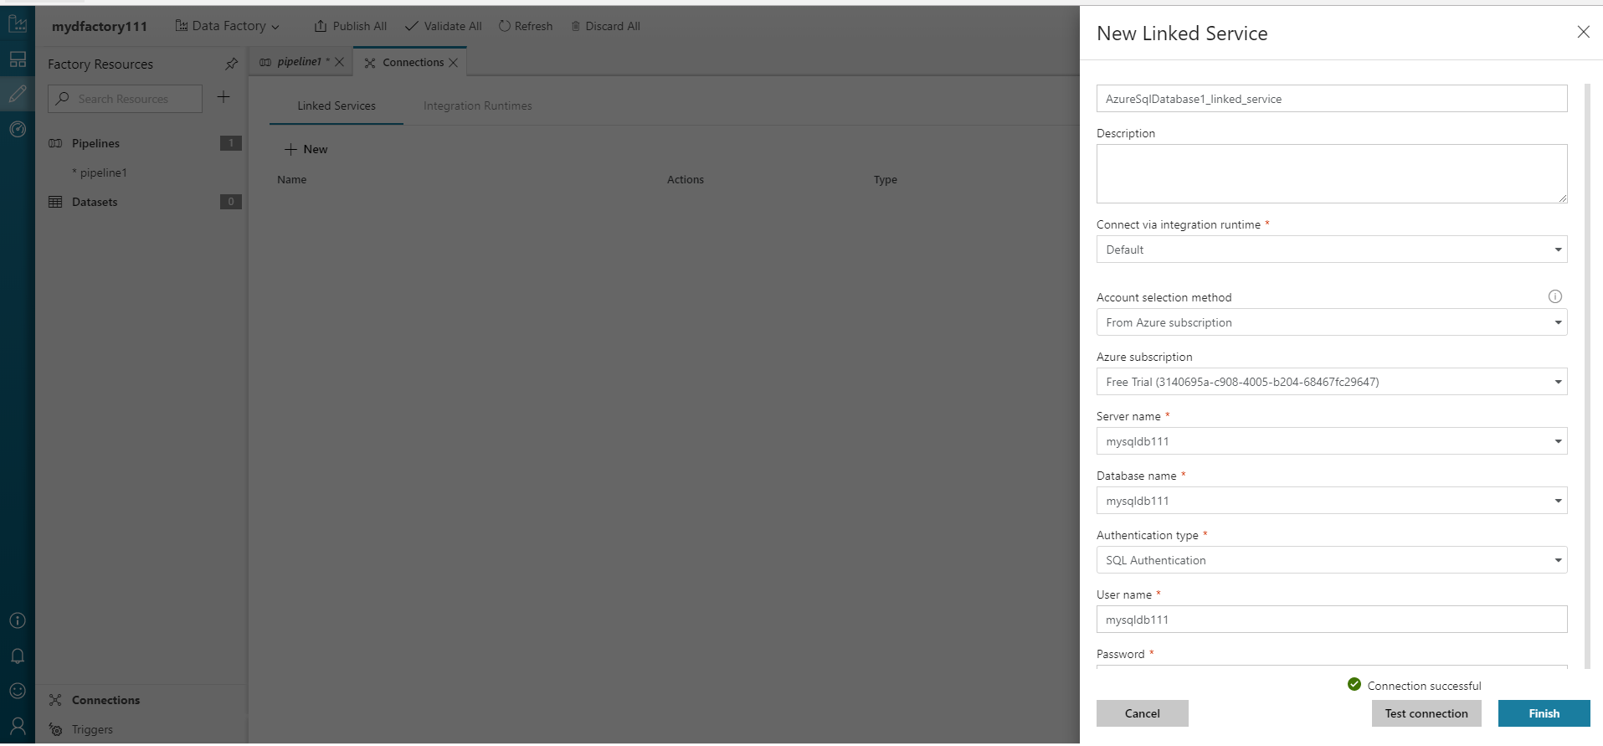

New linked Service for Data Lake: asking for subscription ID and key

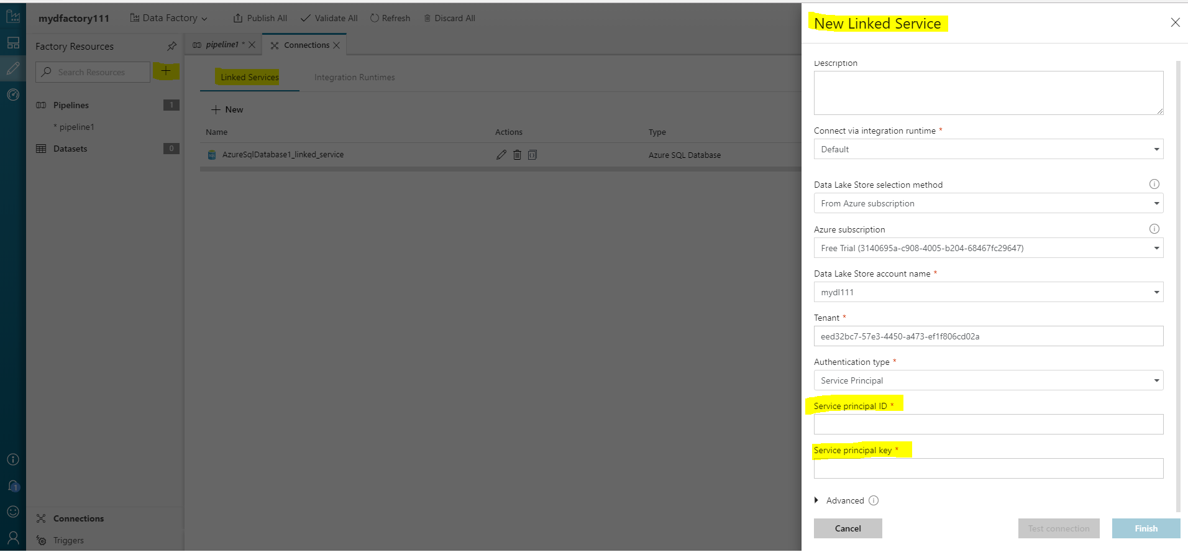

To get those ID and keys GOTO azure Active directory and create NEW APP Registration, do register this app with data lake and then enter credentials to above linked service.

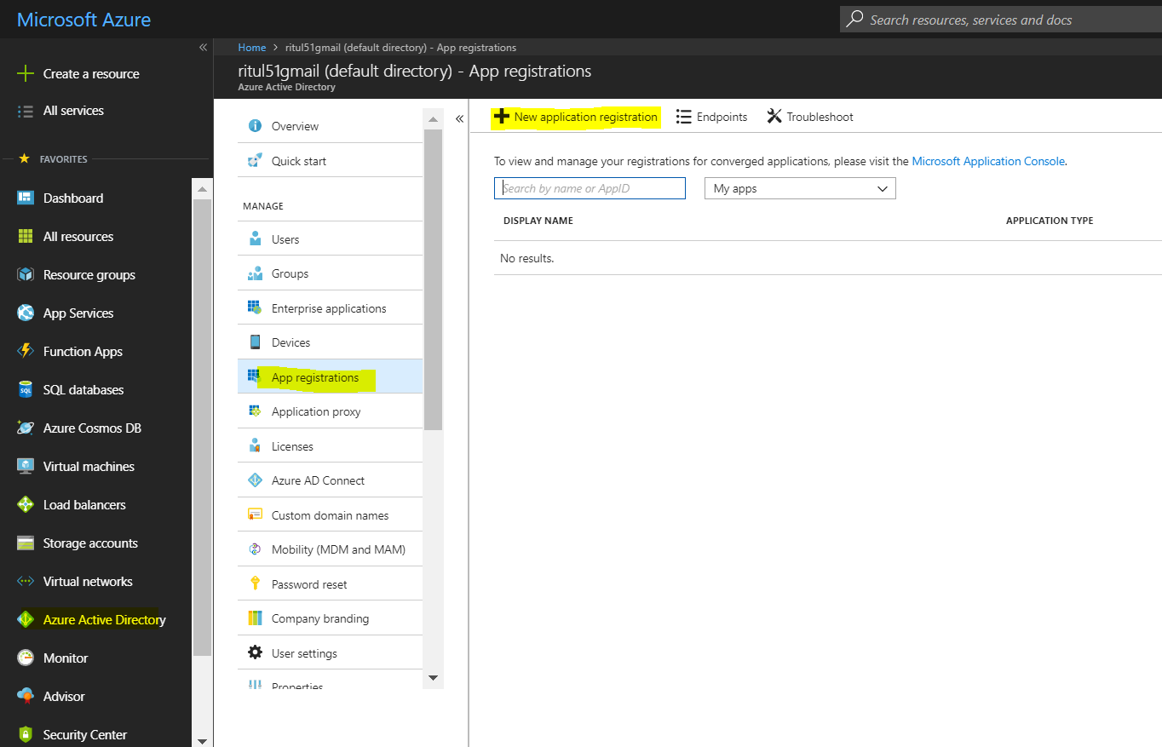

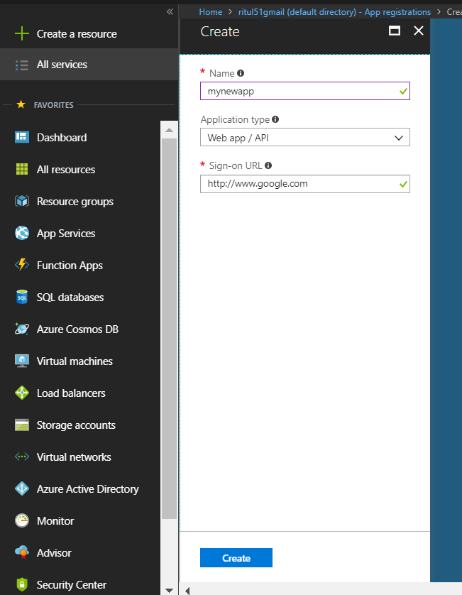

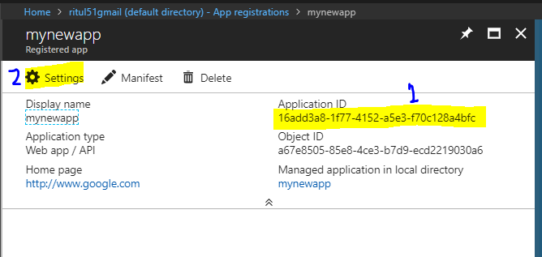

Note down Application/ subscription ID: 16add3a8-1f77-4152-a5e3-f70c128a4bfc

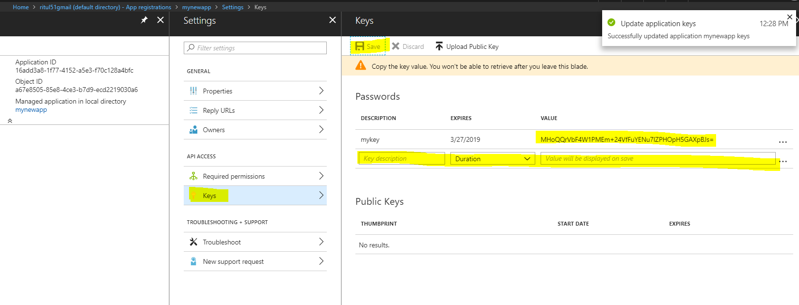

Note down key: MHoQQrVbF4W1PMEm+24VfFuYENu7lZPHOpH5GAXpBJs=

Now go to DATA LAKE🡺 Data Explorer 🡺 Access 🡺 Add access

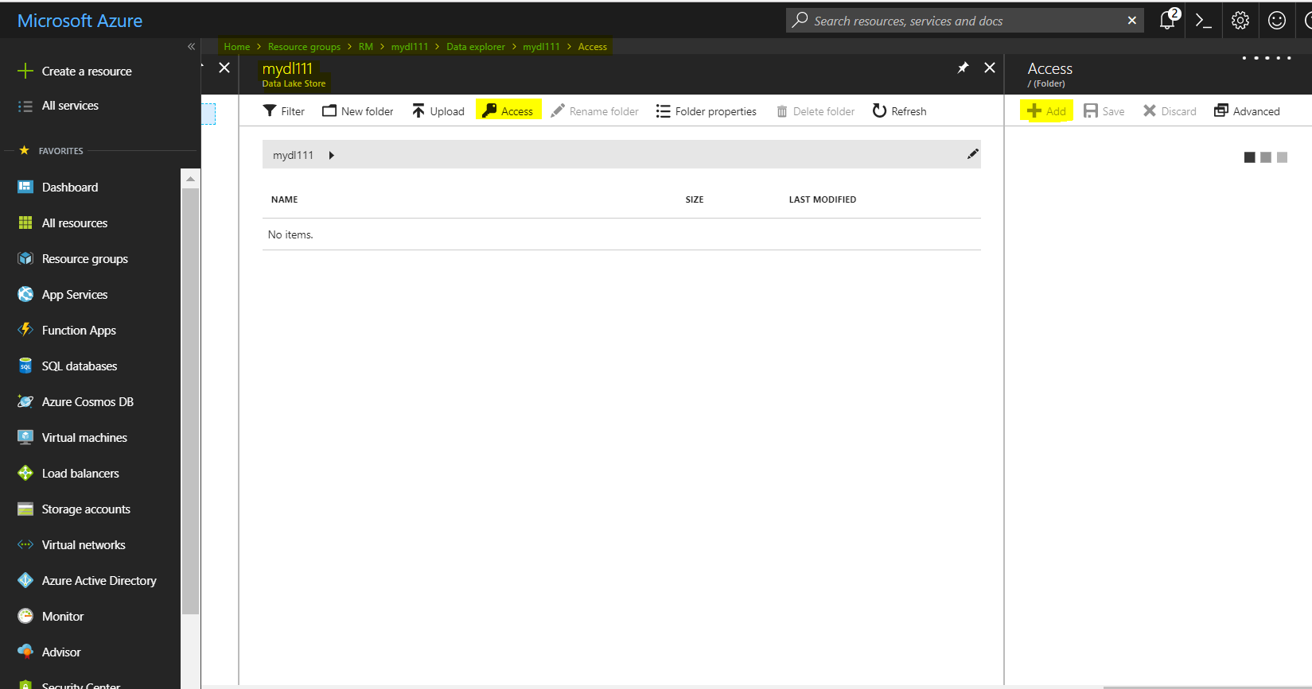

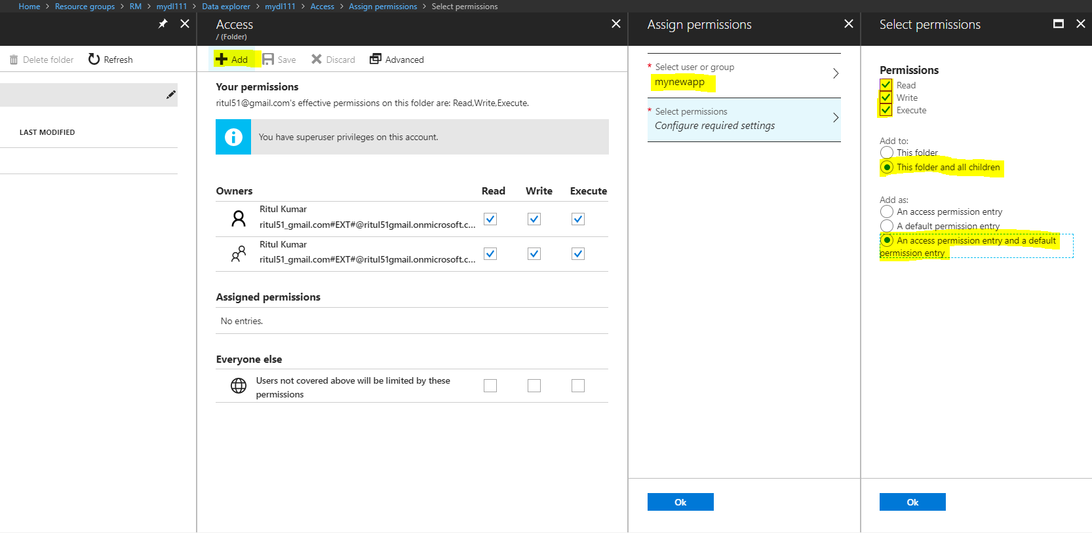

Now go to Access control:

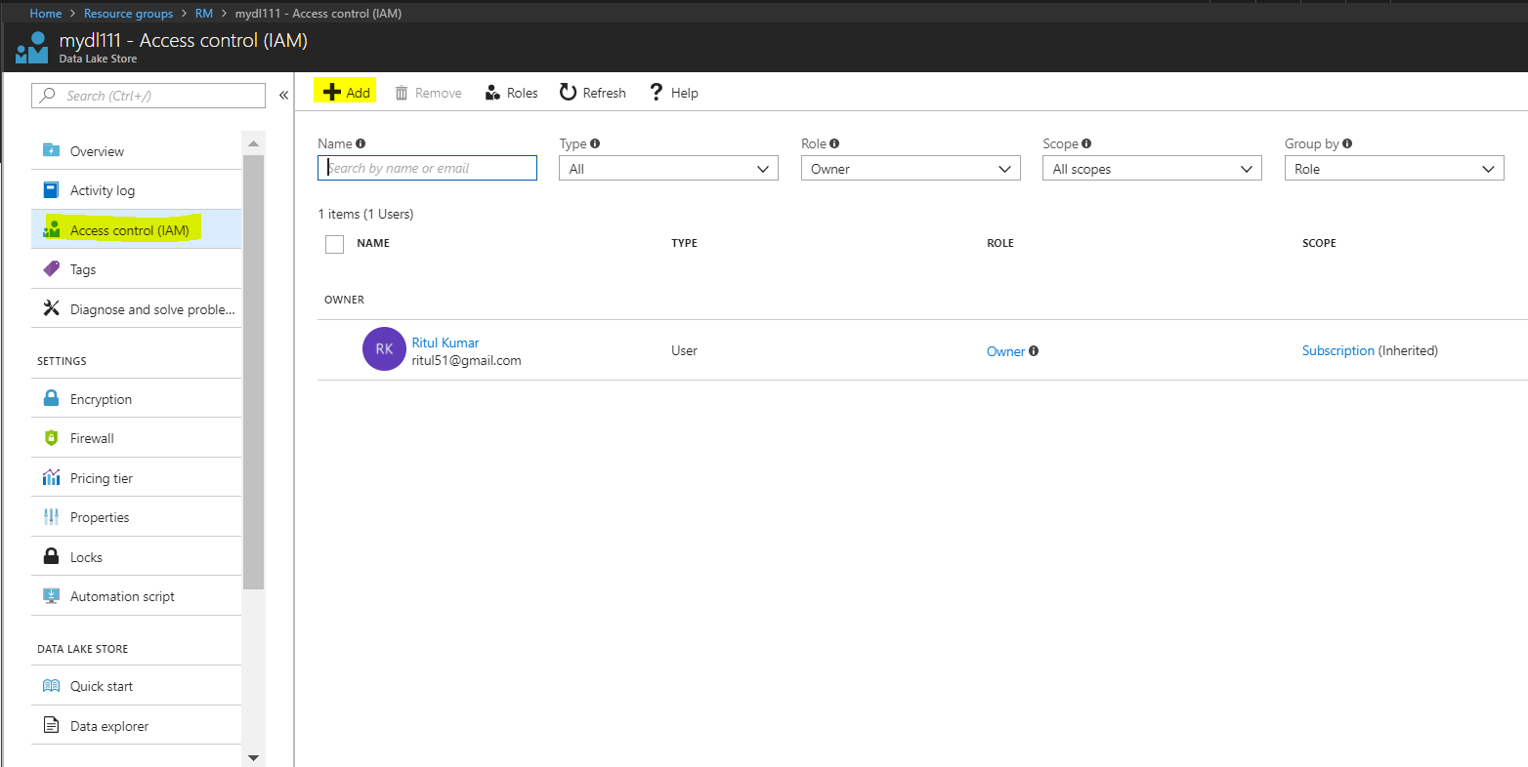

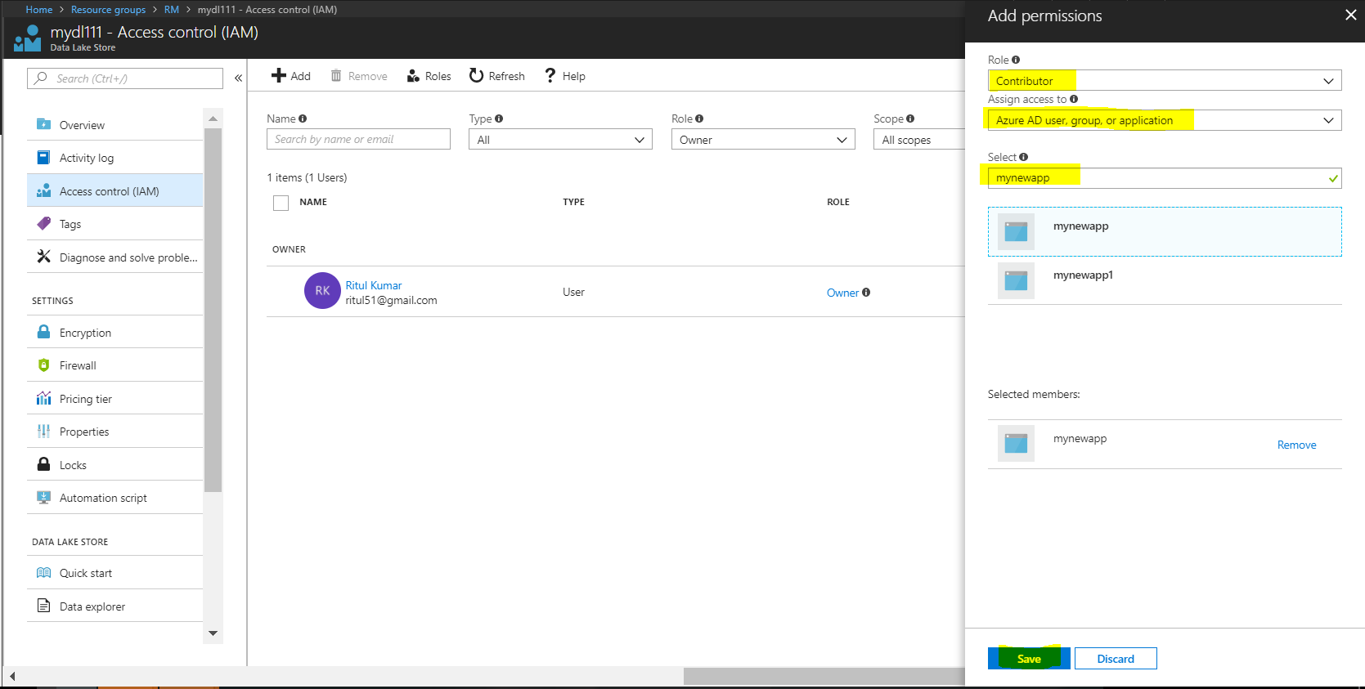

Now enter application ID and key to Linked Service for DATA LAKE:



Data Sets:

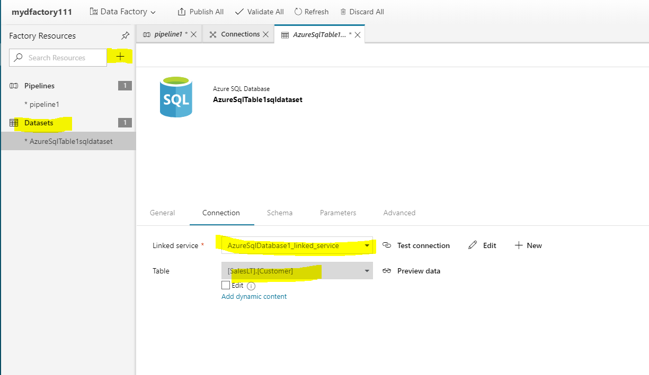

Dataset for DL:

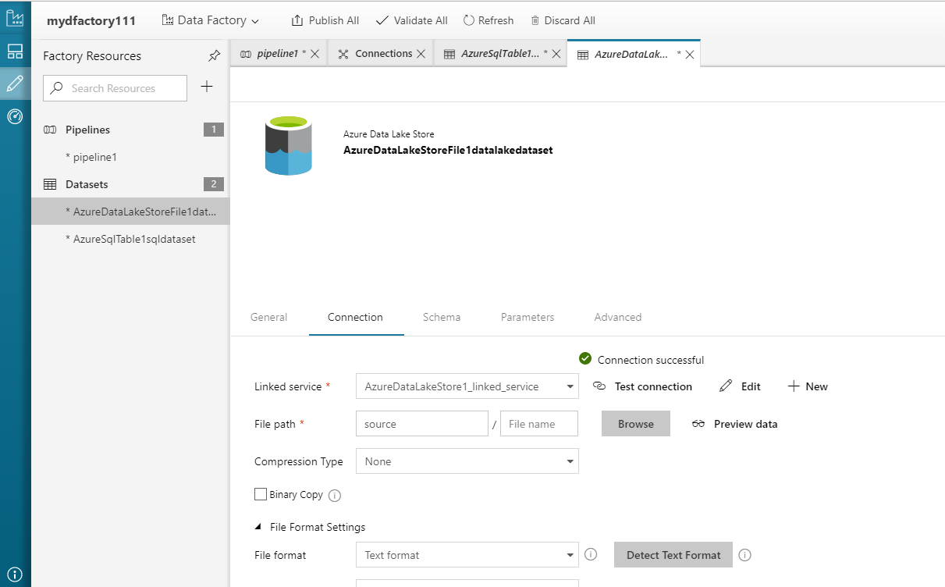

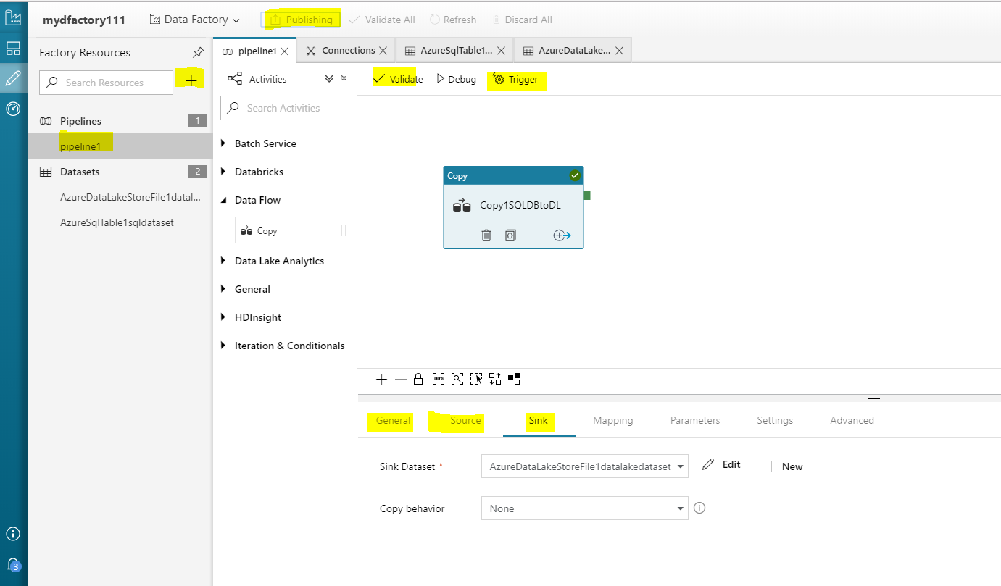

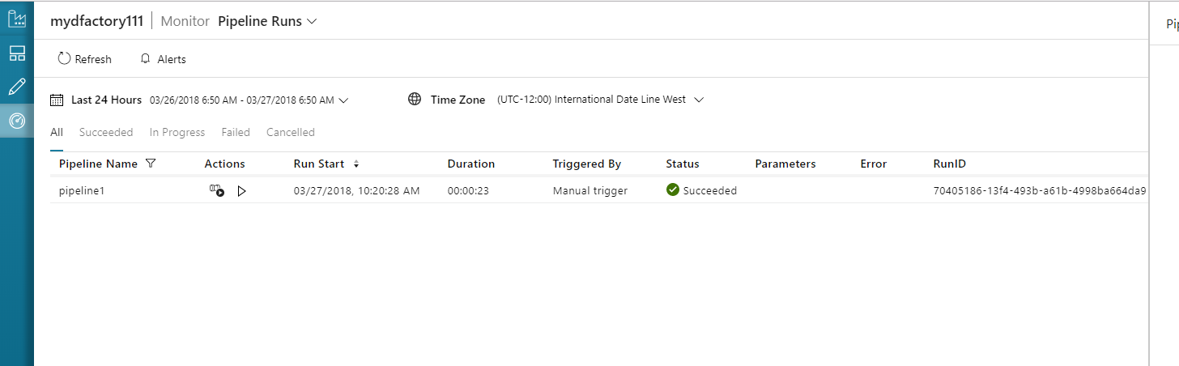

Check in DL:

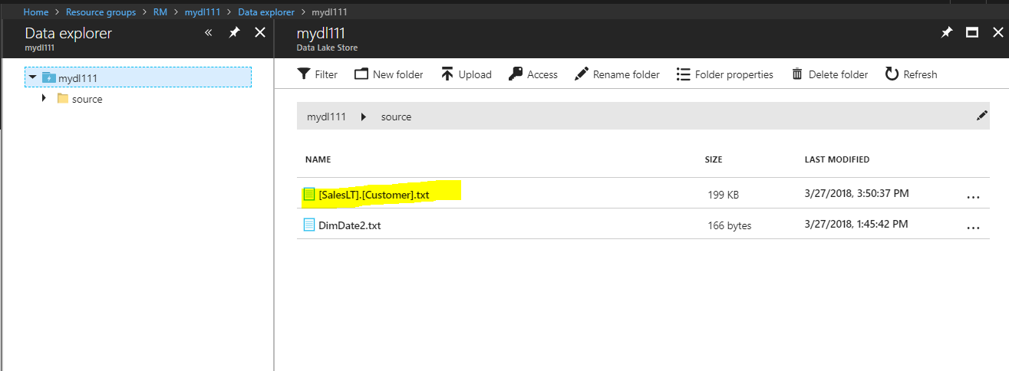

**USQL Activity**

**Task: USQL Activity followed by Copy Activity**

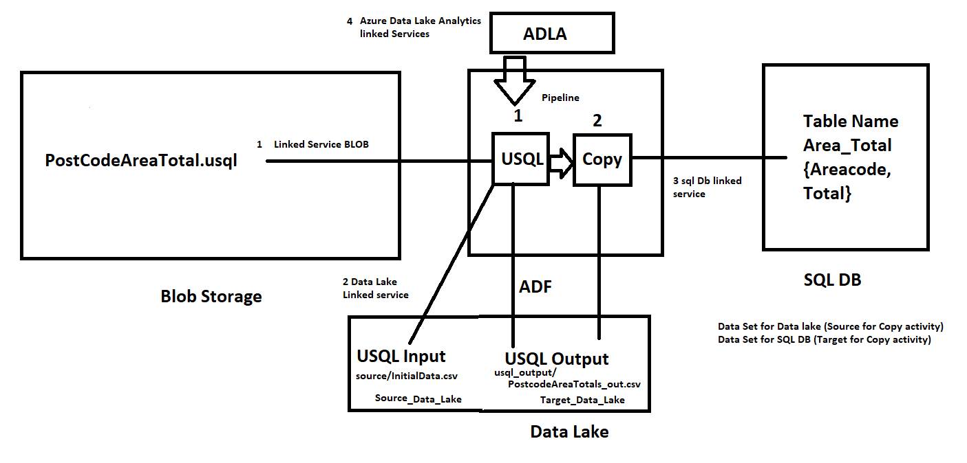

* **Deploy Blob Storage**
  + Create a container with name **adftutorial** and load **PostcodeAreaTotals.usql**
* **Deploy Data Lake / Register with app using AAD and Keep copy Application ID and KEY**
  + Create a folder **source** and **usql_output**, load **InitialDataFile.csv** to **source** folder.
  + Create another **Usql_ouput** folder is for output file of usql analytics.
* **Deploy Azure Data Lake analytics:** 
  + After the Azure Data Lake Analytics account has been provisioned, browse to its blade in the Azure portal, and under **Settings**, click **Data Sources**.
  + Click **Add Data Source**. Then in the **Add Data Source** blade, in the **Storage Type** list, select **Azure Storage**, and then select your Azure storage account. This adds your Azure storage account as a data source to which the Azure Data Lake Analytics account has access, in addition to its default Azure Data Lake Store.

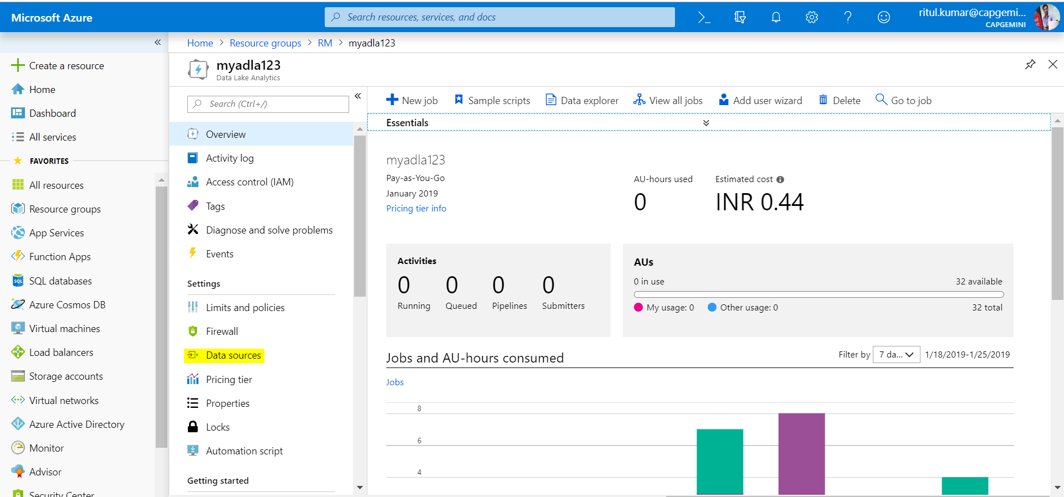

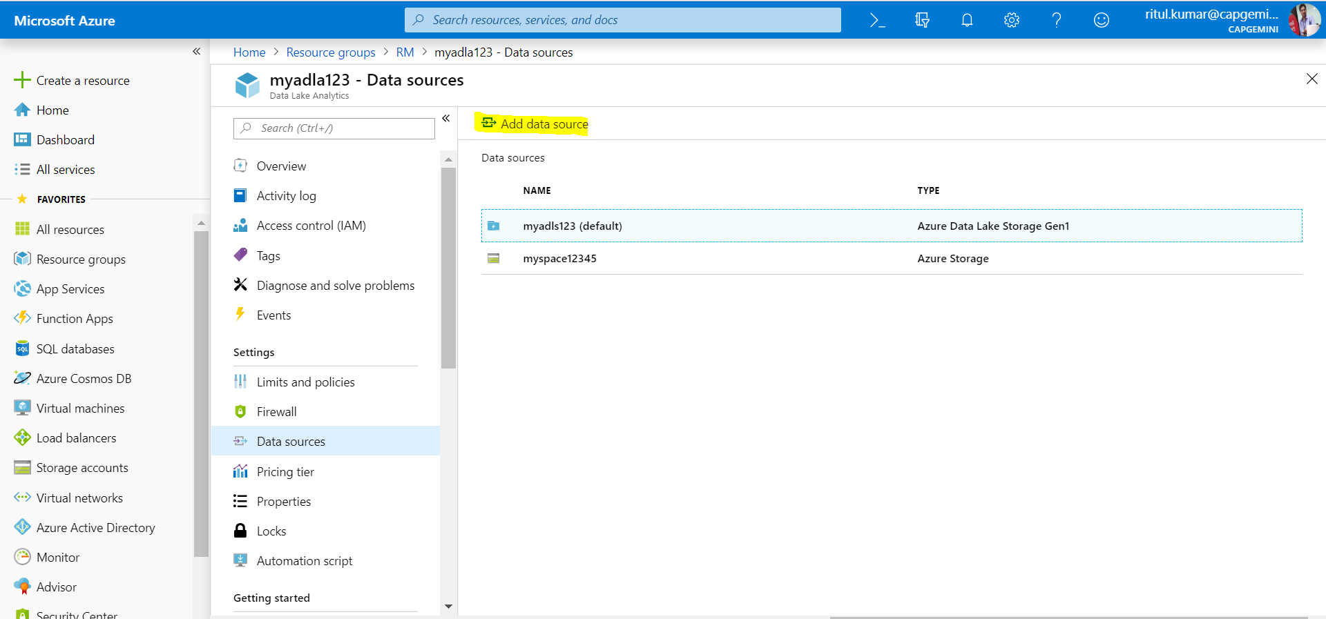

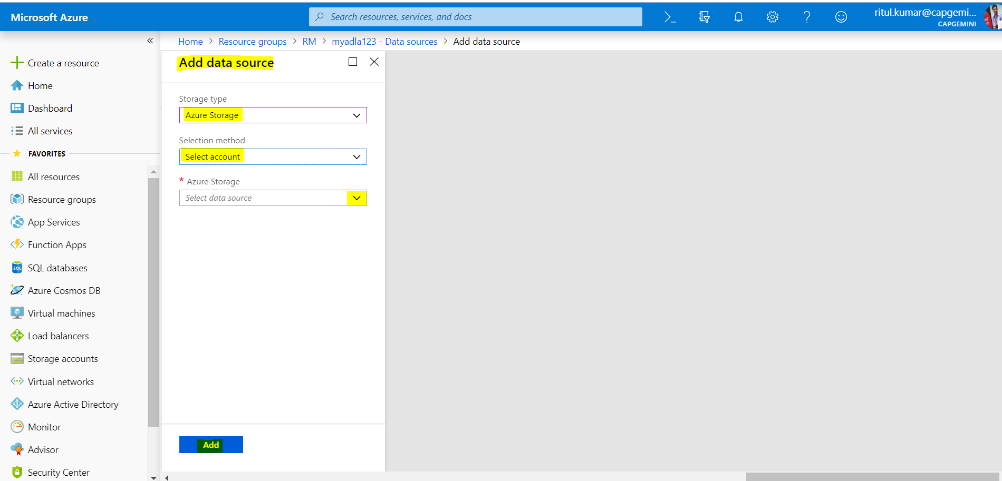

* **Deploy Azure data Factory**
* **Deploy a SQL DB**
  + **Create a target table name area_total**

create table dbo.area_total

(

area_code varchar(20),

total_number int

);

**Create Linked Services:**

* **Azure blob Linked Service**
* **Azure Data lake Linked Services**
* **Azure SQL data Base linked Service**
* **Azure Data lake Analytics linked services**

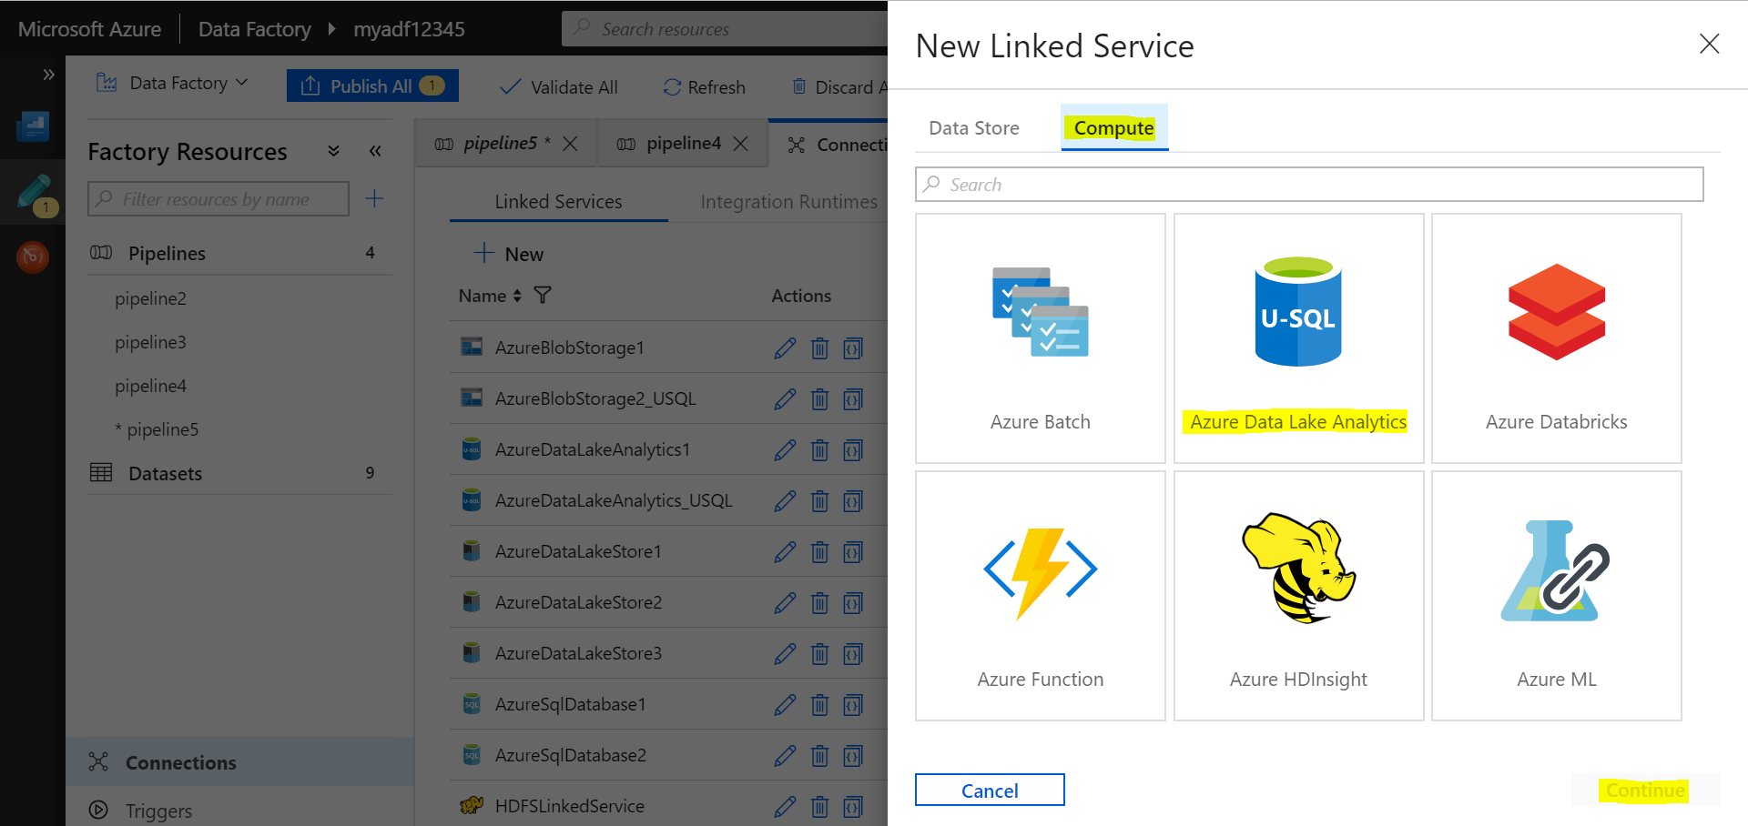

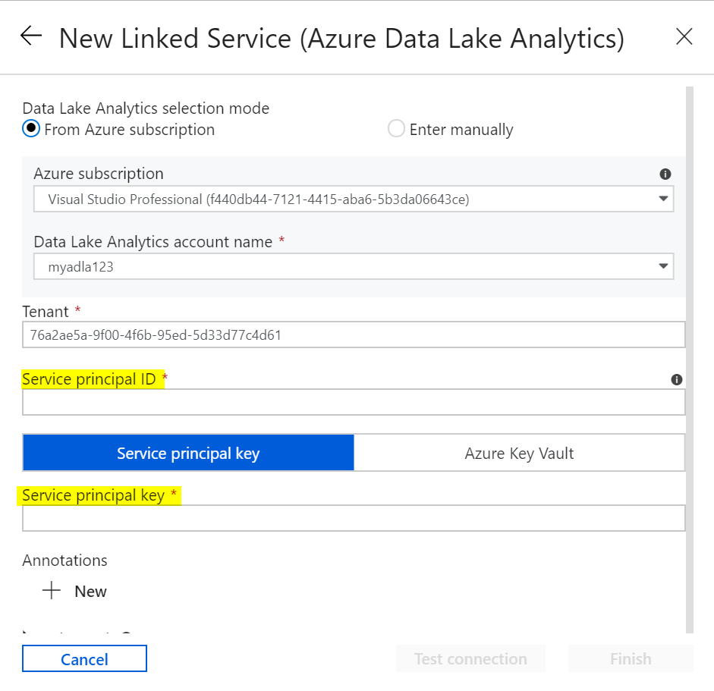

Need **Service Principal ID & Service principal key** for **Azure Data Lake Analytics** linked service.

We can use same **Service Principal ID & Service principal key** we used in **Azure Data lake Linked Service.** But need to **add registered app to ADLA** account.

**Add app to ADLA account and give permissions:**

**Go to ADLA account 🡺 Add user wizard**

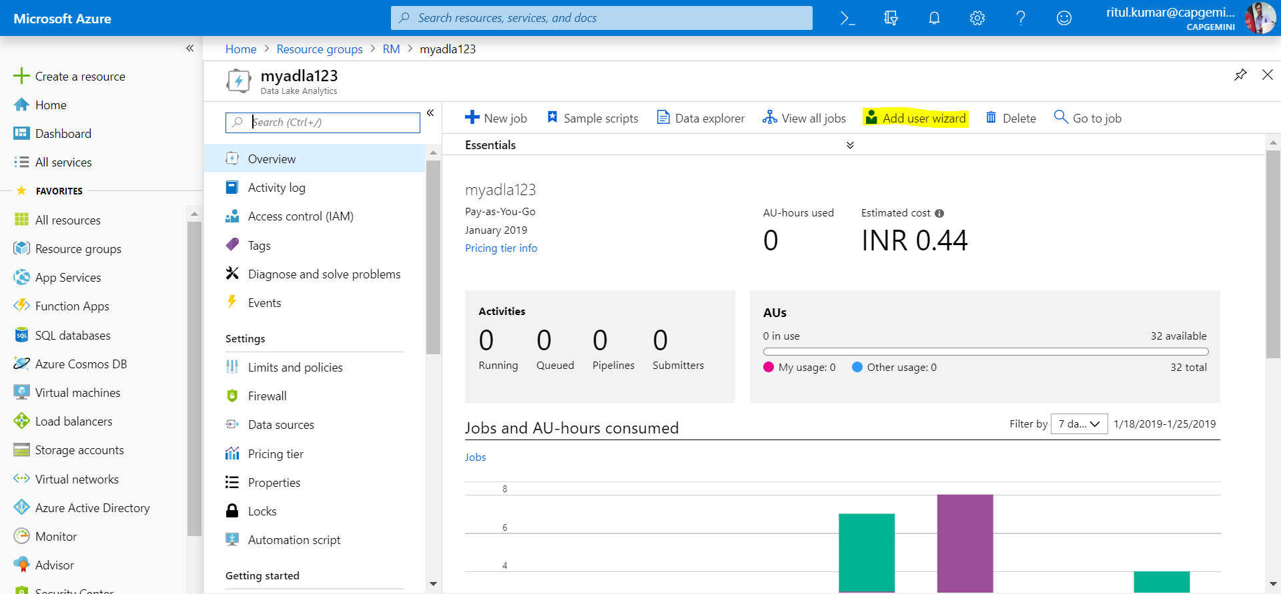

**Select user 🡺 Registered App Name**

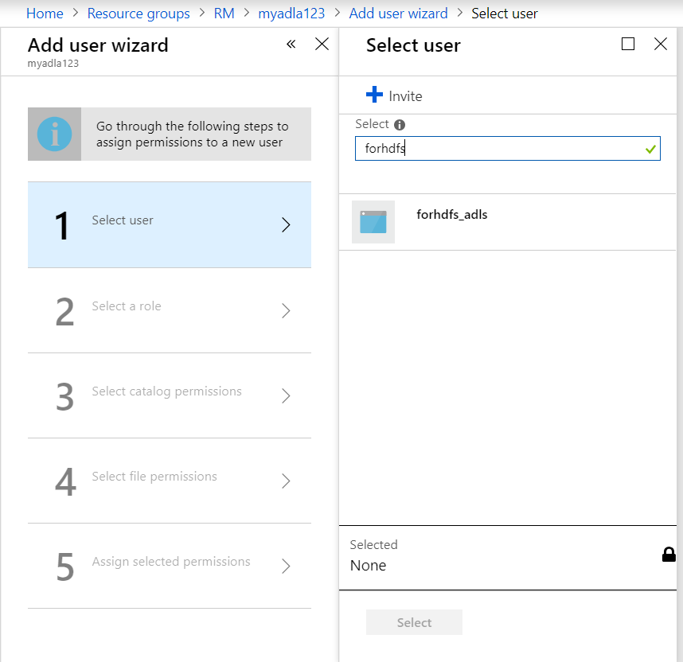

**Select Role 🡺 Owner**

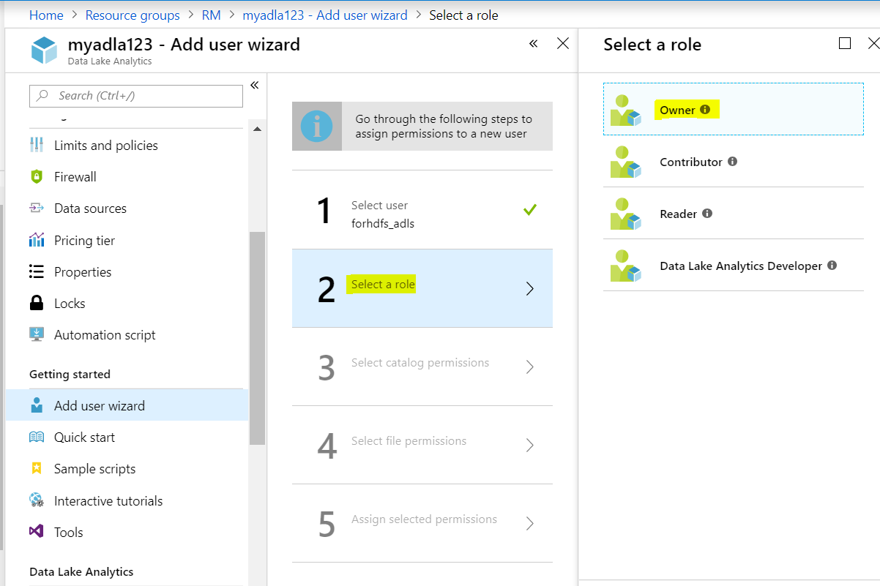

**Select Catalog Permissions:**

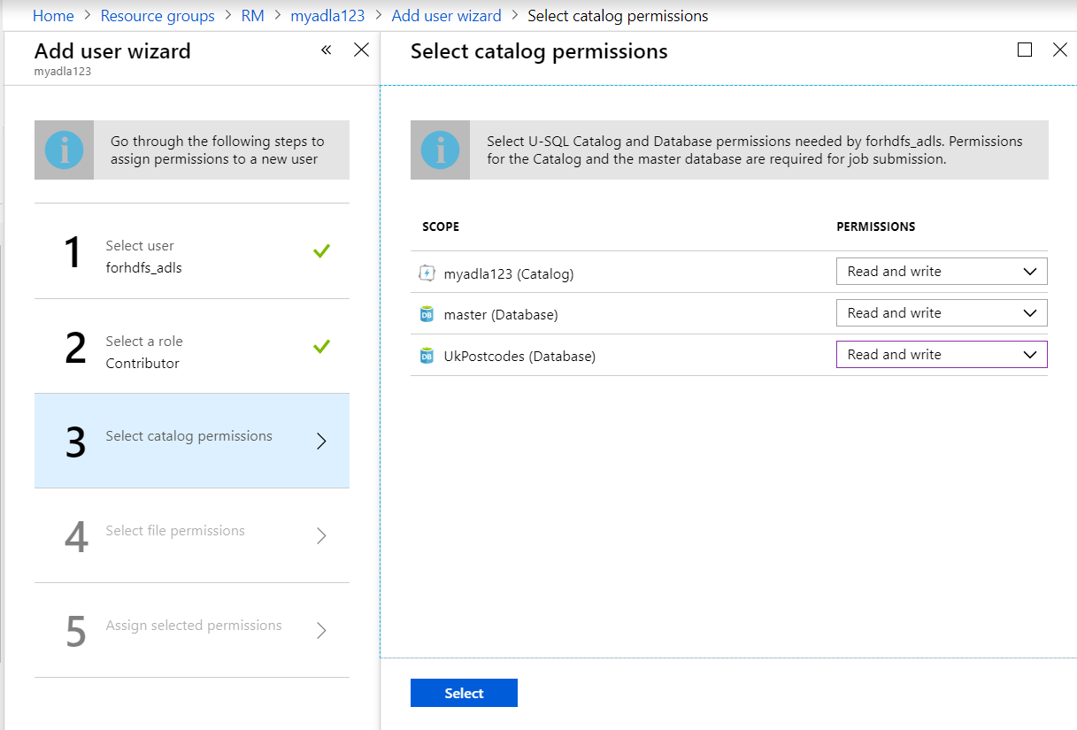

**Select file Permissions:**

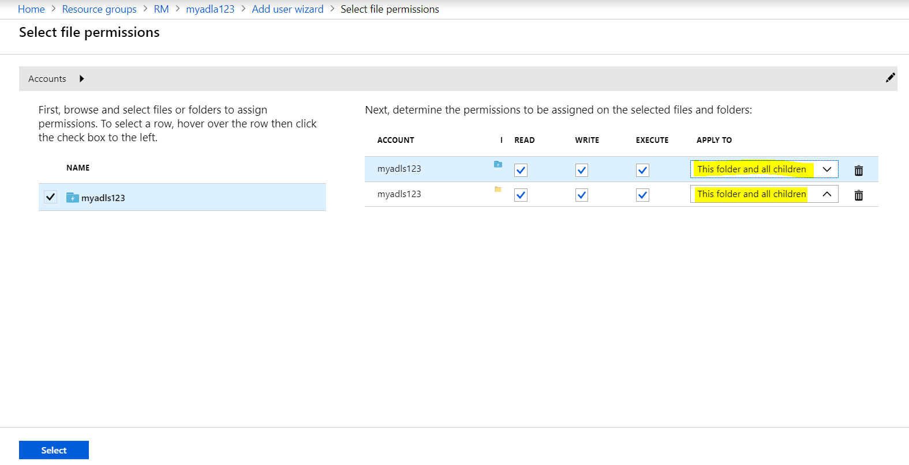

**Assign Selected Permissions: Run**

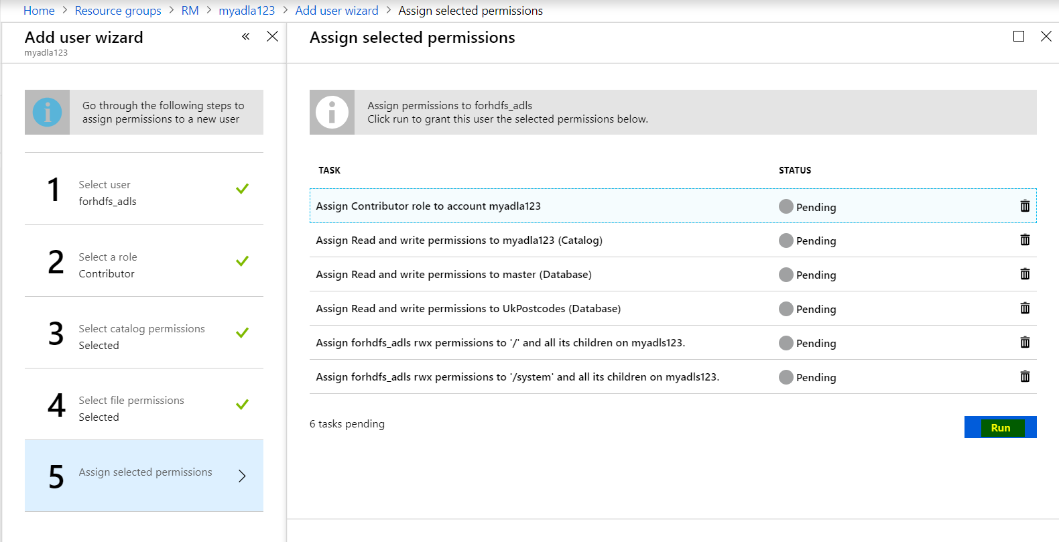

**Create Data Sets:**

**Data Set for Data Lake:** This act as **source** for **copy activity**. After processing using **USQL code** file going to store in **usql_output** folder. So give this folder path as **source to copy activity**.

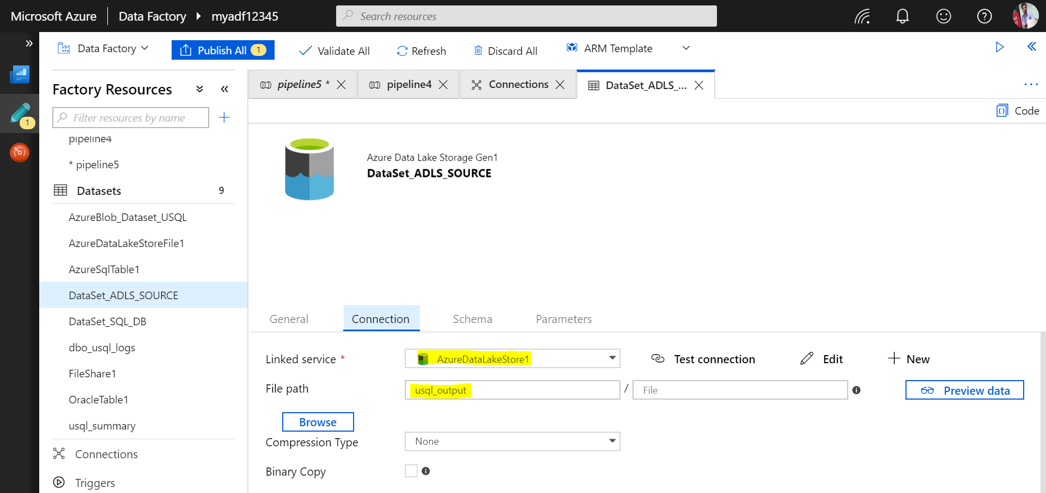

**Now select schema for source file**

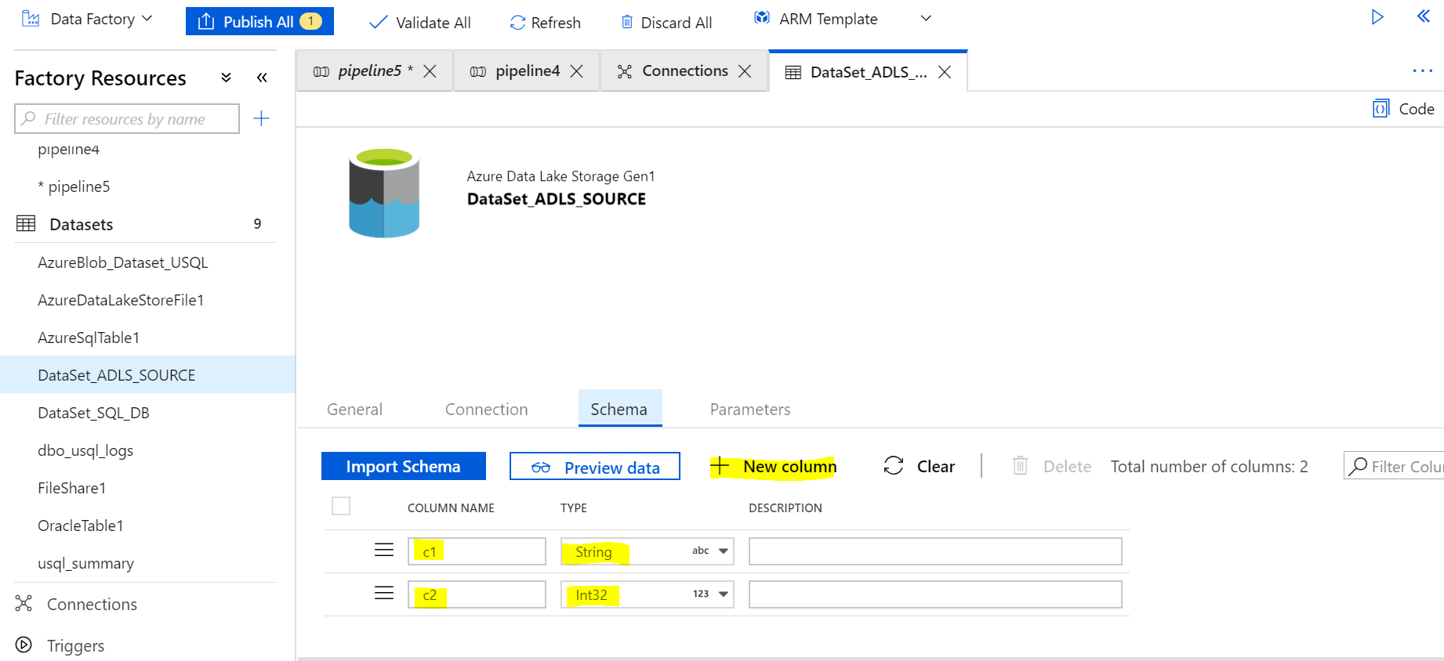

**Data Set for SQL DB: Act as target**

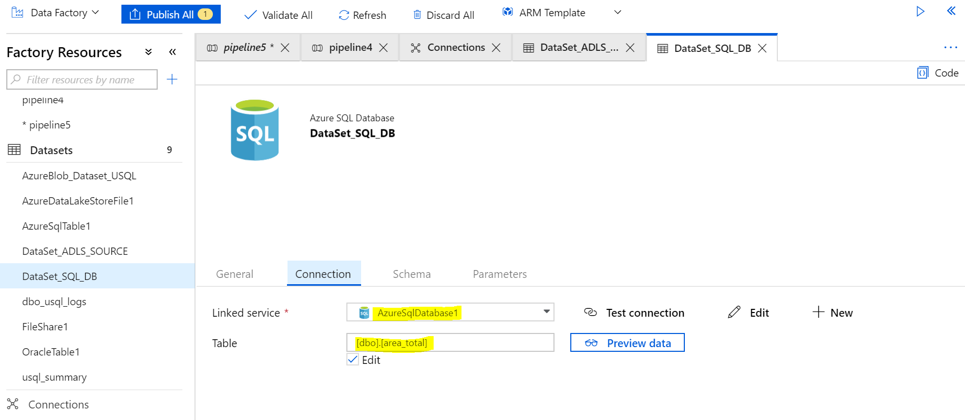

**Go to Schema and import Schema (No need to create, Need to import because SQL table always have schema)**

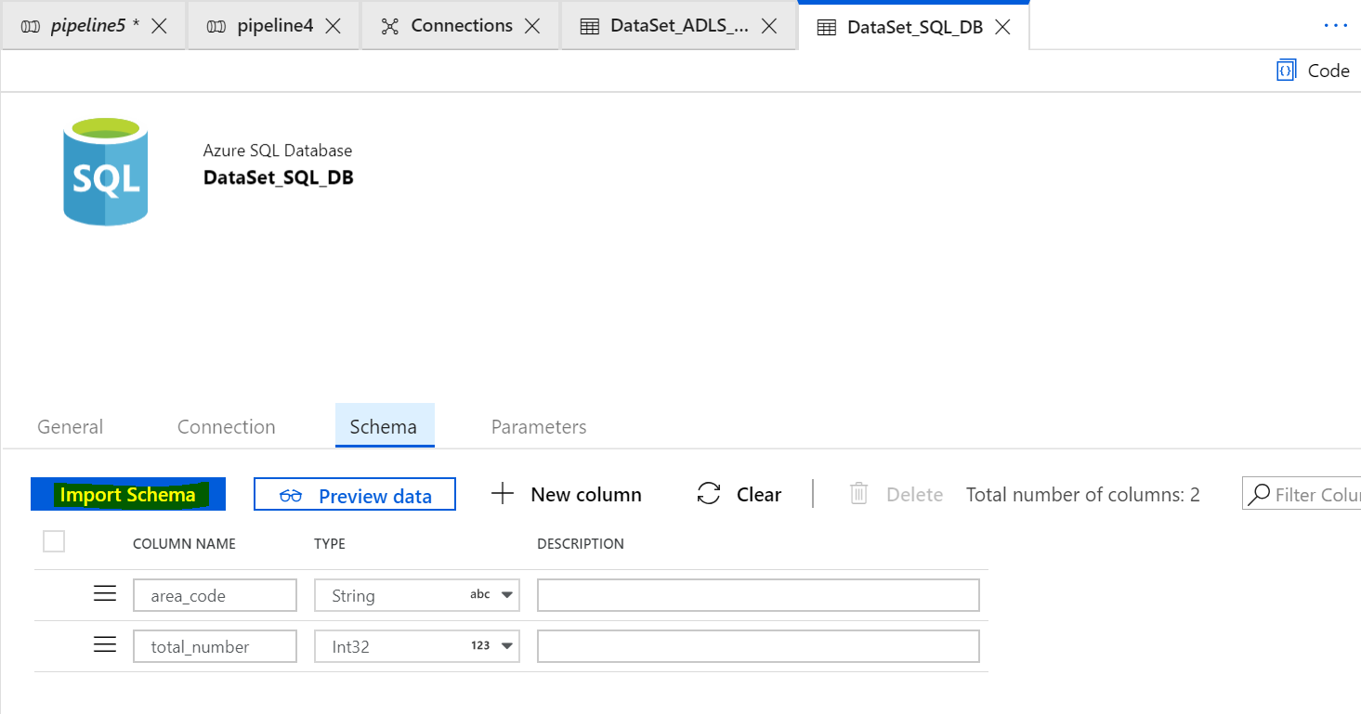

**Create a Pipeline:**

**Drag and Drop USQL activity 🡺 select appropriate linked service**

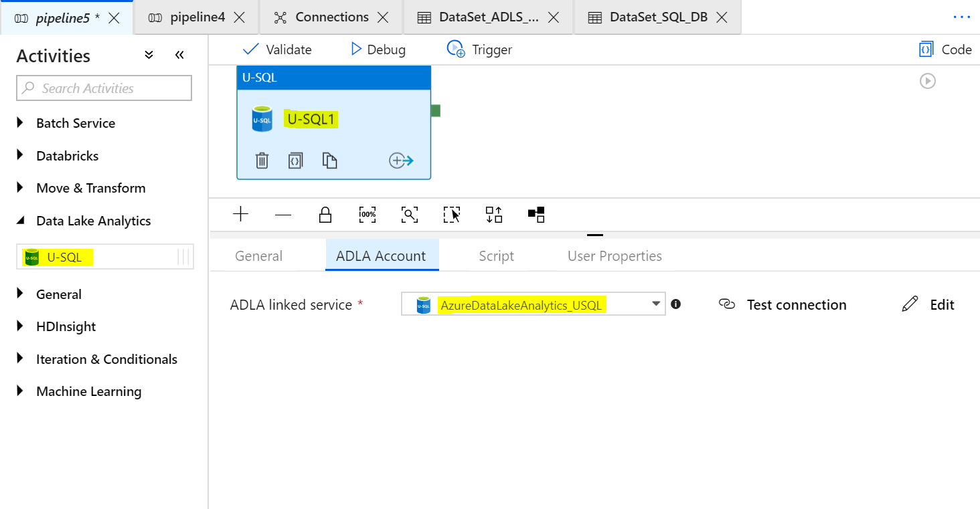

**Go to Script and give path of script: Select Blob storage linked service because usql script is there only.**

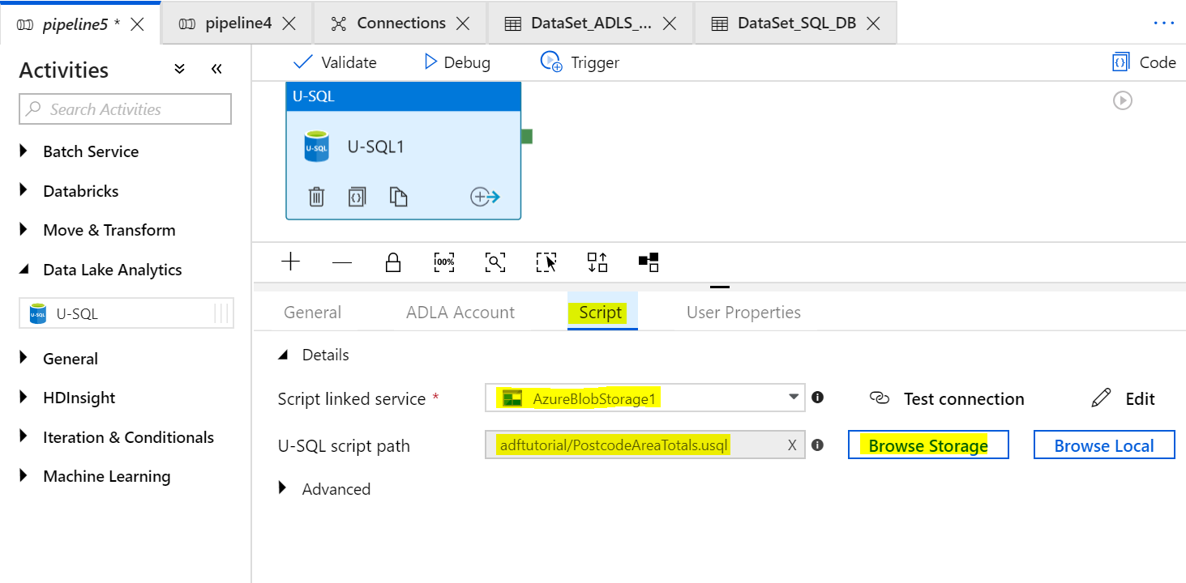

**In advance option give parameters if required:**

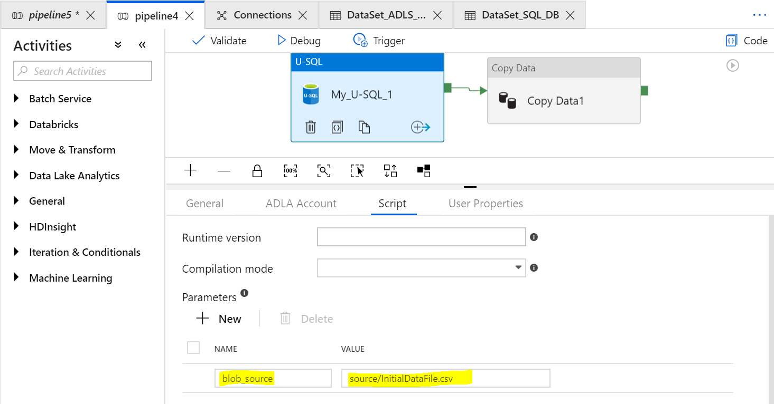

**In this example we used parameter in usql script so here we require parameterize the path.**

**Drag and drop copy activity into pipeline 🡺 Link both the pipeline**

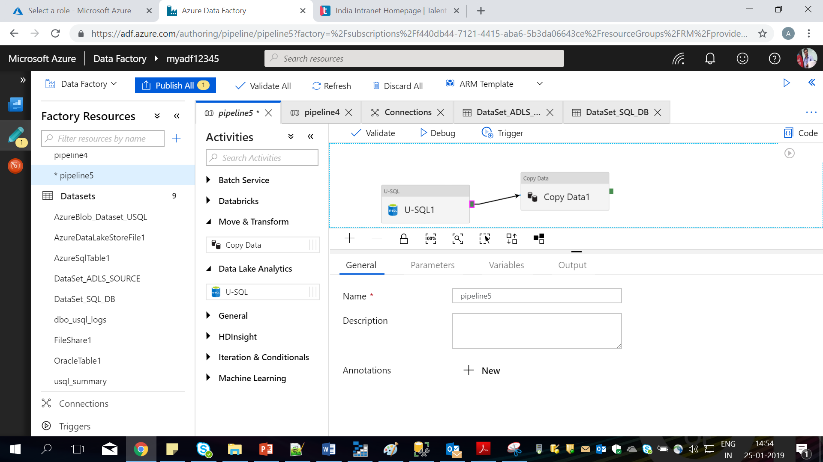

**Select source:**

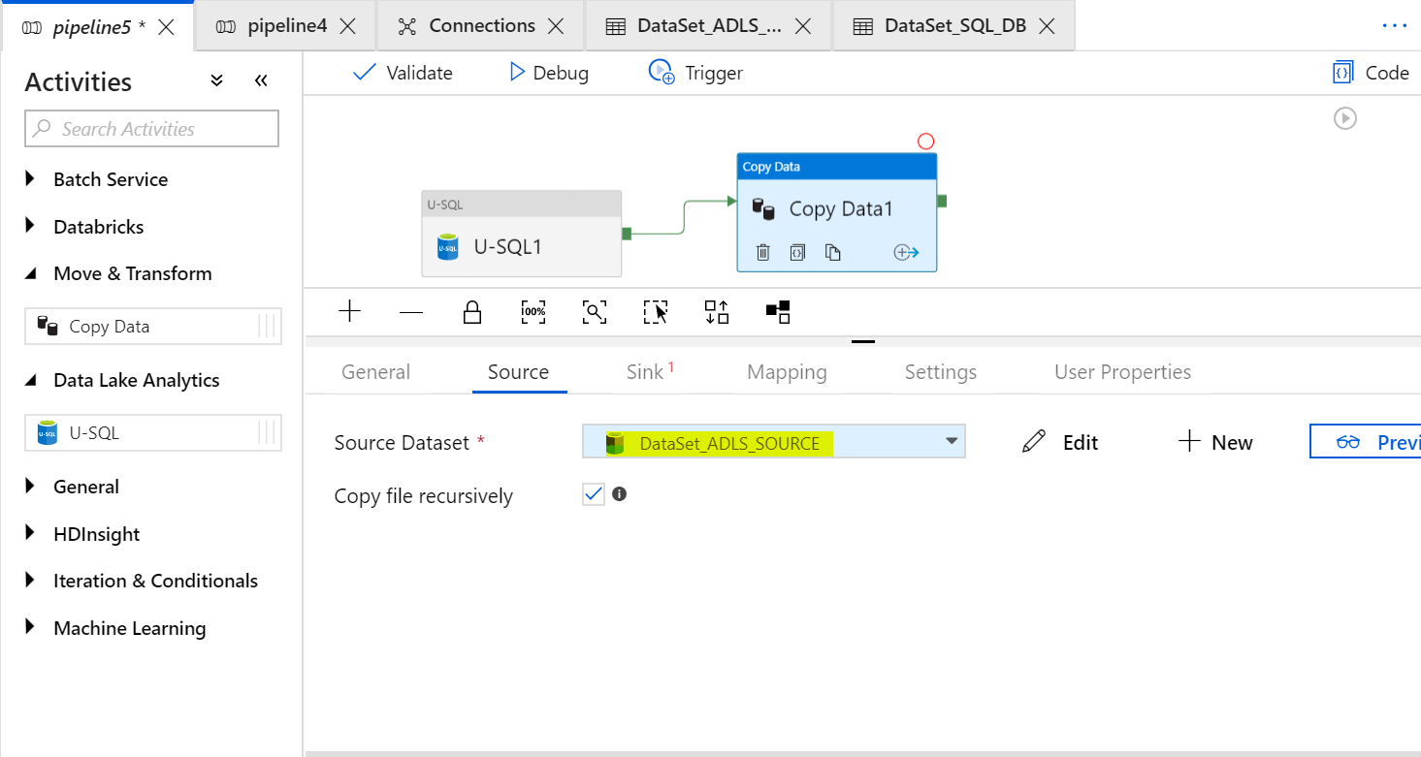

**Select Sink:**

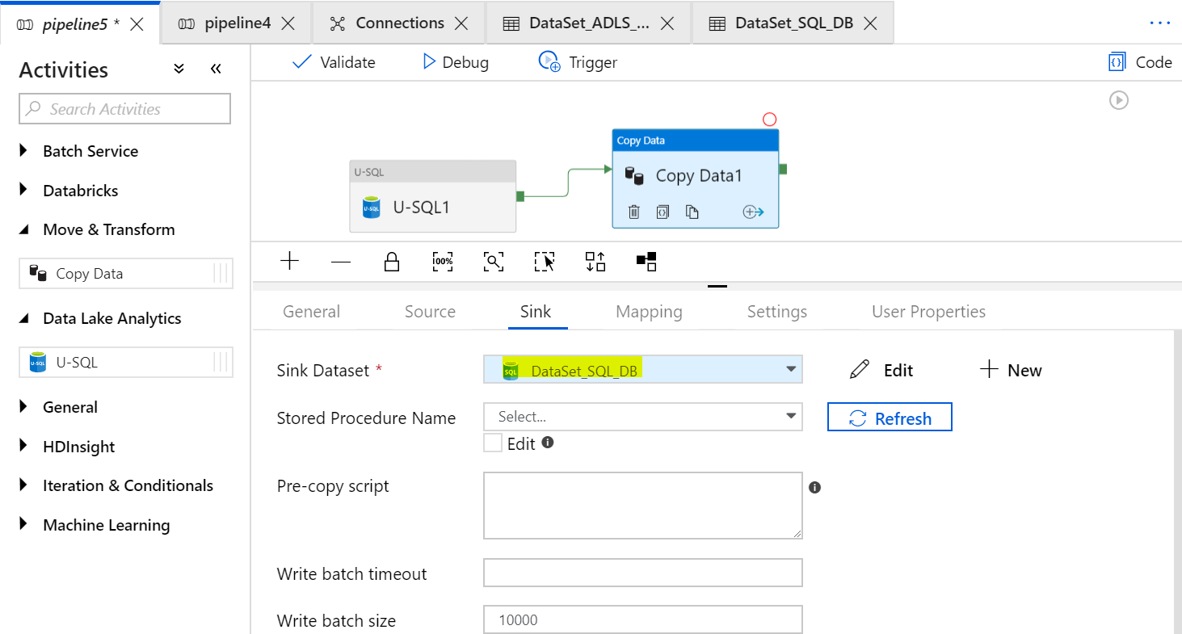

**Go to mapping 🡺 Import Schemas**

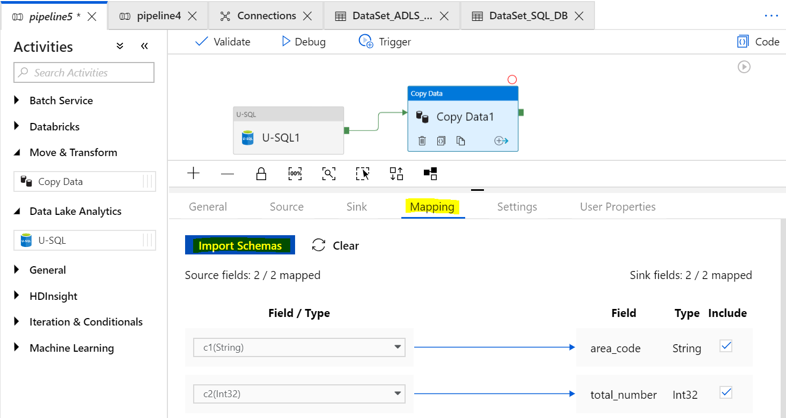

**Validate 🡺 Publish and Triger**

**Go to Monitor:**



**Check output in SQL DB 🡺**

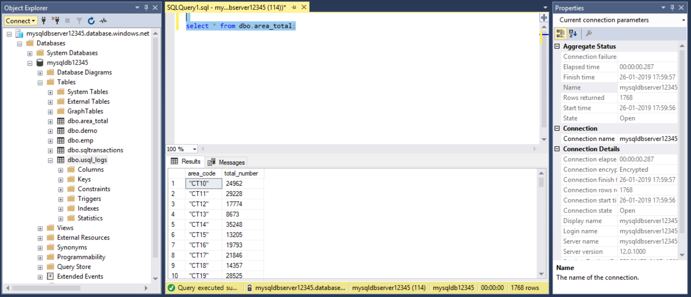

**Hive Activity**

**Create a Blob Storage.**

Upload a **txns** file into **Blob storage** in folder “**myhadoop12345-2019-01-26t09-00-31-280z(Root)/user**”🡺 with folder “**transactions**” using **advanced** properties as shown below.

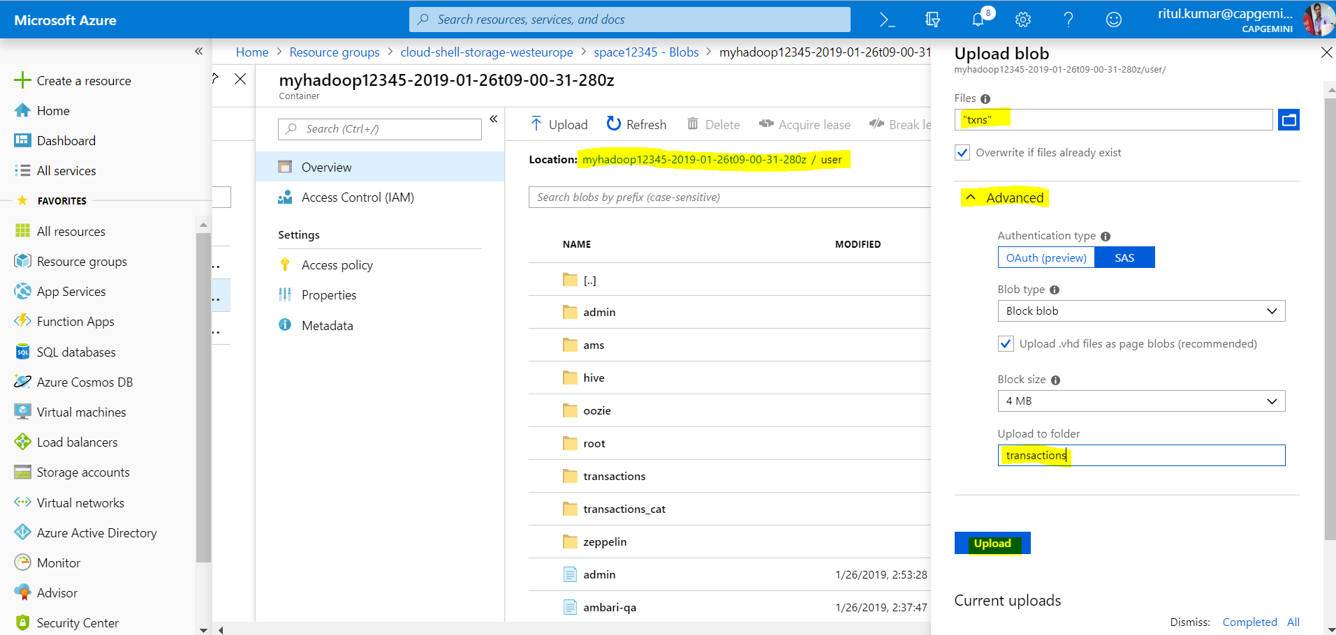

**Load transactions.hql** file to **“myhadoop12345-2019-01-26t09-00-31-280z(Root)/user”**

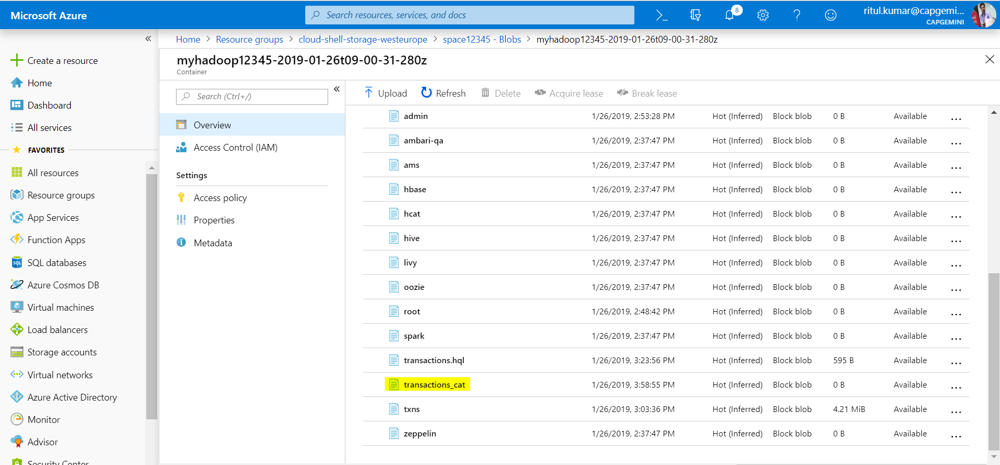

**Transactions.hql**

**create external table transactions(txnno INT, txndate STRING, custno INT, amount DOUBLE, category STRING, product STRING, city STRING, state STRING, spendby STRING)**

**row format delimited**

**fields terminated by ','**

**location '/user/transactions';**

**create external table transactions_cat(category STRING, total_amount DOUBLE)**

**row format delimited**

**fields terminated by ','**

**location '/user/transactions_cat';**

**insert overwrite table transactions_cat**

**select category, sum(amount) from transactions group by category;**

**Create an HdInsight Cluster using Blob storage already created.**

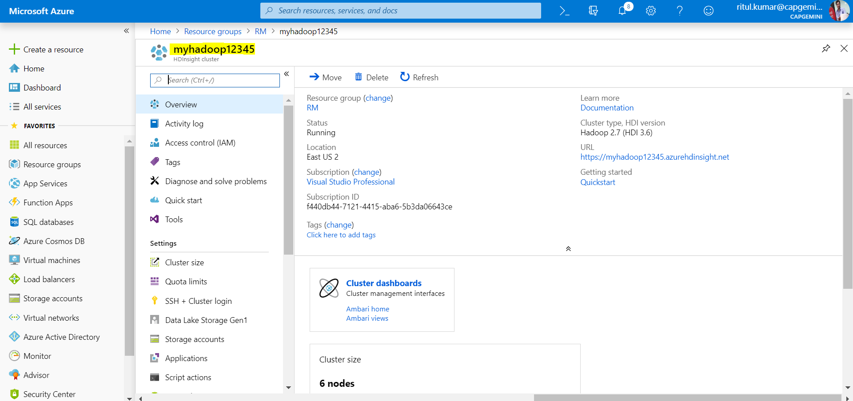

**Create a table into SQL DB:**

**create table dbo.sqltransactions**

**(**

**category STRING,**

**total_amount DOUBLE**

**);**

**Linked Services:**

**Create Blob linked service**

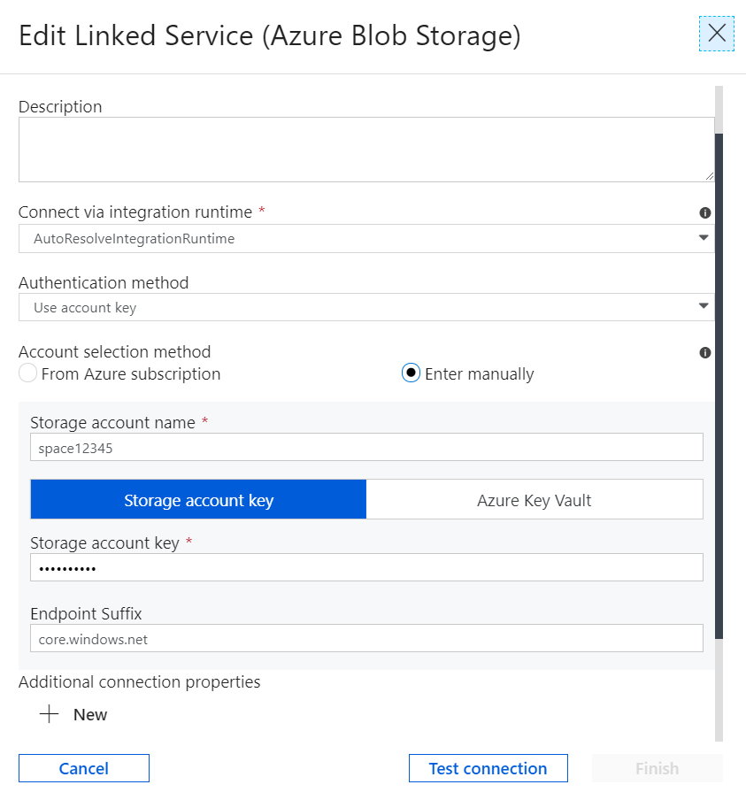

**Linked service for HDInsight**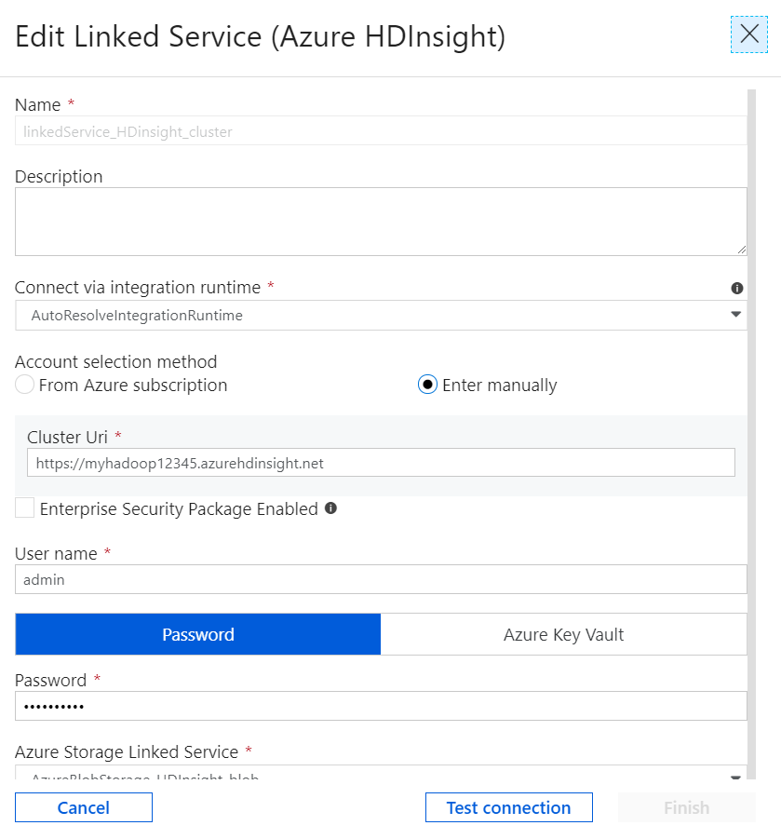

**Linked service for SQLDB**

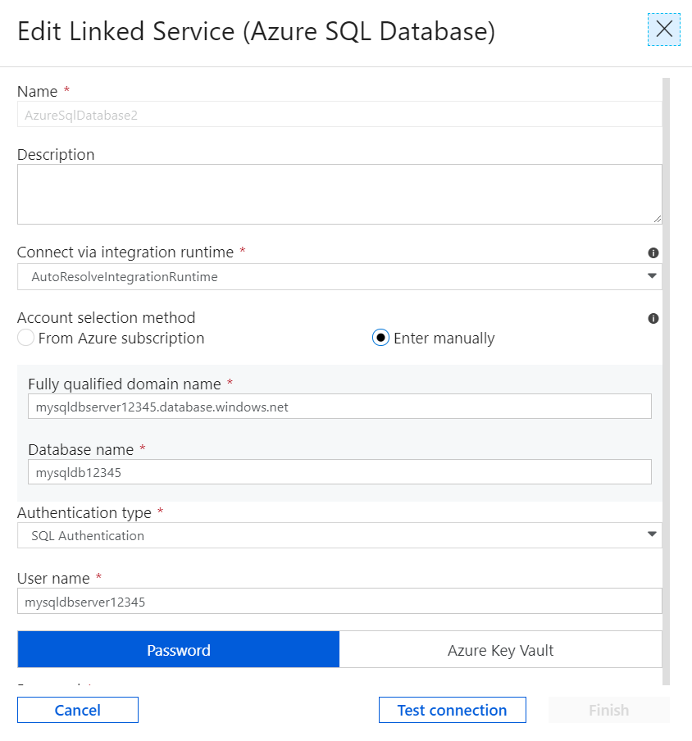

**Create Dataset: (Source for Copy Activity):** Ideally after processing **transactions.hql** data must present in **transaction_cat** folder. But this folder going to create after execution of **transactions.hql** script. So if you browse **this folder in Blob storage will** **not available** so browse till **/user.**

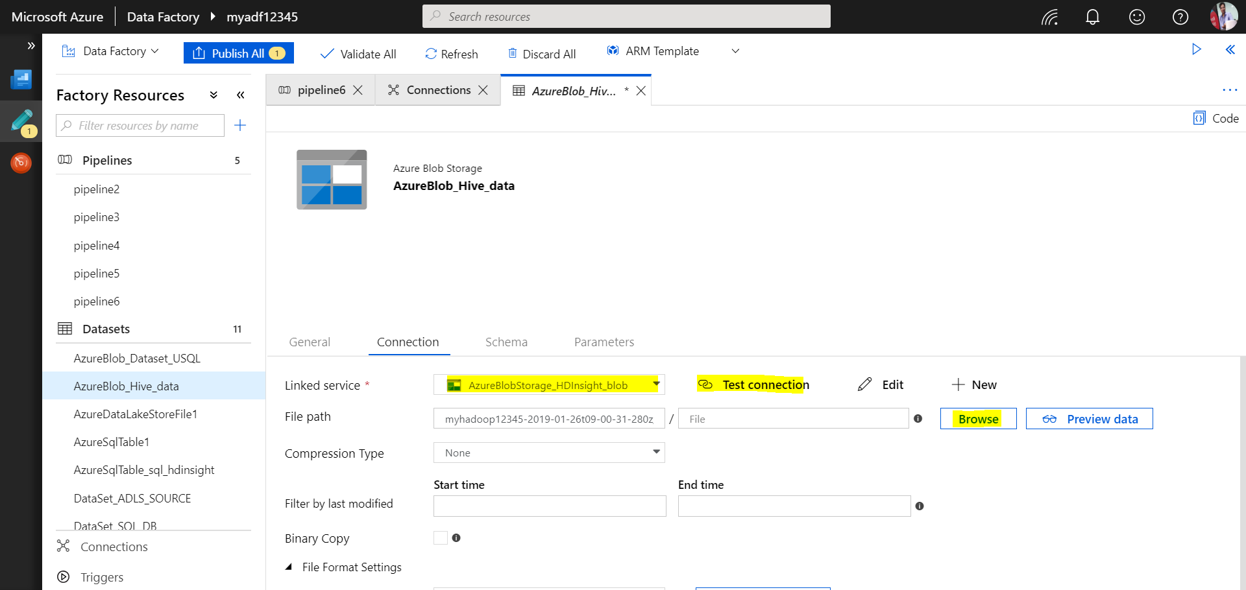

**Browse till /user**

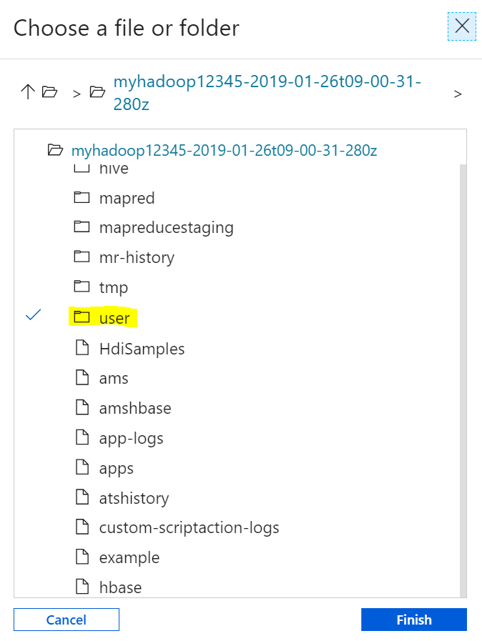

**Now go to Code:**

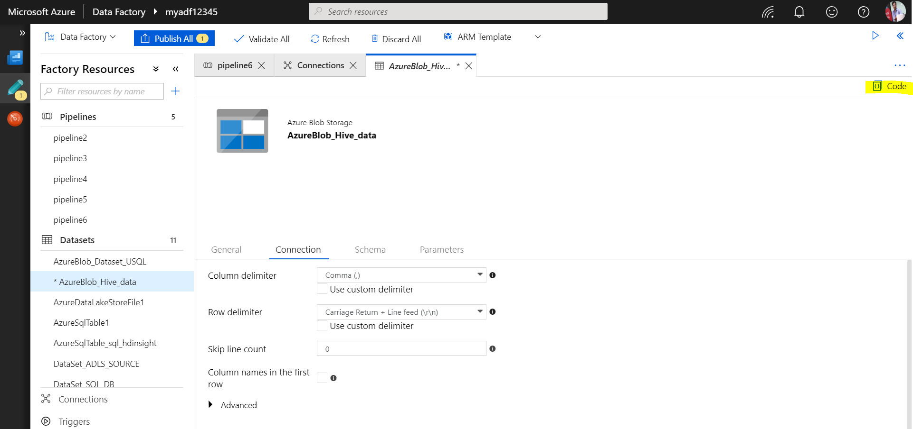

**Edit path in code:**

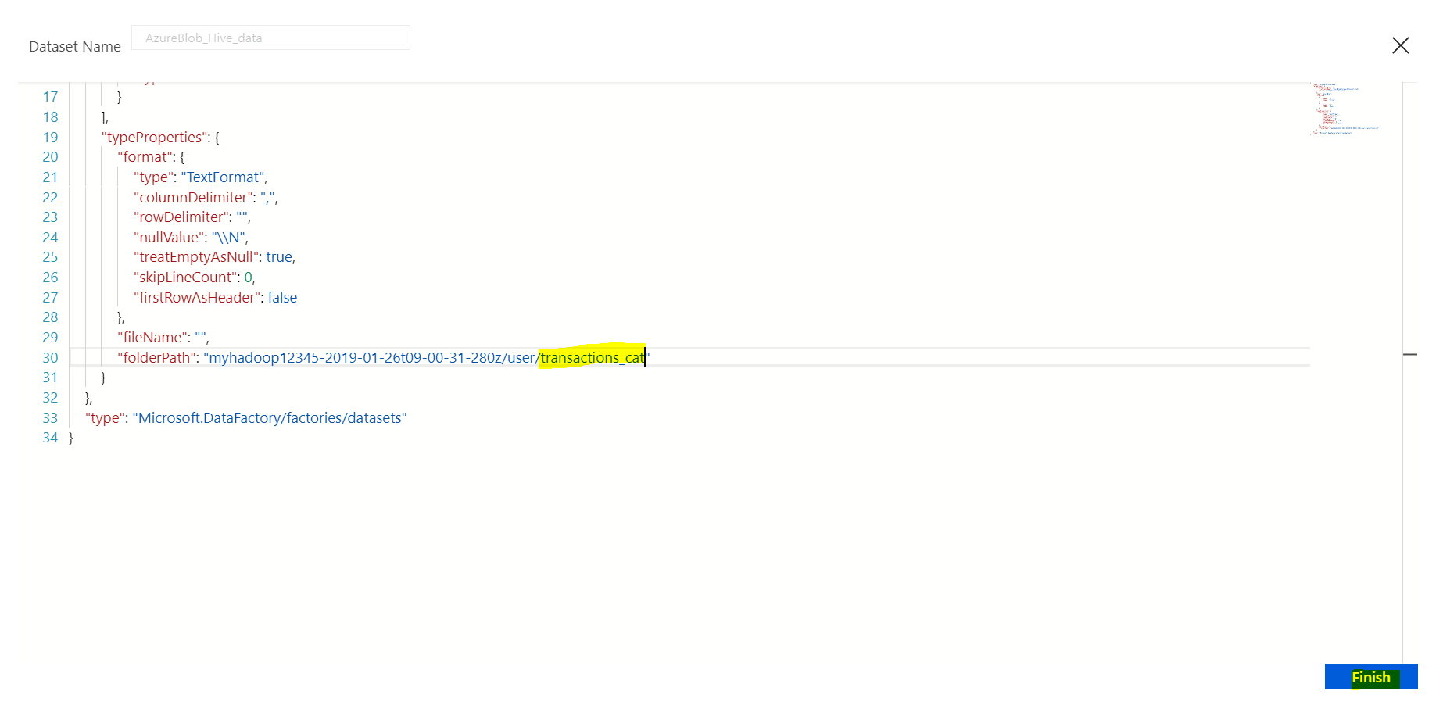

**Go to Schema 🡺 New Schema 🡺 Set as per table “transactions_cat” data**

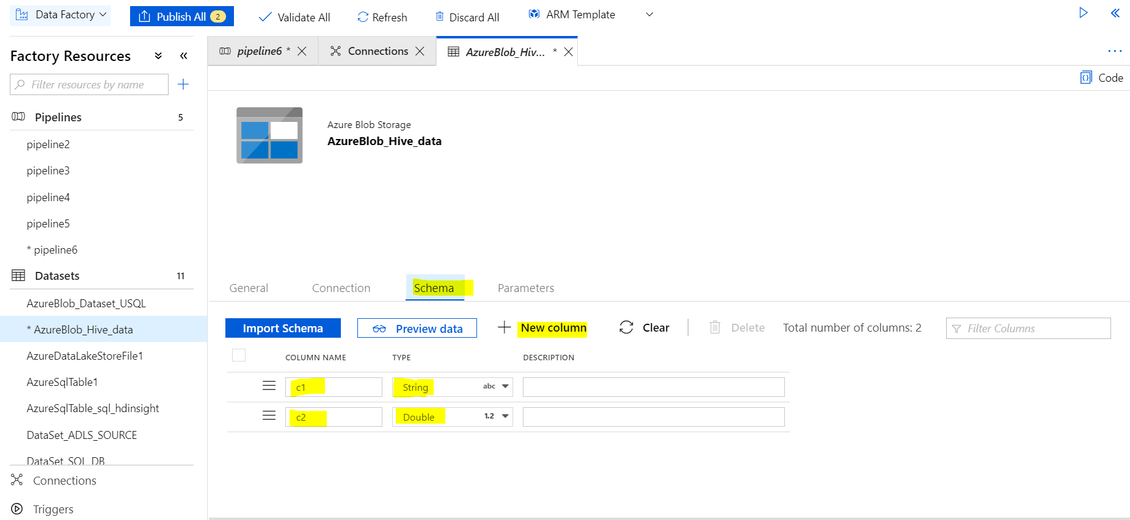

**Create Data set for SQL DB:**

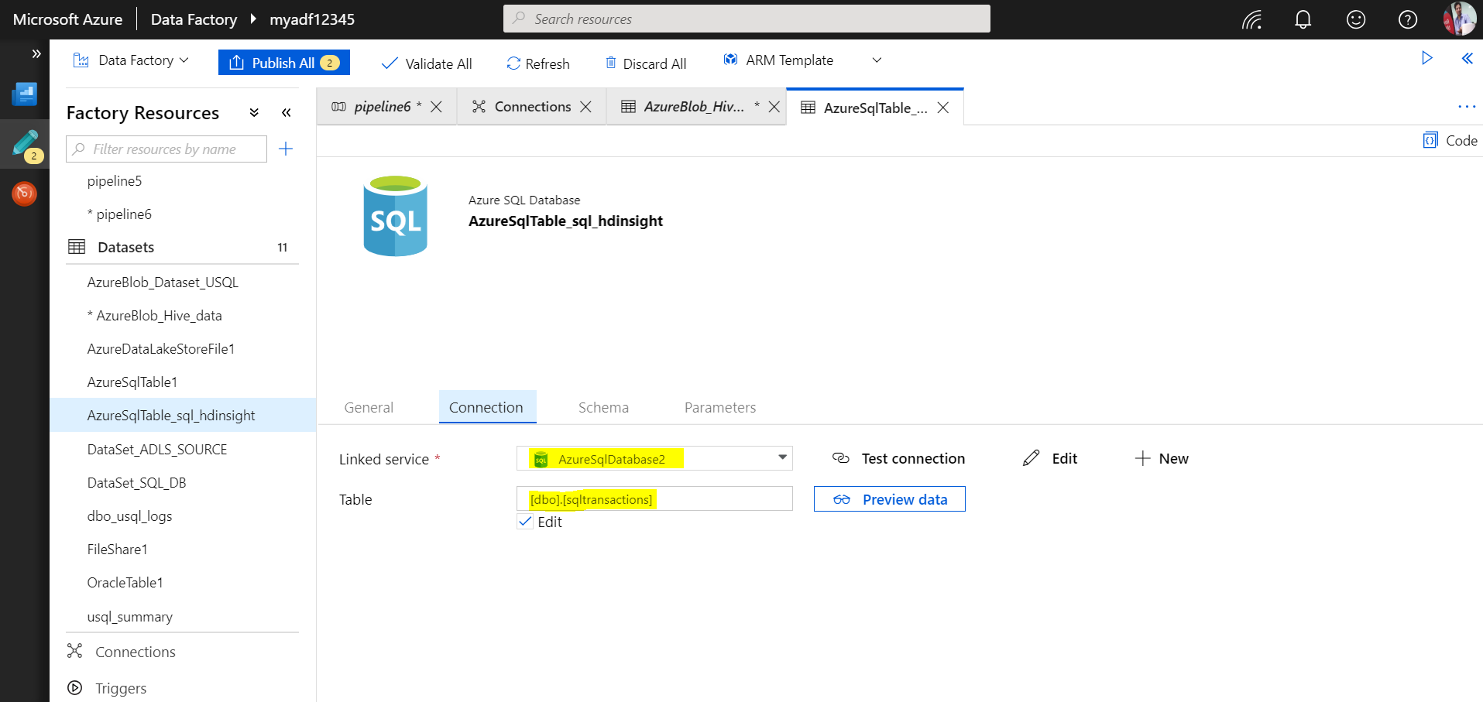

**Import Schema🡺**

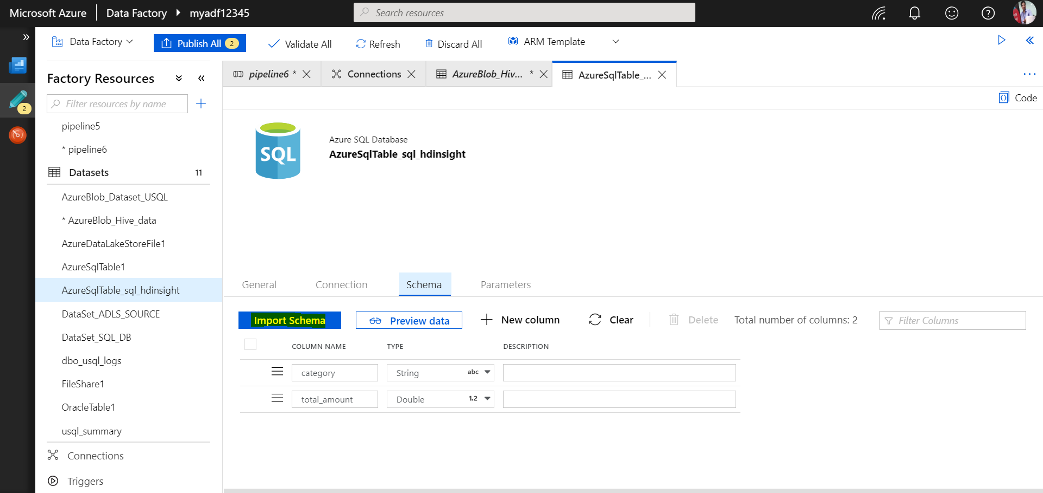

**Create a Pipeline:**

**Drag Hive and Copy Activity:**

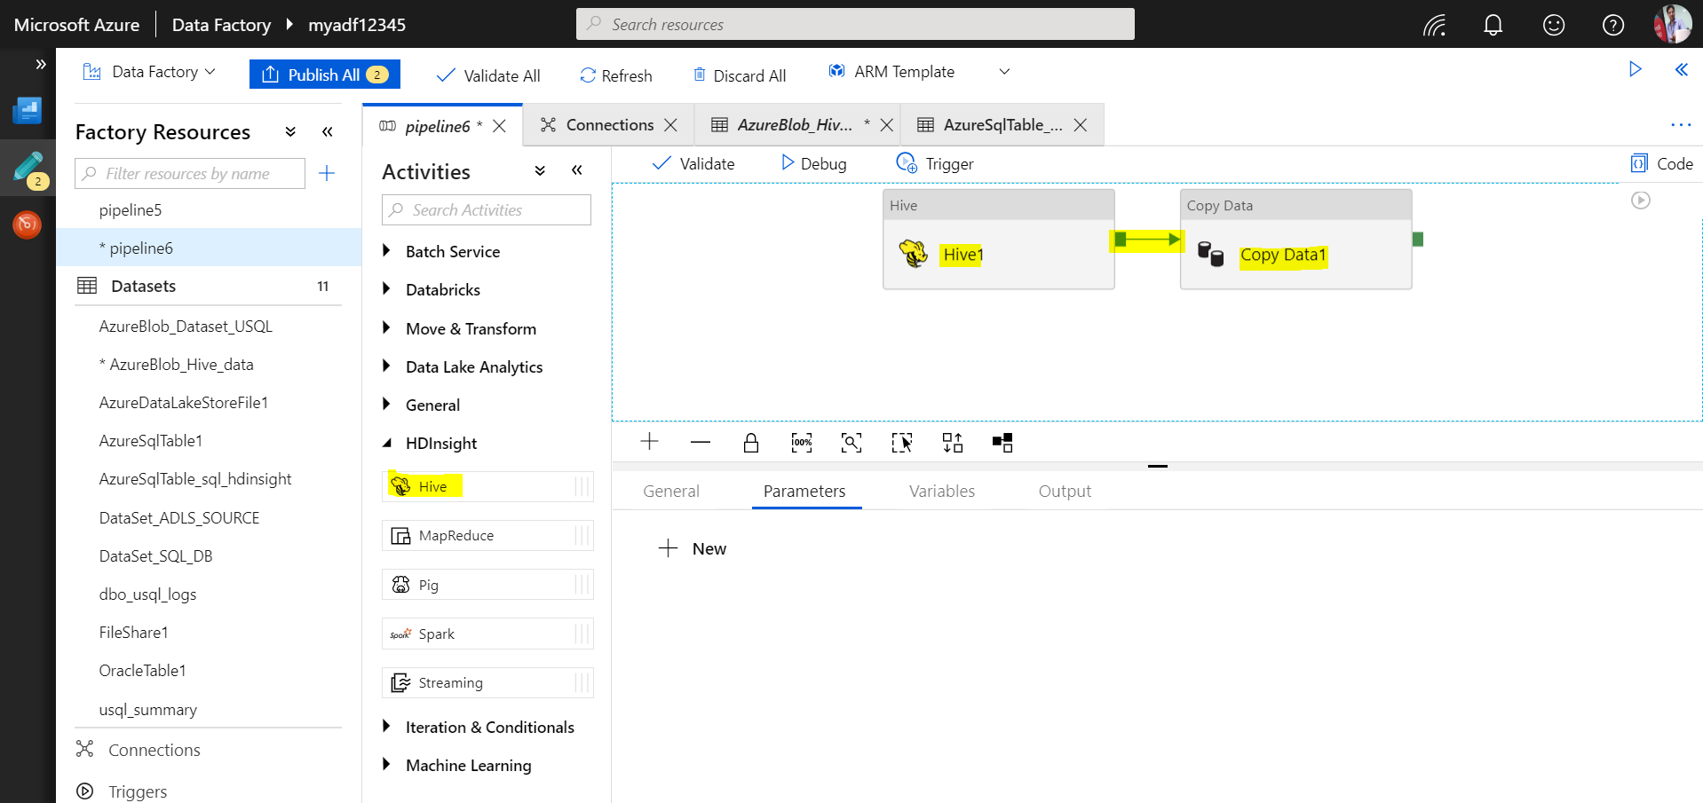

**Select Hive activity 🡺 Select HDInsight linked service 🡺 Test Connection**

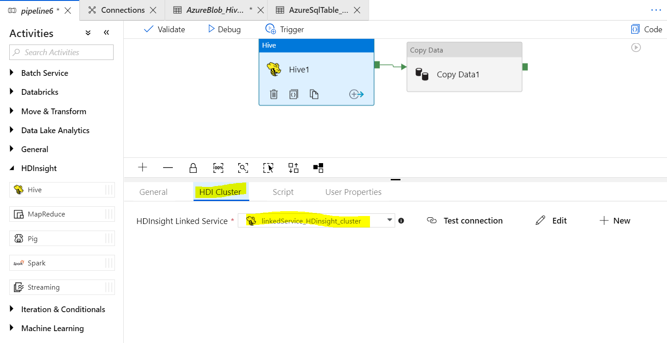

**Go to Script 🡺 Give Linked list of Blob and path to transactions.hql script 🡺 Test Connection**

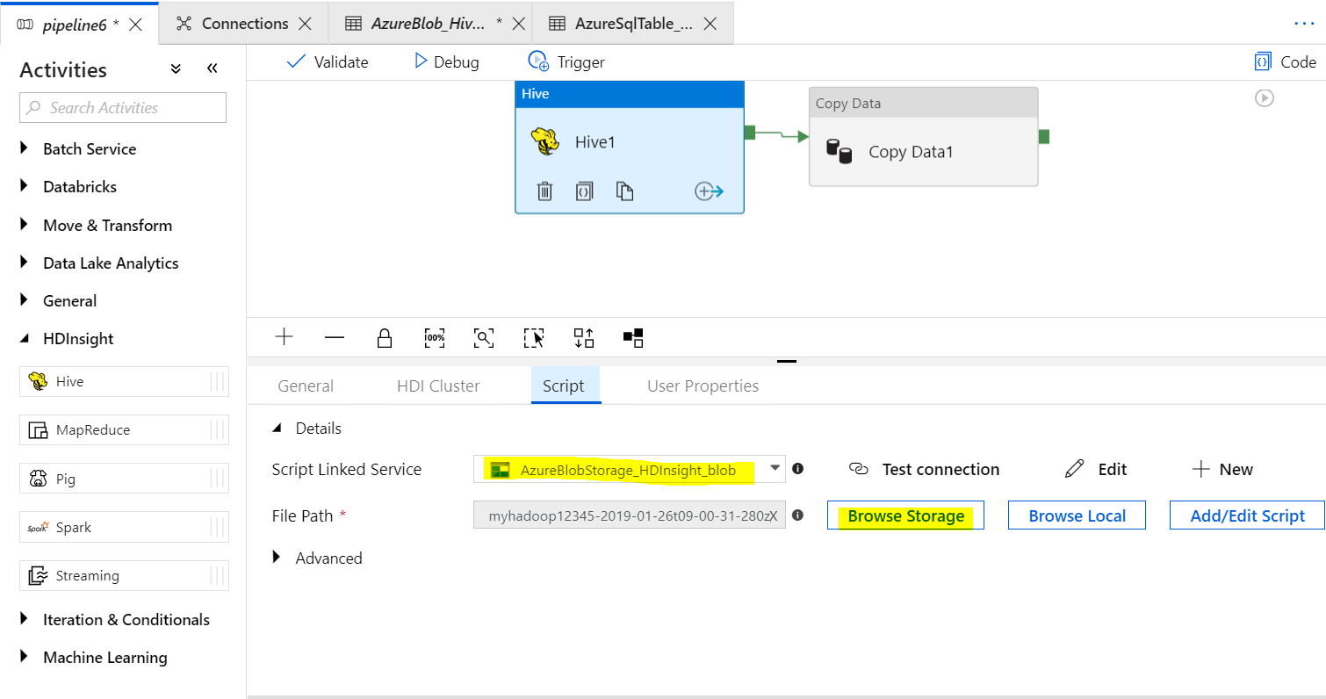

**Select Copy Activity: Set source and sink data set**

**Source Data Set🡺**

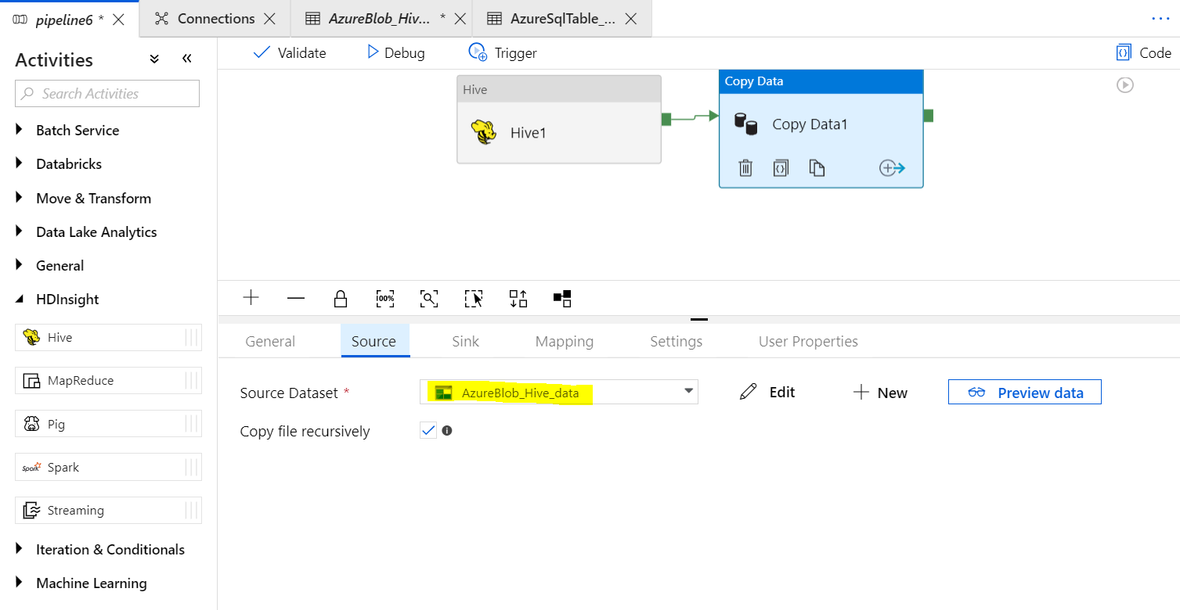

**Set Sink Data Set 🡺**

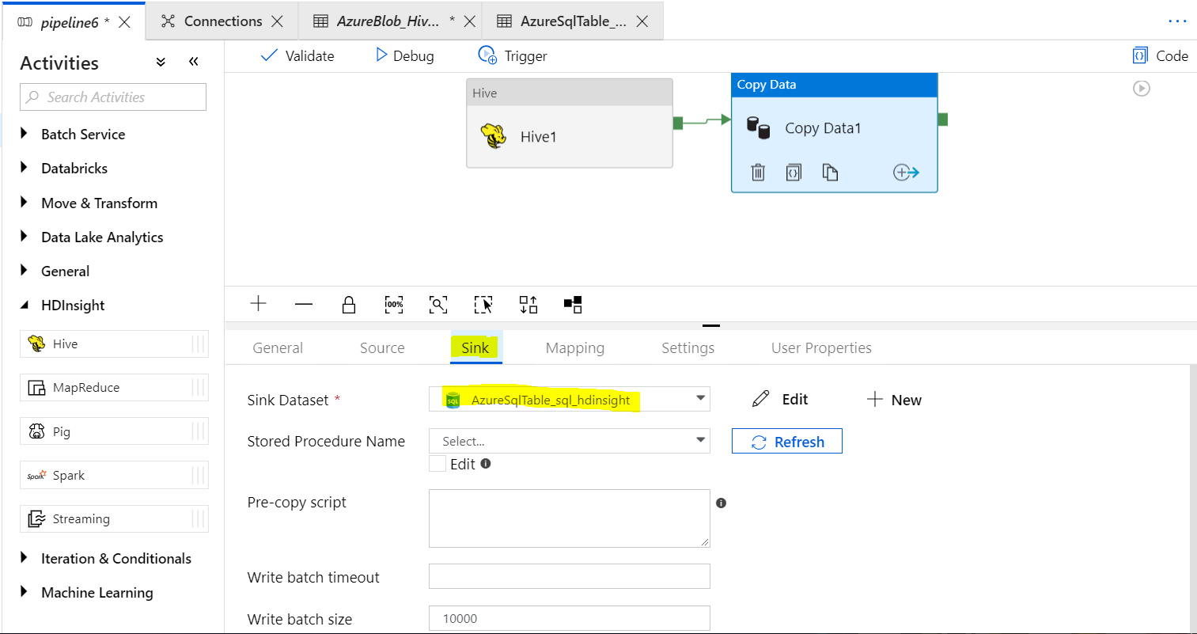

**Go to Mapping 🡺 Import Schema**

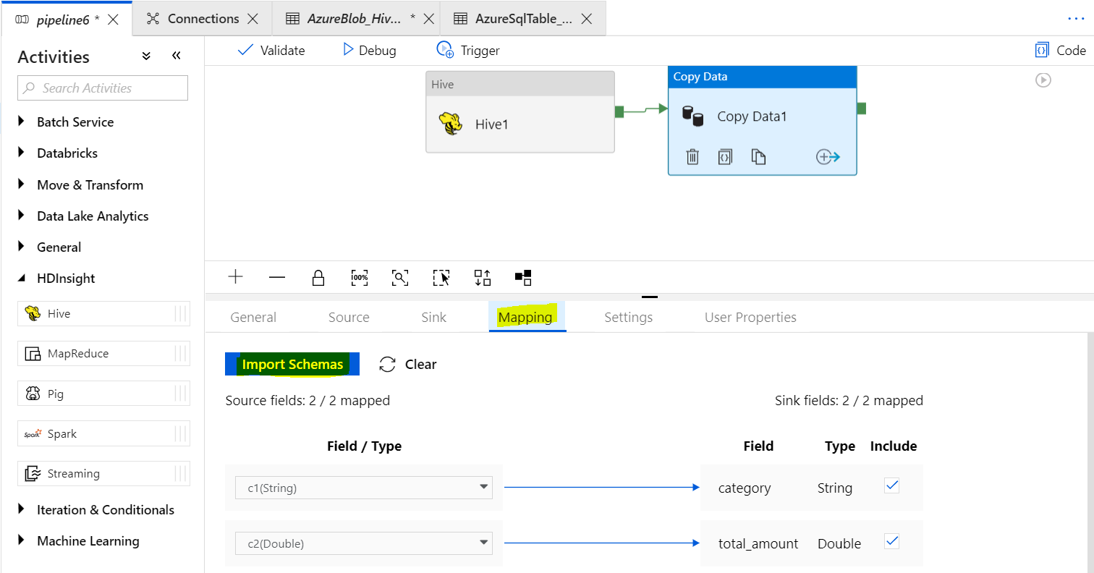

**Validate 🡺 Publish all 🡺 Triger Now.**

**Monitor Pipeline:**



**Check Output in SQL DB:**

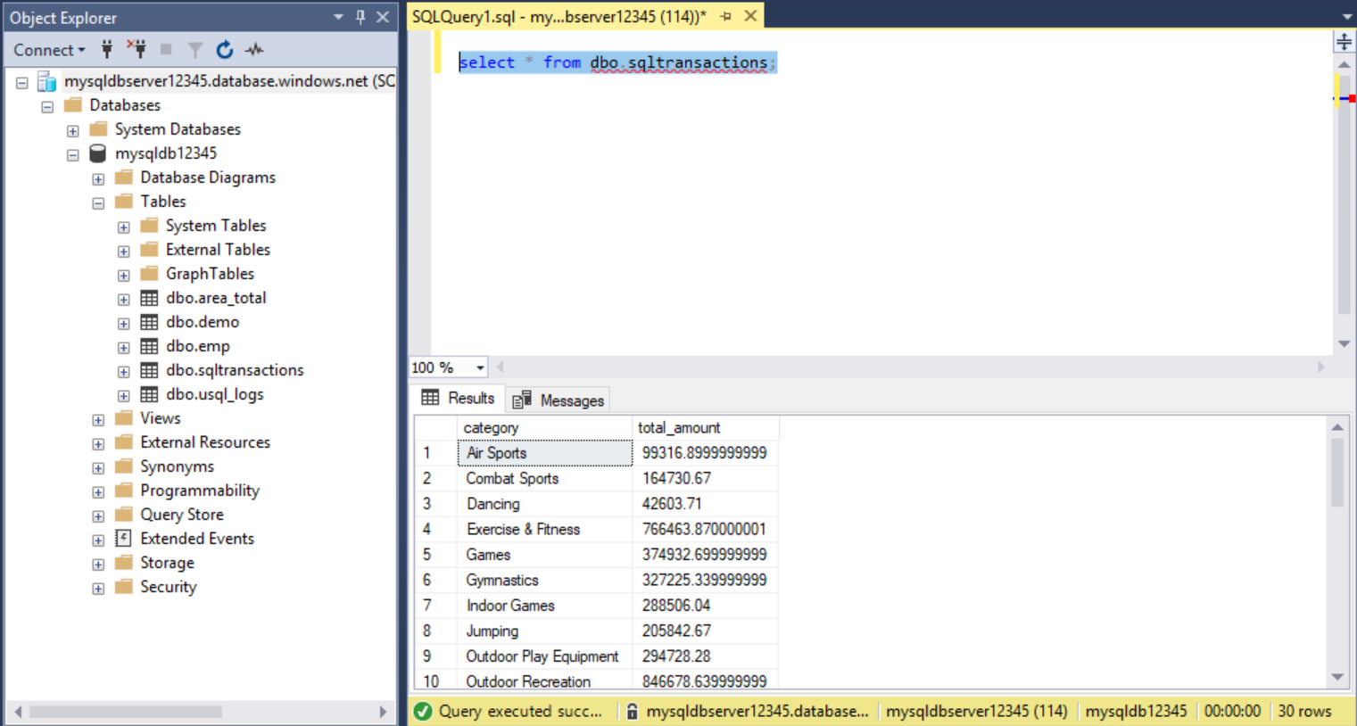

### Spark Activity on Azure Data Factory

### Link: <https://docs.microsoft.com/en-us/azure/data-factory/tutorial-transform-data-spark-portal>

### Prerequisite:

### Blob Storage (Location of Blob and HDInsight cluster must be on same location)

### Upload the Python script to your Blob storage account inside container adftutorial/ **WordCount_Spark.py**

### Upload the input file

### Create a file named **minecraftstory.txt** with some text. The Spark program counts the number of words in this text.

### Upload the **minecraftstory.txt** file to the adftutorial container in blob.

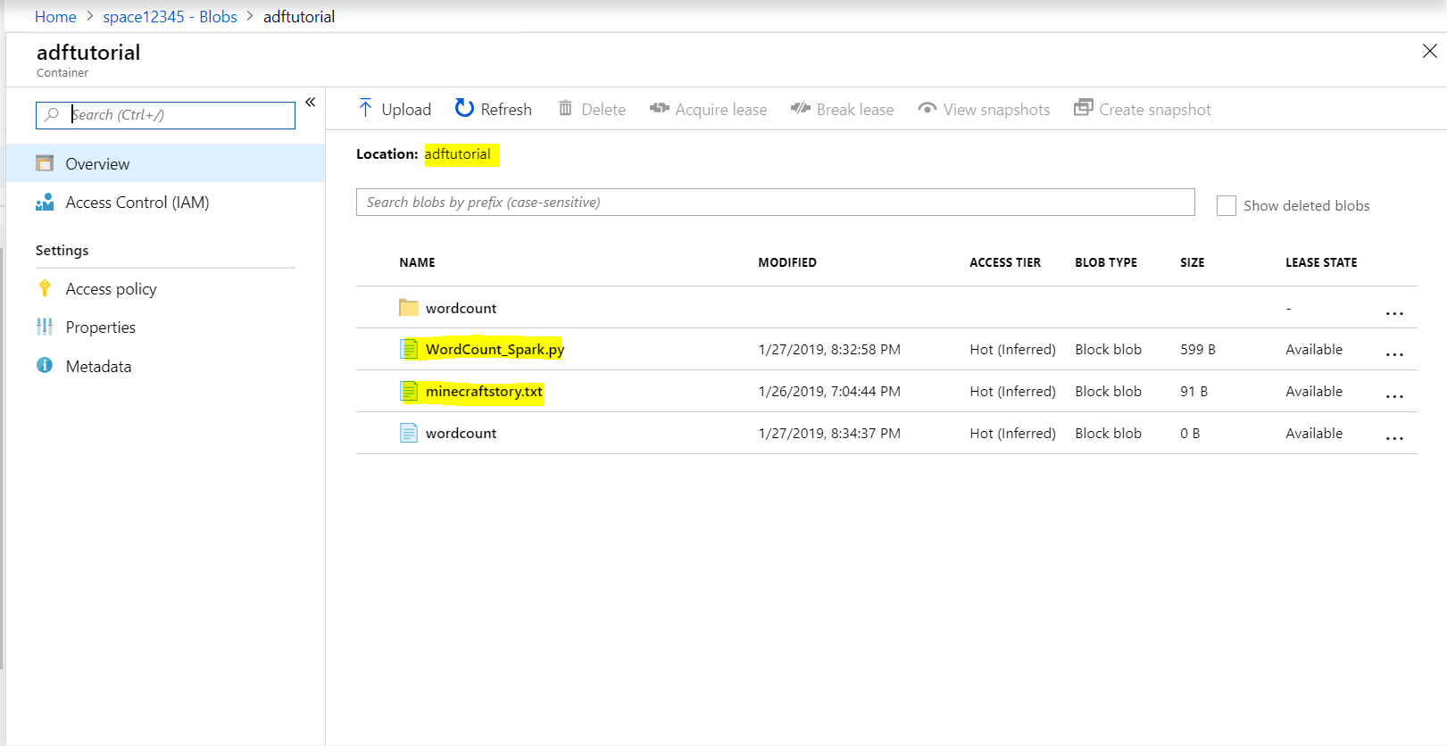

### Deploy a Spark cluster

### 

### Create a Azure Data Factory

### 

### Create an Azure Storage linked service

* On the **let’s get started** page, switch to the **Edit** tab in the left panel.
* Select **Connections** at the bottom of the window, and then select **+ New**.
* In the **New Linked Service** window, select **Data Store** > **Azure Blob Storage**, and then select **Continue**.
* For **Storage account name**, select the name from the list, and then select **Save**.

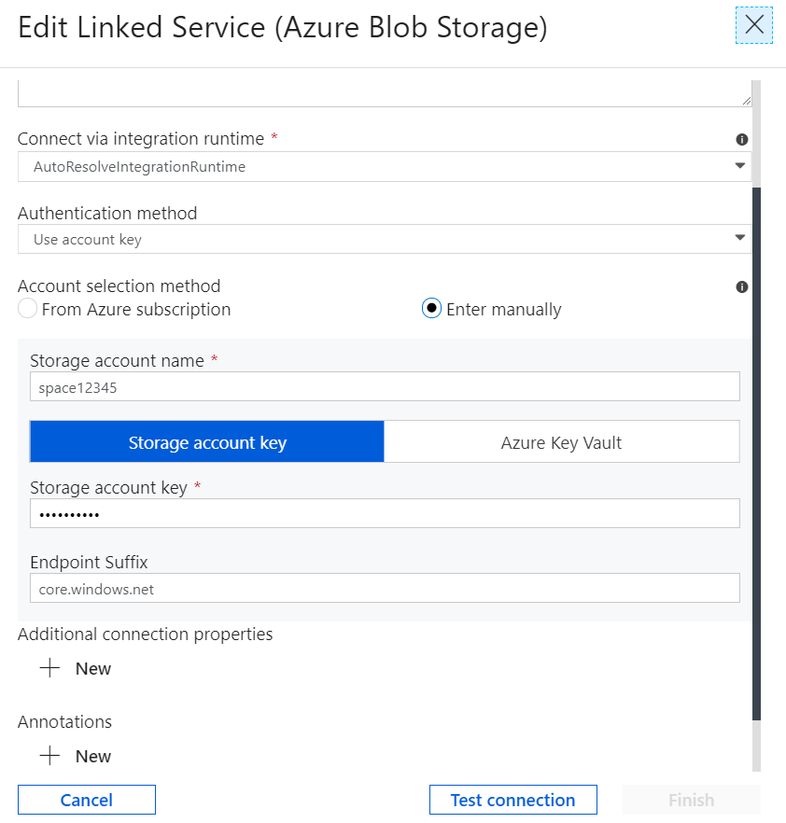

### Create an HDInsight linked service:

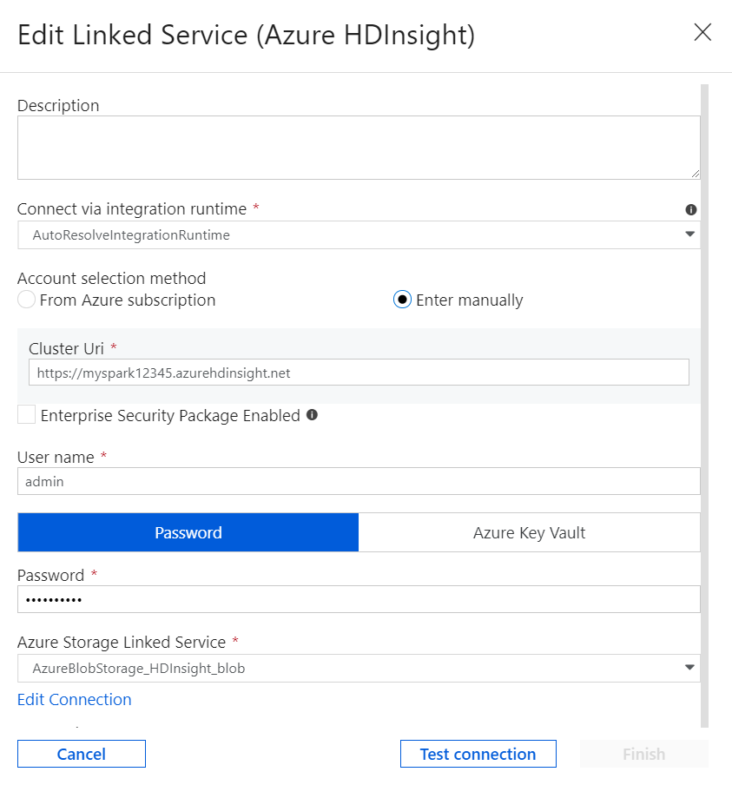

1. **Create a Pipeline: Drag and drop spark activity from Hdinsight.**

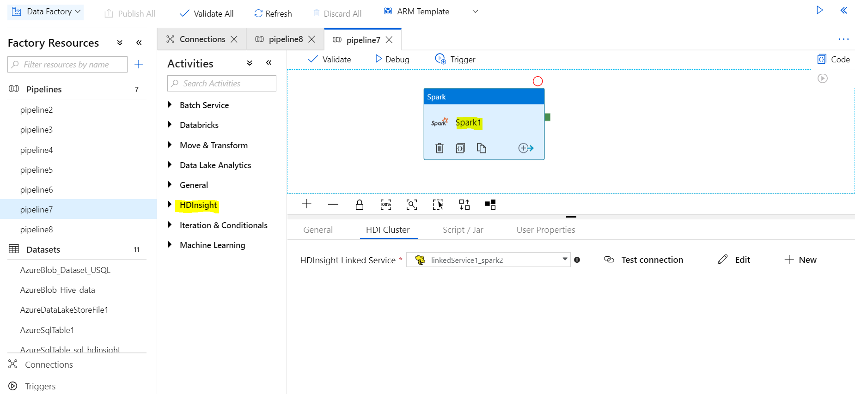

* Switch to the **HDI Cluster** tab.
* Select **AzureHDInsightLinkedService** (which you created in the previous procedure).
* Switch to the **Script/Jar** tab, and complete the following steps:
* For **Job Linked Service**, select **AzureStoragelinkedService**.
* Select **Browse Storage**.
* Browse to the **adftutorial** folder, select **WordCount_Spark.py**, and then select **Finish**.

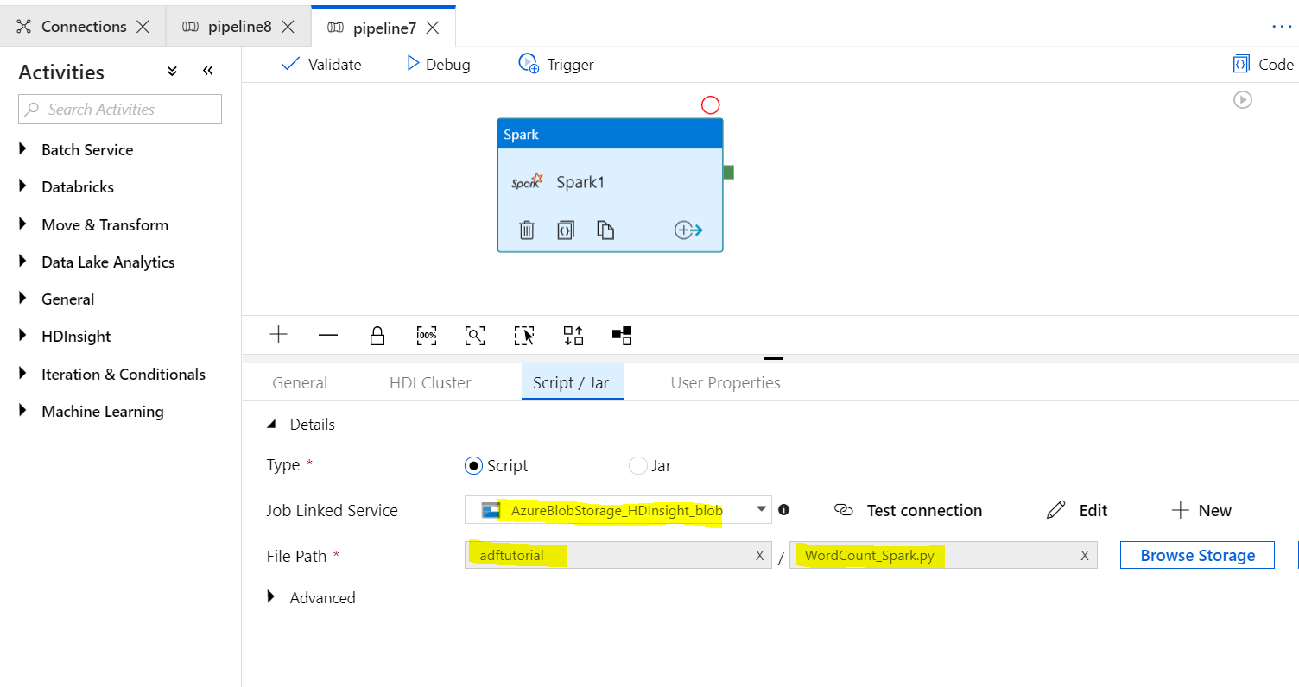

1. To validate the pipeline

* Select the **Validate** button on the toolbar. Select the **>>** (right arrow) button to close the validation window.
* Select **Publish All**. The Data Factory UI publishes entities (linked services and pipeline) to the Azure Data Factory service.

1. Trigger a pipeline run

* Select **Trigger** on the toolbar, and then select **Trigger Now**.

1. Monitor the pipeline run

* Switch to the **Monitor** tab.



## **Verify the output**

## Verify that the output file is created in the adftutorial/wordcount.

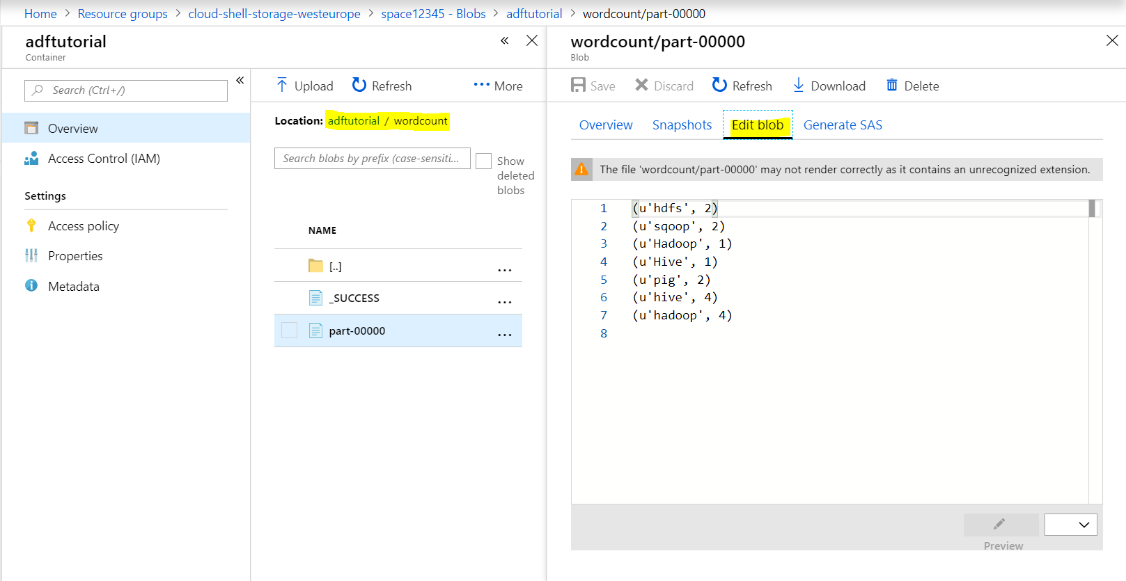

**Hive Activity Using On Demand HDInsight Cluster:**

Link: <https://docs.microsoft.com/en-us/azure/data-factory/v1/data-factory-compute-linked-services#azure-hdinsight-on-demand-linked-service>

Instead of creating Hadoop cluster directly create “**On demand HDInsight cluster**” which is going to be create while needed. Once activity executed its dead after certain (time to live set as per requirement e.g 5 min or 30 min) time.

On demand cluster create with in Linked service.

Data Factory can automatically create a Windows-based or Linux-based on-demand HDInsight cluster for processing data.

The cluster is created in the same region as the storage account that's associated with the cluster. Use the portal or JSON **linkedServiceName** property to create the cluster.

Note the following *key* points about on-demand HDInsight linked service:

* The on-demand HDInsight cluster doesn't appear in your **Azure subscription**. The Data Factory service manages the on-demand HDInsight cluster on your behalf.
* The logs for jobs that are run on an on-demand HDInsight cluster are copied to the storage account that's associated with the HDInsight cluster. To access these logs, in the Azure portal, go to the **Activity Run Details** pane. For more information, see [Monitor and manage pipelines](https://docs.microsoft.com/en-us/azure/data-factory/v1/data-factory-monitor-manage-pipelines).
* You are charged only for the time that the HDInsight cluster is up and running jobs.

**Important**

It typically takes *20 minutes* or more to provision an on-demand HDInsight cluster.

**Example**

The following JSON defines a Linux-based on-demand HDInsight linked service. Data Factory automatically creates a *Linux-based* HDInsight cluster when it processes a data slice.

JSONCopy

{

"name": "HDInsightOnDemandLinkedService",

"properties": {

"type": "HDInsightOnDemand",

"typeProperties": {

"version": "3.6",

"osType": "Linux",

"clusterSize": 1,

"timeToLive": "00:05:00",

"linkedServiceName": "AzureStorageLinkedService"

}

}

}

**Properties**

| **Property** | **Description** | **Required** |
| --- | --- | --- |
| type | Set the type property to **HDInsightOnDemand**. | Yes |
| clusterSize | The number of worker and data nodes in the cluster. The HDInsight cluster is created with 2 head nodes, in addition to the number of worker nodes that you specify for this property. The nodes are of size Standard_D3, which has 4 cores. A 4-worker node cluster takes 24 cores (4*4 = 16 cores for worker nodes, plus 2*4 = 8 cores for head nodes). For details about the Standard_D3 tier, see [Create Linux-based Hadoop clusters in HDInsight](https://docs.microsoft.com/en-us/azure/hdinsight/hdinsight-hadoop-provision-linux-clusters). | Yes |
| timeToLive | The allowed idle time for the on-demand HDInsight cluster. Specifies how long the on-demand HDInsight cluster stays alive when an activity run is finished, if there are no other active jobs in the cluster.  For example, if an activity run takes 6 minutes and **timeToLive**is set to 5 minutes, the cluster stays alive for 5 minutes after the 6 minutes of processing the activity run. If another activity run is executed in the 6-minute window, it's processed by the same cluster.  Creating an on-demand HDInsight cluster is an expensive operation (it might take a while). Use this setting as needed to improve performance of a data factory by reusing an on-demand HDInsight cluster.  If you set the **timeToLive** value to **0**, the cluster is deleted as soon as the activity run finishes. However, if you set a high value, the cluster might stay idle, unnecessarily resulting in high costs. It's important to set the appropriate value based on your needs.  If the **timeToLive** value is appropriately set, multiple pipelines can share the instance of the on-demand HDInsight cluster. | Yes |
| version | The version of the HDInsight cluster. For allowed HDInsight versions, see [Supported HDInsight versions](https://docs.microsoft.com/azure/hdinsight/hdinsight-component-versioning#supported-hdinsight-versions). If this value isn't specified, the [latest HDI default version](https://docs.microsoft.com/azure/hdinsight/hdinsight-component-versioning#hadoop-components-available-with-different-hdinsight-versions) is used. | No |
| linkedServiceName | The Azure Storage linked service to be used by the on-demand cluster for storing and processing data. The HDInsight cluster is created in the same region as this storage account.  Currently, you can't create an on-demand HDInsight cluster that uses Azure Data Lake Store as the storage. If you want to store the result data from HDInsight processing in Data Lake Store, use Copy Activity to copy the data from Blob storage to Data Lake Store. | Yes |
| additionalLinkedServiceNames | Specifies additional storage accounts for the HDInsight linked service. Data Factory registers the storage accounts on your behalf. These storage accounts must be in the same region as the HDInsight cluster. The HDInsight cluster is created in the same region as the storage account that's specified by the **linkedServiceName** property. | No |
| osType | The type of operating system. Allowed values are **Linux** and **Windows**. If this value isn't specified, **Linux** is used.   We strongly recommend using Linux-based HDInsight clusters. The retirement date for HDInsight on Windows is July 31, 2018. | No |
| hcatalogLinkedServiceName | The name of the Azure SQL linked service that points to the HCatalog database. The on-demand HDInsight cluster is created by using the SQL database as the metastore. | No |

# **Incrementally load data from an Azure SQL database to Azure Blob storage**

LINK: <https://docs.microsoft.com/en-us/azure/data-factory/tutorial-incremental-copy-portal>

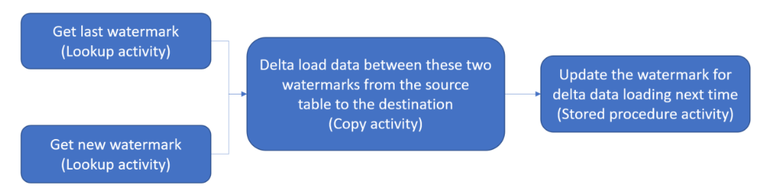

Here are the important steps to create this solution:

1. **Select the watermark column**. Select one column in the source data store, which can be used to slice the new or updated records for every run. Normally, the data in this selected column (for example, last_modify_time or ID) keeps increasing when rows are created or updated. **The maximum value in this column is used as a watermark.**
2. **Prepare a data store to store the watermark value**: You store the watermark value in a SQL database.
3. **Create a pipeline with the following workflow**:

The pipeline in this solution has the following activities:

* + **Create two Lookup activities**. Use the **first Lookup** activity to retrieve the **last watermark value**. Use the **second Lookup activity** to retrieve the **new watermark value**. These watermark values are passed to the Copy activity.
  + **Create a Copy activity** that copies rows from the source data store with the value of the watermark column greater than the old watermark value and less than the new watermark value. **Then, it copies the delta data from the source data store to Blob storage as a new file**.
  + Create a **StoredProcedure activity** that updates the watermark value for the pipeline that runs next time.

### Create a data source table in your SQL database

1. Open SQL Server Management Studio. In **Server Explorer**, right-click the database, and choose **New Query**.
2. Run the following SQL command against your SQL database to create a table named data_source_table as the data source store:

create table data_source_table

(

PersonID int,

Name varchar(255),

LastModifytime datetime

);

INSERT INTO data_source_table

(PersonID, Name, LastModifytime)

VALUES

(1, 'aaaa','9/1/2017 12:56:00 AM'),

(2, 'bbbb','9/2/2017 5:23:00 AM'),

(3, 'cccc','9/3/2017 2:36:00 AM'),

(4, 'dddd','9/4/2017 3:21:00 AM'),

(5, 'eeee','9/5/2017 8:06:00 AM');

Select * from data_source_table;

### Create another table in your SQL database to store the high watermark value

create table watermarktable

(

TableName varchar(255),

WatermarkValue datetime,

);

Set the default value of the high watermark with the table name of source data store.

INSERT INTO watermarktable

VALUES ('data_source_table','1/1/2010 12:00:00 AM')

Review the data:

Select * from watermarktable

### Create a stored procedure in your SQL database to update last watermark and new watermark

CREATE PROCEDURE usp_write_watermark @LastModifiedtime datetime, @TableName varchar(50)

AS

BEGIN

UPDATE watermarktable

SET [WatermarkValue] = @LastModifiedtime

WHERE [TableName] = @TableName

END

* **Create a Data Factory**
* **Create a Linked service for SQL DB**
* **Create a linked Service for Blob**

Note: We will create Data Set at real time.

**Create a pipeline:**

In the **General** page of the **Properties** window for the pipeline, enter **IncrementalCopyPipeline** name

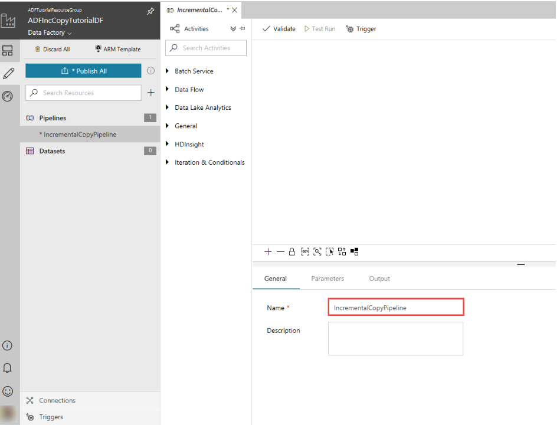

Let's add the first lookup activity to get the old watermark value. In the **Activities** toolbox, expand **General**, and drag-drop the **Lookup** activity to the pipeline designer surface. Change the name of the activity to **LookupOldWaterMarkActivity.**

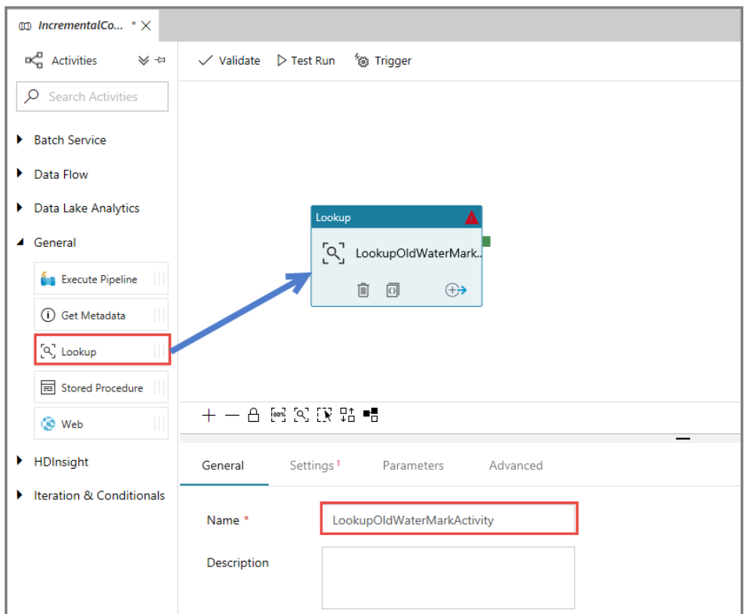

Switch to the **Settings** tab, and click **+ New** for **Source Dataset**. In this step, you create a dataset to represent data in the **watermarktable**. This table contains the old watermark that was used in the previous copy operation.

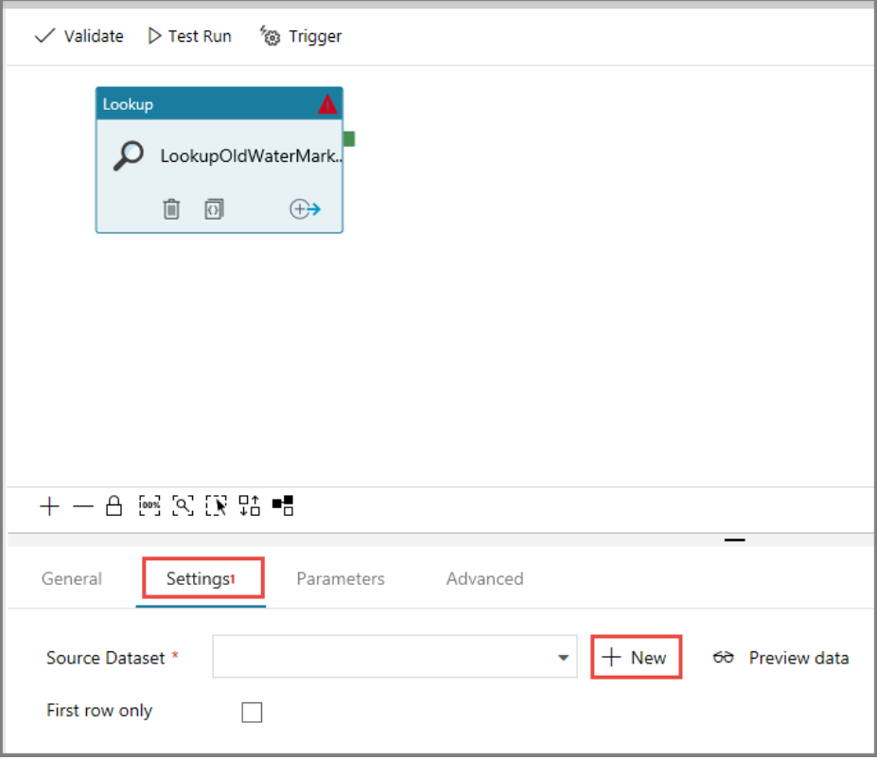

In the **New Dataset** window, select **Azure SQL Database**, and click **Finish**. You see a new tab opened for the dataset.

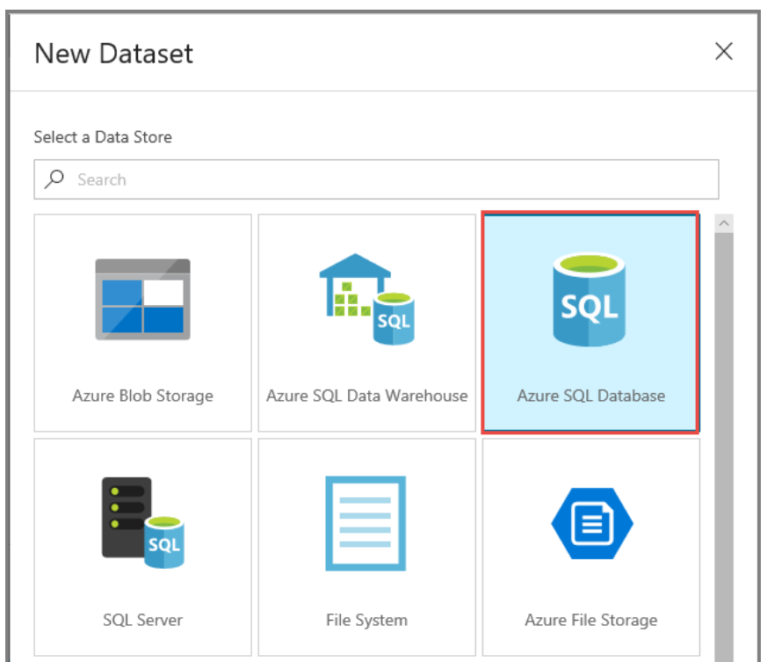

In the properties window for the dataset, enter **WatermarkDataset** for **Name**.

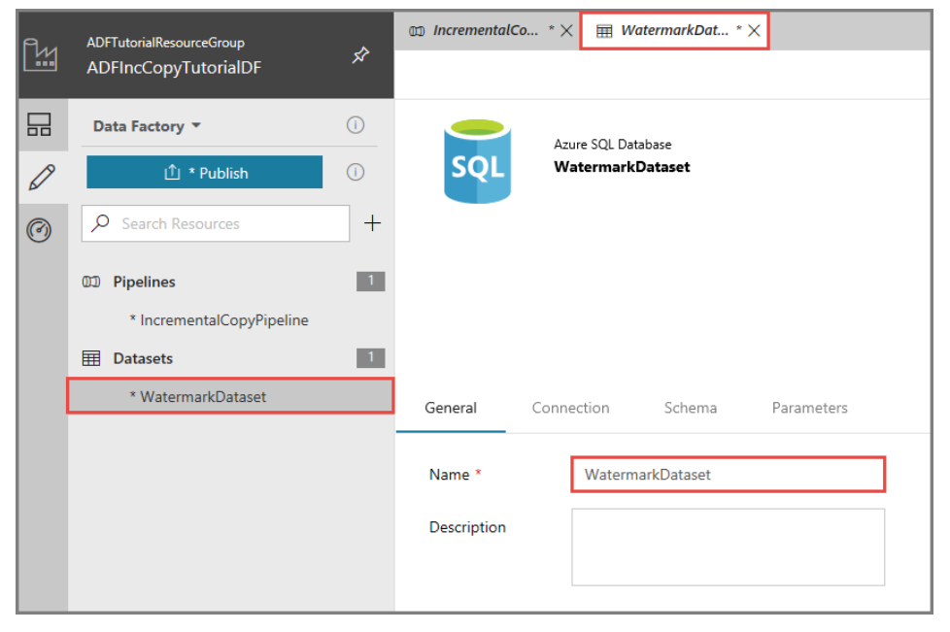

Switch to the **Connection** tab, and linked service for your Azure SQL database which we already created.

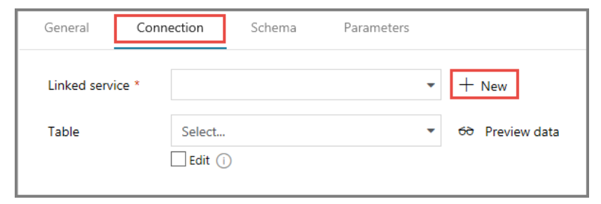

Select **[dbo].[watermarktable]** for **Table**. If you want to preview data in the table, click **Preview data**.

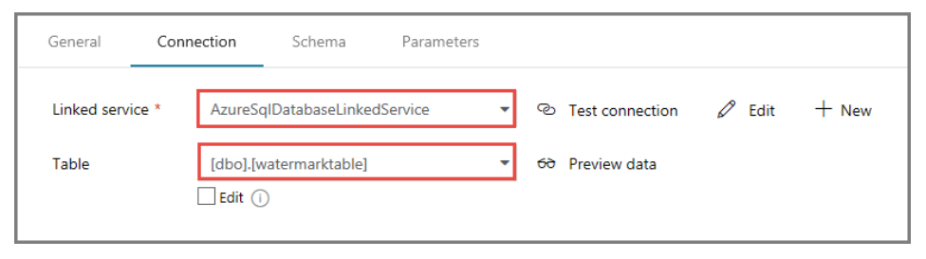

Switch to the pipeline editor by clicking the pipeline tab at the top or by clicking the name of the pipeline in the tree view on the left. In the properties window for the **Lookup** activity, confirm that **WatermarkDataset** is selected for the **Source Dataset** field.

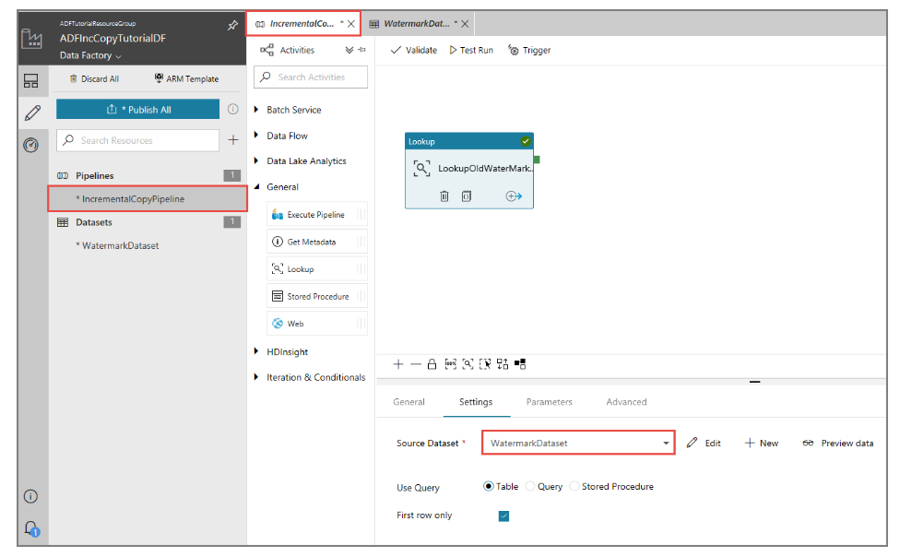

In the **Activities** toolbox, expand **General**, and drag-drop another **Lookup** activity to the pipeline designer surface, and set the name to **LookupNewWaterMarkActivity** in the **General** tab of the properties window. This Lookup activity gets the new watermark value from the table with the source data to be copied to the destination.

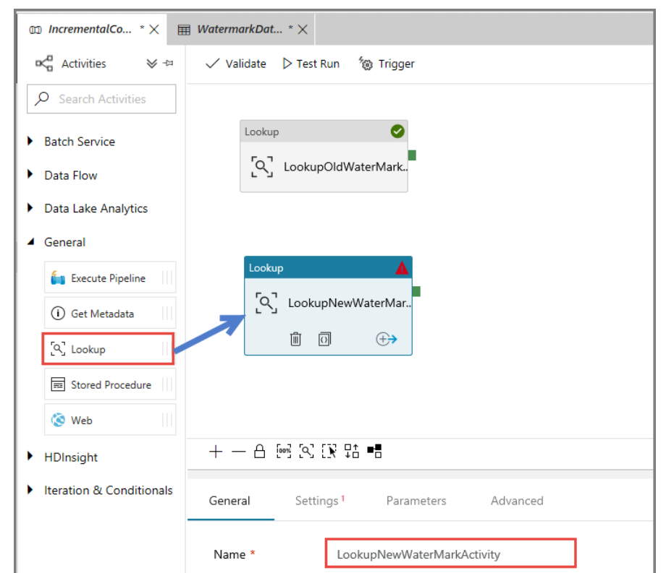

In the properties window for the second **Lookup** activity, switch to the **Settings** tab, and click **New**. You create a dataset to point to the source table that contains the new watermark value (maximum value of LastModifyTime).

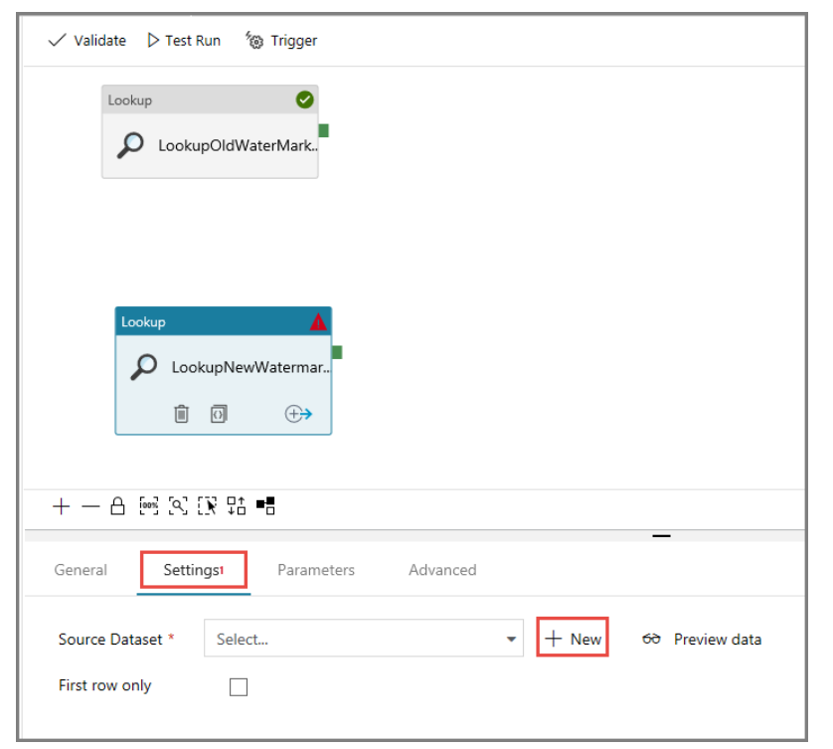

In the **New Dataset** window, select **Azure SQL Database**, and click **Finish**. You see a new tab opened for this dataset. You also see the dataset in the tree view.

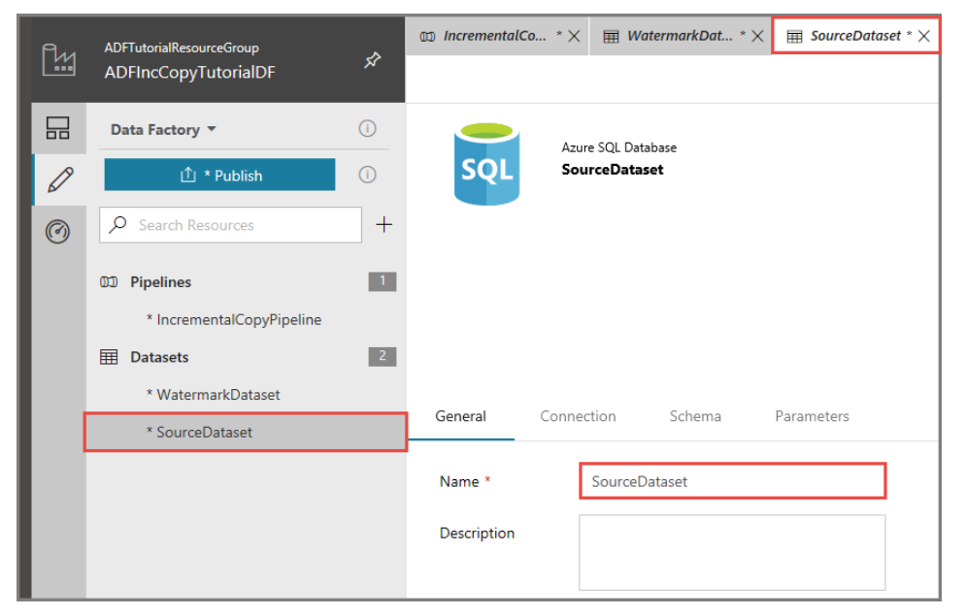

Switch to the **Connection** tab, and do the following steps:

1. Select **AzureSqlDatabaseLinkedService** for **Linked service**.
2. Select **[dbo].[data_source_table]** for Table. You specify a query on this dataset later in the tutorial. The query takes the precedence over the table you specify in this step.

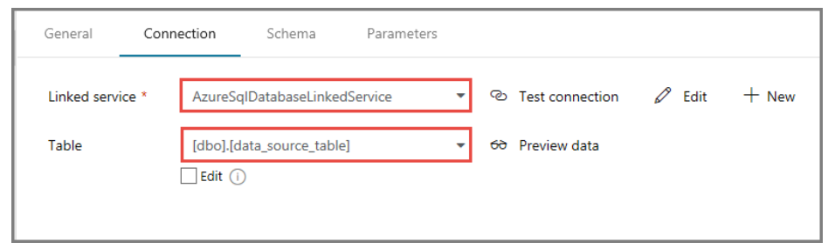

**Go back to pipeline**

Select **Query** for the **Use Query** field, and enter the following query: you are only selecting the maximum value of **LastModifytime** from the **data_source_table**. If you don't have this query, the dataset gets all the rows from the table as you specified the table name (data_source_table) in the dataset definition.

**select MAX(LastModifytime) as NewWatermarkvalue from data_source_table**

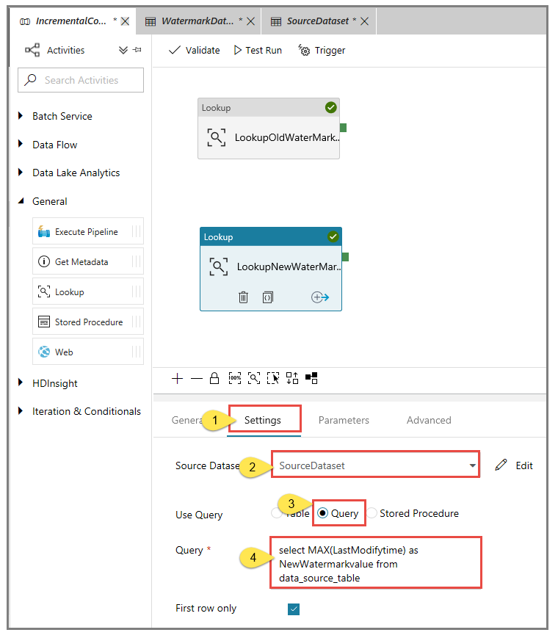

In the **Activities** toolbox, expand **DataFlow**, and drag-drop the **Copy** activity from the Activities toolbox, and set the name to **IncrementalCopyActivity**

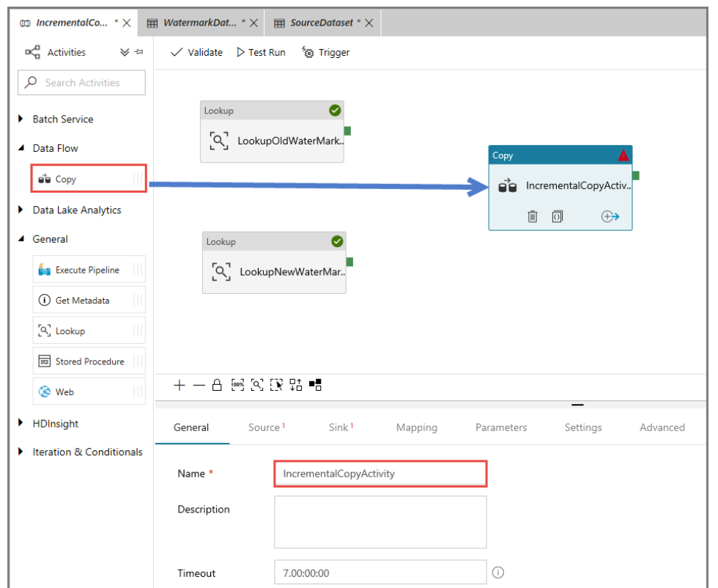

**Connect both Lookup activities to the Copy activity** by dragging the **green button** attached to the Lookup activities to the Copy activity. Release the mouse button when you see the border color of the Copy activity changes to blue.

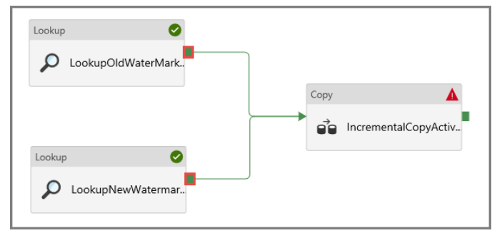

Select the **Copy activity** and confirm that you see the properties for the activity in the **Properties** window.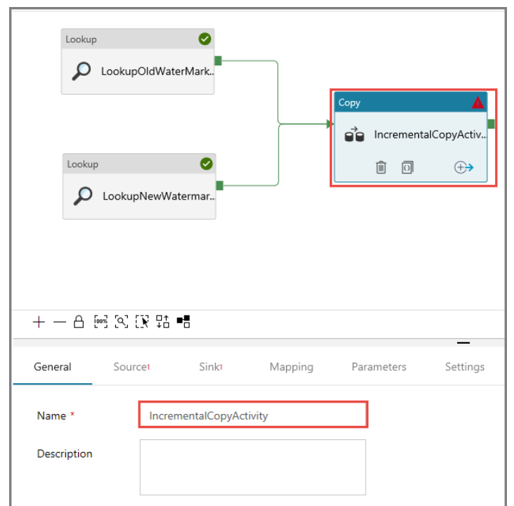

Switch to the **Source** tab in the **Properties** window, and do the following steps:

1. Select **SourceDataset** for the **Source Dataset** field.
2. Select **Query** for the **Use Query** field.
3. Enter the following SQL query for the **Query** field.

select * from data_source_table where LastModifytime > '@{activity('LookupOldWaterMarkActivity').output.firstRow.WatermarkValue}' and LastModifytime <= '@{activity('LookupNewWaterMarkActivity').output.firstRow.NewWatermarkvalue}'

NOTE: Please check there should not any extra space and / new line in above script.

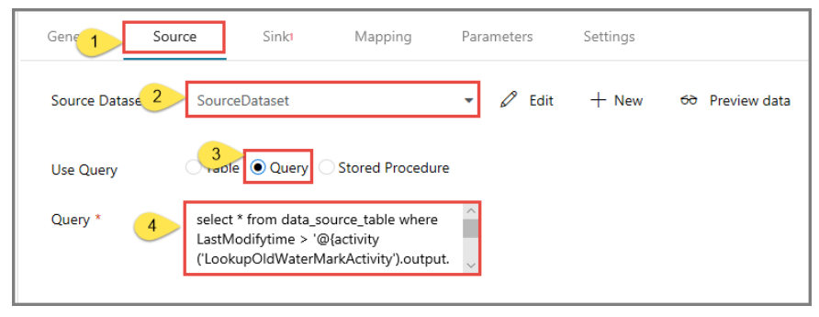

Sink data store is of type Azure Blob Storage. Therefore, select **Azure Blob Storage**, and click **Finish** in the **New Dataset** window

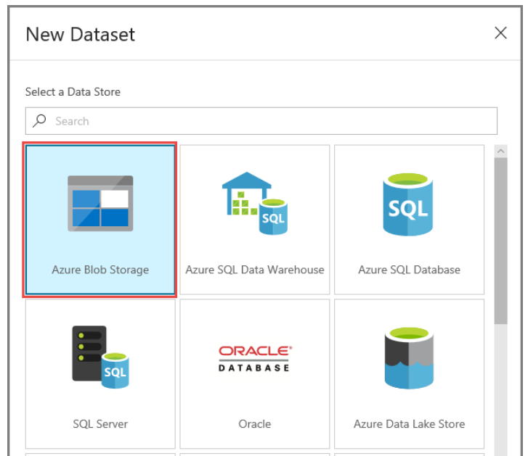

In the **General** tab of the Properties window for the dataset, enter **SinkDataset** for **Name**.

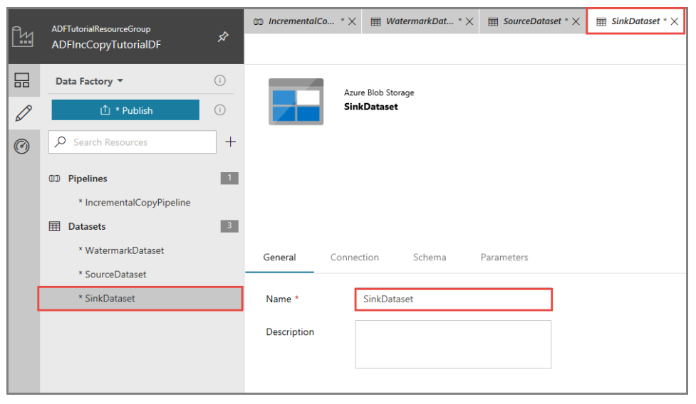

Switch to the **Connection** tab, and Choose linked service for your **Azure Blob storage**

In the **Connection** tab, do the following steps:

1. Confirm that **AzureStorageLinkedService** is selected for **Linked service**.
2. For the **folder** part of the **File path** field, enter **adftutorial/incrementalcopy**. **adftutorial** is the blob container name and **incrementalcopy** is the folder name. This snippet assumes that you have a blob container named adftutorial in your blob storage. Create the container if it doesn't exist, or set it to the name of an existing one. Azure Data Factory automatically creates the output folder **incrementalcopy** if it does not exist. You can also use the **Browse** button for the **File path** to navigate to a folder in a blob container. .RunId, '.txt')`.
3. For the **filename** part of the **File path** field, enter @CONCAT('Incremental-', pipeline().RunId, '.txt'). The file name is dynamically generated by using the expression. Each pipeline run has a unique ID. The Copy activity uses the run ID to generate the file name.

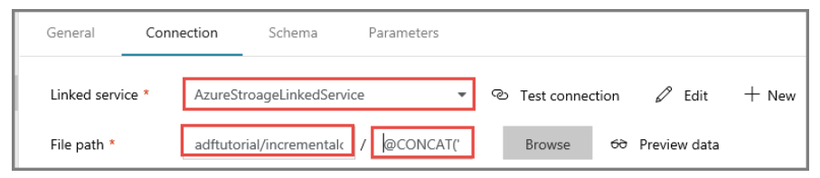

Switch to the **pipeline** editor by clicking the pipeline tab at the top or by clicking the name of the pipeline in the tree view on the left.

In the **Activities** toolbox, expand **General**, and drag-drop the **Stored Procedure** activity from the **Activities** toolbox to the pipeline designer surface. **Connect** the green (Success) output of the **Copy** activity to the **Stored Procedure** activity.

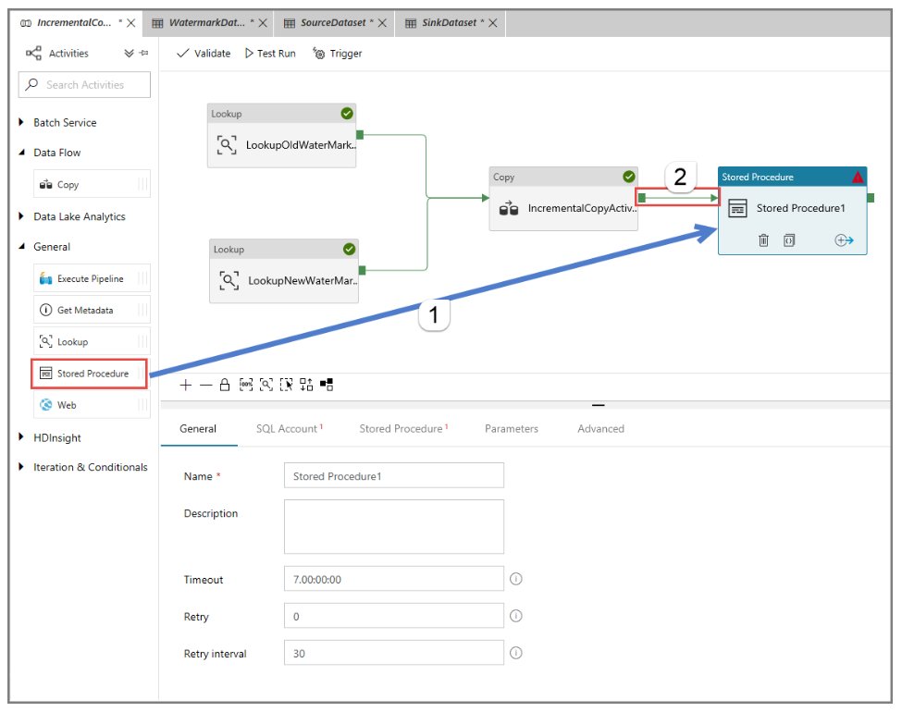

Select **Stored Procedure Activity** in the pipeline designer, change its name to **StoredProceduretoWriteWatermarkActivity**.

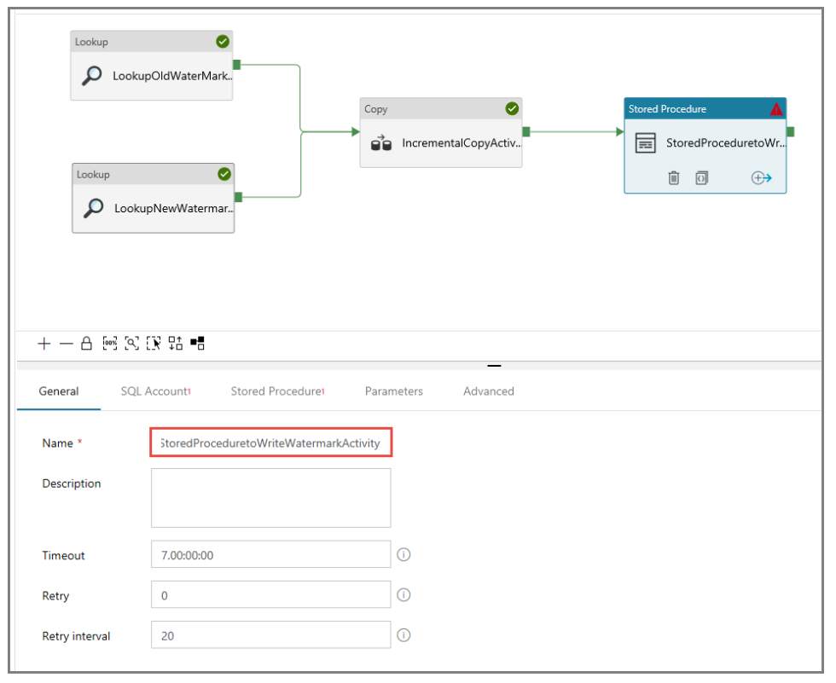

Switch to the **SQL Account** tab, and select AzureSqlDatabaseLinkedService* for **Linked service**.

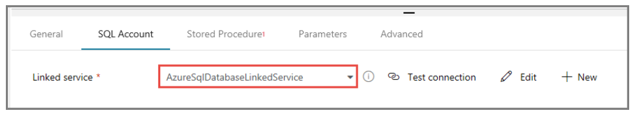

Switch to the **Stored Procedure** tab, and do the following steps:

1. For **Stored procedure name**, select **usp_write_watermark**.
2. To specify values for the stored procedure parameters, click **Import parameter**, and enter following values for the parameters:

| **Name** | **Type** | **Value** |
| --- | --- | --- |
| LastModifiedtime | DateTime | @{activity('LookupNewWaterMarkActivity').output.firstRow.NewWatermarkvalue} |
| TableName | String | @{activity('LookupOldWaterMarkActivity').output.firstRow.TableName} |

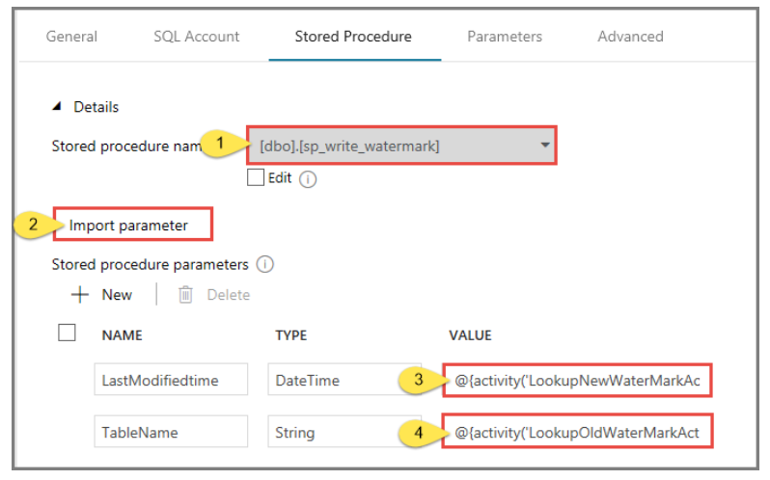

**Validate 🡺 Publish All 🡺 Trigger Now.**

## **Review the results**

1. Connect to your Azure Storage Account by using tools such as [Azure Storage Explorer](https://azure.microsoft.com/features/storage-explorer/). Verify that an output file is created in the **incrementalcopy** folder of the **adftutorial** container.

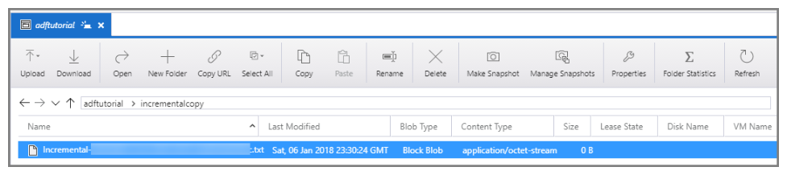

Open the output file and notice that all the data is copied from the **data_source_table** to the blob file.

1,aaaa,2017-09-01 00:56:00.0000000

2,bbbb,2017-09-02 05:23:00.0000000

3,cccc,2017-09-03 02:36:00.0000000

4,dddd,2017-09-04 03:21:00.0000000

5,eeee,2017-09-05 08:06:00.0000000

Check the latest value from watermarktable. You see that the watermark value was updated.

Select * from watermarktable

Here is the output:

| **TableName** | **WatermarkValue** |
| --- | --- |
| data_source_table | 2017-09-05 8:06:00.000 |

## 

## **Add more data to source**

Insert new data into the SQL database (data source store).

INSERT INTO data_source_table

VALUES (6, 'newdata','9/6/2017 2:23:00 AM')

INSERT INTO data_source_table

VALUES (7, 'newdata','9/7/2017 9:01:00 AM')

**Triger Pipeline again and check Blob Output**

**Copy Data from HDFS to Azure Data Lake**

<https://docs.microsoft.com/en-us/azure/data-factory/connector-hdfs>